

**IMIBARE**

**18/10/2019**

**9:00 am -11:00 am**

**IKIZAMINI GISOZA UMWAKA WA GATATU W’AMASHURI ABANZA, 2019**

**IMIBARE**

**Igihe kimara: Amasaha abiri (2h00)**

/100

**Amanota:**

**Amabwiriza:**

1. Ibisubizo bigomba kuba bifututse kandi byuzuye.
2. Gusiribanga no guhindagura ibisubizo bifatwa nko gukopera.
3. Ukurikize amabwiriza ari ku bibazo.
4. Koresha gusa ikaramu y’**ubururu** cyangwa iy’**umukara**

**A) IBARA N’AMATEGEKO YARYO (AMANOTA 60)**

1.Andika mu mibare **(amanota 2**)

(a) Ibihumbi bitandatu ,Magana inani na mirongo ikenda na

gatandatu:…………………..

(b) Ibihumbi ikenda na cumi n’ikenda …………………………….

2)Andika mu magambo (**amanota 3)**

(a) 9997: ……………………..

(b) 8083:……………………….

(c) ………………………

3) Sesengura iyi mibare mo ibinyabumwe, ibinyacumi , ibinyajana n’ibinyagihumbi: **(amanota 2)**

(a) 7236 : …………………………..

(b)9904:…………………………………………….

4) Andika umubare wasesenguwe **(amanota 4)**

a)……

b) …….

c) ………..

d) =……………..

5)Gereranya imibare ukoresheje <,> cyangwa = **(amanota 3)**

a)8791 8691

b)9090 9909

c)8500 9000-500

6)Tondeka uhereye ku mubare muto ujya ku munini **(amanota 4)**

(a) 7851, 4725, 8965, 1910 :

(b) 5809, 2930, 3390, 4903

7)Tondeka uhereye ku munini ujya ku muto **(amanota 4)**

(a) 1871, 775, 1519,2718

(b)9 293, 5923 ,8239, 7932

8) Shaka igisubizo **(amanota 2)**

(a)5343 + 2456 =….

(b) 4526 + 4159 =……

9)Shaka igisubizo **(amanota 2)**

(a)9896 – 5434 =……

(b) 9972 – 7359 =………

10)Shaka igisubizo (**amanota6**)

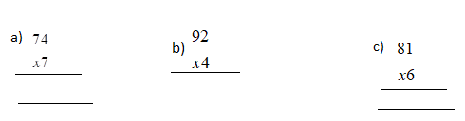

11) Shaka igisubizo (**amanota 6)**

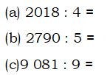

12)Uzuza umubare ubura mu kazu **(amanota 2)**

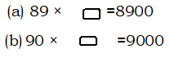

13)Itegereze uru rukurikirane rw’imibare maze wuzuze imibare ibura

**(amanota 4**)

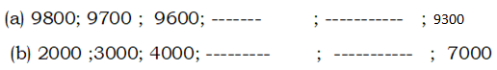

14) Ishuri ryigamo abakobwa 997 n’abahungu 987. Shaka umubare w’abanyeshuri biga muri iryo shuri **(amanota 3)**

…………………………………………………………………………………………………………………………………………….

15) Mu cyumba cy’inama harimo intebe 397. Kuri buri ntebe hicara abantu 18. Urwo rusengero rwakwakira abantu bangahe?

….. ………………………………………………………….. …… **(amanota 3)**

16) Gabanya ku buryo bungana inzitiramibu 9 875, imidugudu 5. Buri mudugudu uzahabwa inzitiramibu zingahe?

…………………………………………………………………………………………………………………… **(amanota 3)**

17) Umudugudu utuwe n’ingo 6 830. Muri zo 5 987zatanze ubwishingizi mu kwivuza. Shaka umubare w’ingo zitaratanga ubwishingizi **(amanota 3)**

……………………………………………………………………………………………………………………………………………

…………………………………………………………………………………………………………………………………………………

18) Umurima w’amashu urimo imirongo 357 kandi kuri buri murongo hateyeho amashu 29. Shaka umubare w’amashu ateye muri uwo murima wose.

**( amanota 3**)

………………………………………………………………………………………………………………………………………………………………………………………………………………………………………………………………………………………………………………………………………

19) Uzuza mu tuzu umubare ubura **(amanota 4)**

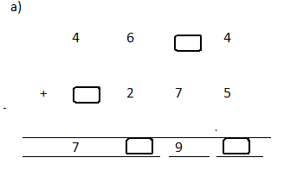

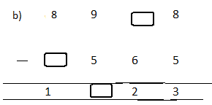

**B) IMIGABANE (AMANOTA 5)**

20) Andika mu magambo iyi migabane **(inota 1)**

a) ……………………………

b) ………………………………

21**) Andika mu mibare (inota 1 )**

a)Birindwi by’umunani:

c) Umunani by’ikenda:

22) Geraranya imigabane ukoresheje <;> na = **(inota 2)**

a) 

b) 

d) Tondeka iyi migabane uhereye ku muto ujya ku munini **(inota1)**



**C) INGERO N’AMAFARANGA(AMANOTA 25)**

**24)Hindura ingero (amanota 2 )**



**25) Gereranya ingero ukoresheje <,> na = (amanota 3)**

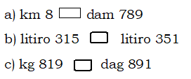

**26)Teranya ingero (amanota 2)**

a) dag 1300 + hg 70 = kg ……

b) dl 45 + 3l = cl__

**27)Kuramo ingero (amanota 3)**

(a) hm 5 – m 298 = m

(b) g 321 – dag 27 **=**

(c) litiro 7 – dl 58 = ml……

**28)Shaka igisubizo (amanota 2)**

a) cm 24 × 2 = cm…..

b) dam140 : 7 = cm……

c) dl 45 x 12 = dl……

d)kg 900:9=kg……..

29) Mutesi afite umurima wa km175 .Baciyeho km75 z’umuhanda.Mutesi asigaranye umurima ureshya gute muri hm. (**amanota 2)**

30)Shaka uburebure bw’imigozi 7muri m niba buri mugozi ureshya na m 80.

**(amanota 2)**

31) Gabanya ku buryo bungana lititiro 8000 by’amazi ingo 8. Buri kigo kizahabwa litiro zingahe z’amazi? **(amanota 2)**

32) Itegereze iyi mbonerahamwe ,maze usubize ibibazo bikurikira **(amanota 3)**

|  |  |
| --- | --- |
| **Ibicuruzwa** | **Ibiciro bya kg1** |
| ibitoki | F150 |
| Umuceri | F700 |
| Ibirayi 1 | F300 |

**a)**Uwase yaguze kg 2 z’ibirayi na kg 4 z’umuceri .Yishyuye F angahe ?

b)Manase yaguze kg 5 z’ibitoki na kg 3 z’ibirayi.Yishyuye F angahe?

d)Ana yaguze kg 3 z’umuceri na kg 10 z’ibitoki. Yishyuye F angahe?

**33) Andika umubare w’inoti cyangwa ibiceri biri mu mafaranga akurikira: (amanota 2)**

**(**a) F5000 = Inoti …. za F500

(b) F2000 = Ibiceri ….. bya F100

**34)Uzuza ahari ududomo** **(amanota 2)**

a) Ibyumweru 3 = Iminsi …………………….

b)Umwaka usanzwe uba ufite ukwezi kwa Gashyantare gufite iminsi …….

**C) AMASHUSHONGERO (amanota 10)**

35) Shaka umuzenguruko wa kare ifite cm 75 z’uruhande. (**inota 1)**

36)Shaka umuzenguruko w’iyi mashusho

**(amanota 2)**

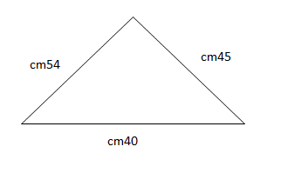

b) Shaka umuzenguruko w’umurima ufite ishusho y’urukiramende rwa m 570 z’uburebure na m 450 z’ubugari (**amanota 2)**

37) Uzuza ahari utudomo **(amanota 2)**

a. Umwaka ugira amezi ……….

b. Iminsi 3 = Amasaha ……………………….

38) Vuga igihe kerekanwa n’iyi saha (**inota 1** )

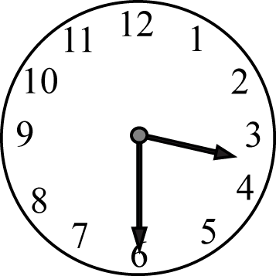

Ni saa………….

39) Huza ukoresheje akarongo amazina y’imfuruka n’ibipimo byazo

(**amanota 2)**

|  |  |
| --- | --- |
| **Imfuruka** | **Uko ipima** |
| Igororotse  Yagutse | 1500  900 |

‘