

**PHYSICS**

**02/07/2021**

**8:30 am – 11:30 am**

**SENIOR FIVE END OF YEAR EXAMINATIONS, 2021**

**SUBJECT: PHYSICS THEORY**

**COMBINATIONS:**

**PHYSICS-CHEMISTRY-MATHEMATICS (PCM)**

**MATHEMATICS- PHYSICS- COMPUTER SCIENCE (MPC)**

**PHYSICS –CHEMISTRY- BIOLOGY (PCB)**

**MATHEMATICS –PHYSICS- GEOGRAPHY (MPG)**

|  |
| --- |
| **/100**    **Marks:** |

**DURATION: 3 HOURS**

**INSTRUCTIONS:**

1. Do not open this question paper until you are told to do so.
2. Answer all questions: **100 marks**
3. Use only a **blue** or **black** pen.

**PART I: MULTIPLE CHOICE QUESTIONS (30 MARKS)**

Choose the letter that corresponds to the correct answer

1)Which of the following does Compton shift depend on?

a) Incident radiation b) Nature of scattering substance

c) Angle of scattering d) Compton wavelength of the electron

**(2 marks)**

**2)** Fill in the blank with appropriate acronym used in mobile phone or

radio communication.

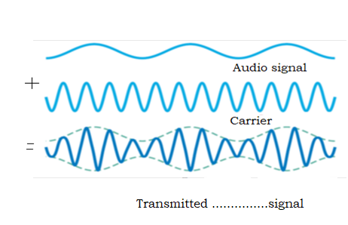

a)AM b)FM c)PTT d)PM

**(2 marks)**

**3)** If the length of a simple pendulum is doubled, its period will:

a) Halve b)be greater by a factor of  c)be less by a factor of

d) double

**(2 marks)**

**4)** Oscillations are damped due to

a)linear motion b)restoring force c)frictional force d)gravitational force

**(2 marks)**

**5)** When an outside driving force causes an object to oscillate at certain

frequency, the resulting oscillations are called.

a)Resonant oscillations b)natural oscillations c)damped oscillations

d) Forced oscillations.

**(2 marks)**

**6)** What type of fossil fuel is mined from the ground?

a)Copper b)Geothermal energy c)coal d)biomass

**(2 marks)**

**7)** Which of the following produces greenhouse gases?

a) Burning fossil fuel b) nuclear fission c) Use of solar energy

d)Use of electricity.

**(2marks)**

**8)** Two objects, one with a mass m and other with a mass 4 m are

attracted to each other by gravitational force.

If the gravitational force on 4 m is F, what is the force on mass m

in terms of F?

1. 16 F b)4 F c)F d) F/4

**(2 marks)**

**9)** The escape velocity of a projectile from the Earth can be calculated

using the formula ( where G: gravitational constant ,:radius of the

Earth , M mass of the Earth ,g acceleration due to gravity)

a) b)  c)  d) 

**(2 marks)**

**10)** Which of the following characterizes an analog quantity?

a) Discrete levels represent changes in a quantity.

b)Its values follow a logarithmic response curve.

c) It can be described with a finite number of steps.

d)It has a continuous set of values over a given range.

**(2 marks)**

**11)** Which of the following is **NOT** a component of communication system?

a)Transmitter b)Transmission channel c)Noise d)receiver **(2 marks)**

**12)** Half duplex system for communication has

a)communication in single direction

b) Communication in both directions but only one at a time

c) Communication in both directions at the same time

d)None of the above

**(2 marks)**

**13)** According to the theory of relativity, the speed of light in a vacuum

is …………………………………for all observers.

a) dependent on the motion of the source of light b)the same

c) dependent on the relative motion of the observers d)different

**(2 marks)**

**14)** Light years is the unit of

a) Distance b) Weight c) time d) Intensity of light

**(2 marks)**

**15)** -------------- is a measure of the amount of the brightness of a star

or other astronomical object observed from the Earth.

a)Absolute magnitude b) Fusion c)Apparent magnitude d) Parallax

**(2 marks)**

**PART II: ATTEMPT ALL QUESTIONS (70 MARKS)**

**16)**a)A particle executes a simple harmonic motion with amplitude A

(i) Write the expression of the potential energy of this particle in terms

of displacement x **(1 mark)**

(ii)Write out the formula of the kinetic energy of this particle in terms of

displacement x. **(1 mark)**

b)The figure below shows how the potential energy of the oscillator

performing simple harmonic motion varies with displacement x .

This varies between -0.2 m and +0.2 m.

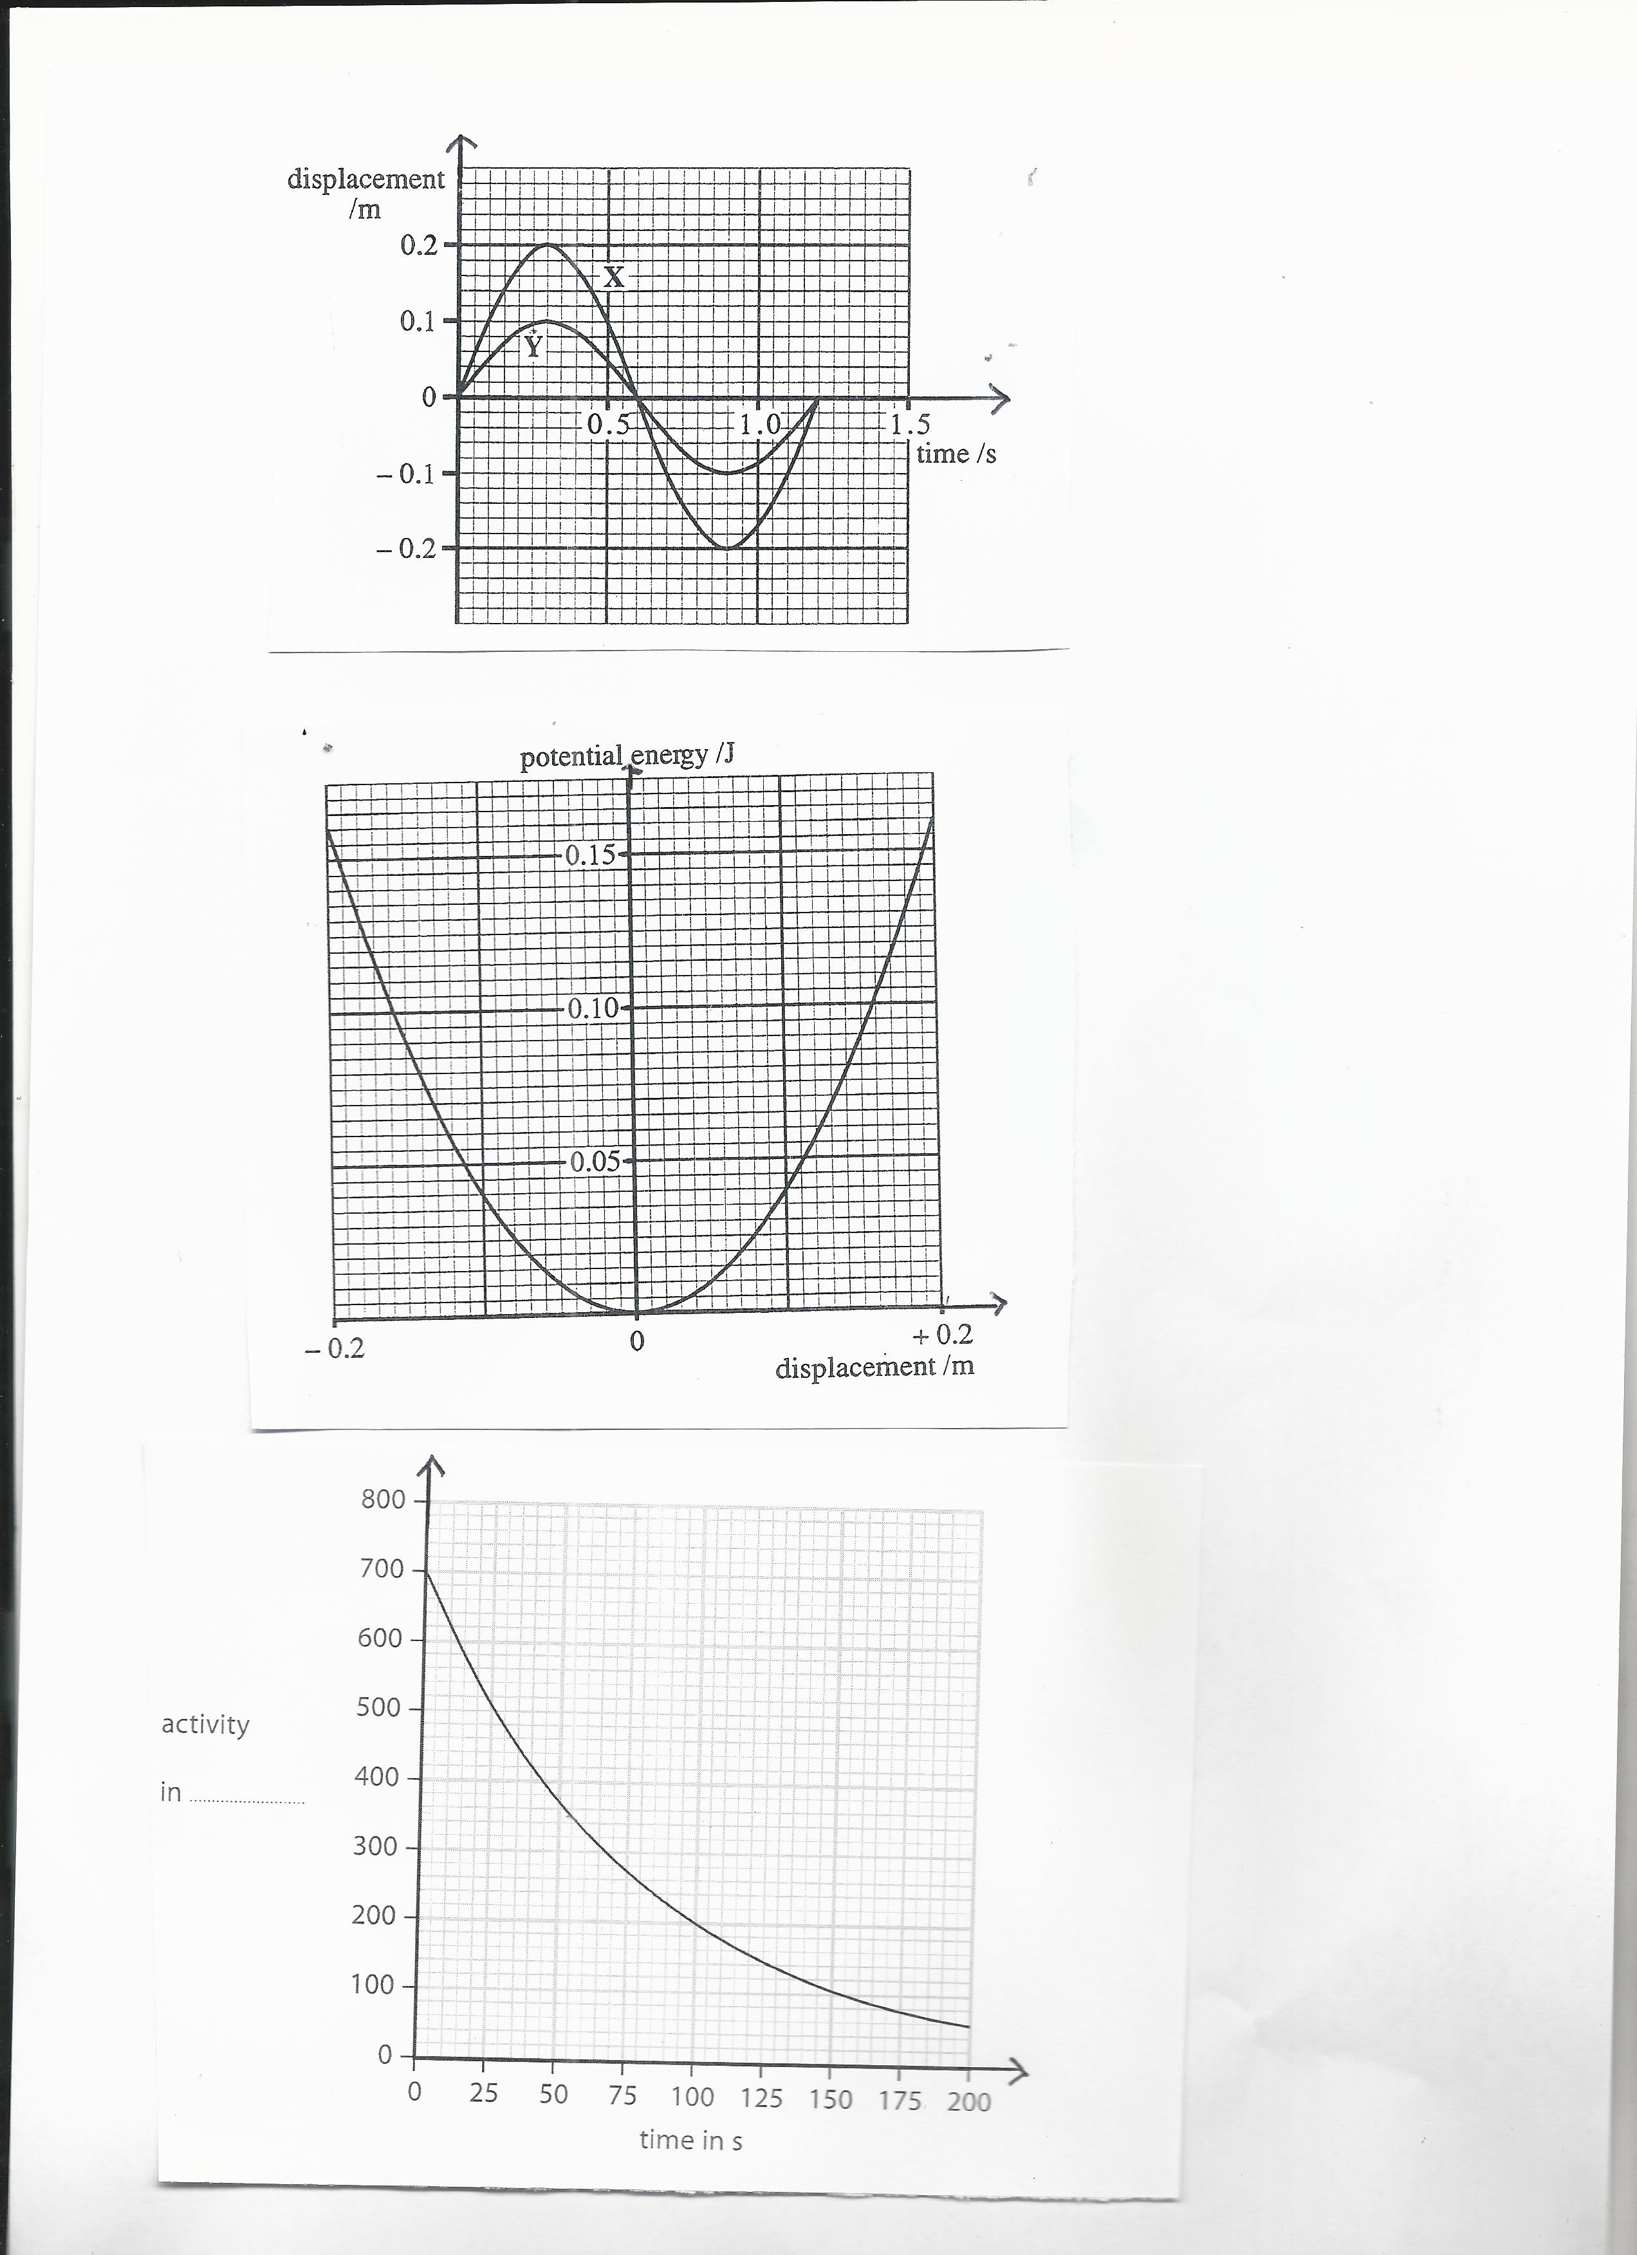

Find

(i)the amplitude of oscillations **(1 mark)**

(ii) the total energy of the mass of this oscillator  **(1mark)**

(iii) its kinetic energy if the potential energy is 0.10J **(1 mark)**

**17)**  a) Use true or false to answer the following sub questions

(i)Gravitational force is always attractive **(1 mark)**

(ii)Electrostatic force may be attractive or repulsive **(1mark)**

(iii)Gravitational potential has always positive values **(1mark)**

(iv)Cathode rays are composed of protons **(1 mark)**

b) Point charges Q1=3.5  and a point A are 0.0 5 m apart.



Find the electric potential due to Q1 at point A.

The coulomb’s constant k=9x109Nm2/C2 **(3 marks)**

c) Three 0.300 kg billiard balls are placed on a table at the corners

of a right triangle, as shown in figure below.

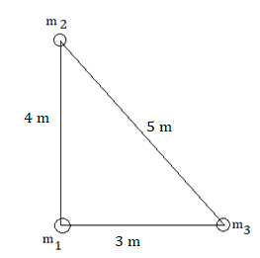

Copy the diagram and indicate the direction of the gravitational

force on the cue ball (designated m1 ) resulting from the other two

balls. Show how this gravitational force is obtained. **(3 marks)**

**18)** a)Enumerate any two factors on which the resistance of a conductor

depends **(2 marks)**

b) In the following electric circuit, 5 resistors are connected as

shown below

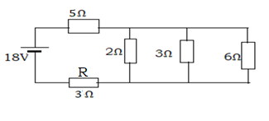

Find

(i)Equivalent resistance of the circuit **(3 marks)**

(ii)The electric current through the circuit **(2 marks)**

(iii) The electric power dissipated by the resistor R of3Ω**. (2 marks)**

c) Use Kirchhoff’s laws to find the currents *I*1, *I*2, and *I*3 in the

circuit shown below.

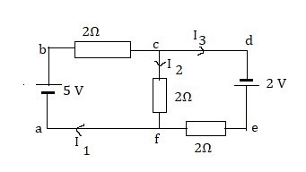

**(6 marks)**

**19)** a)Use true or false to answer these sub-questions.

(i) Stationary/standing wave is the combination of two progressive

waves moving in opposite directions ,each having the same amplitude

and frequency. **(1mark)**

(ii)When the particles of a medium are vibrating at right angles

to the direction of energy transport, then the wave is longitudinal

wave **(1mark)**

(iii)Transverse waves are waves in which the displacement of the

particles of medium is in the same direction as the direction of

propagation of the wave. **(1mark)**

(iv)Progressive wave is a wave where continuous energy transfer

takes place in elastic medium between the crest and

trough(transverse wave) or rarefactions and compressions

(longitudinal wave. **(1mark)**

b) One end of a long string is attached to an oscillator.

The string passes over a frictionless pulley and is kept taut by means

of a weight as shown below.

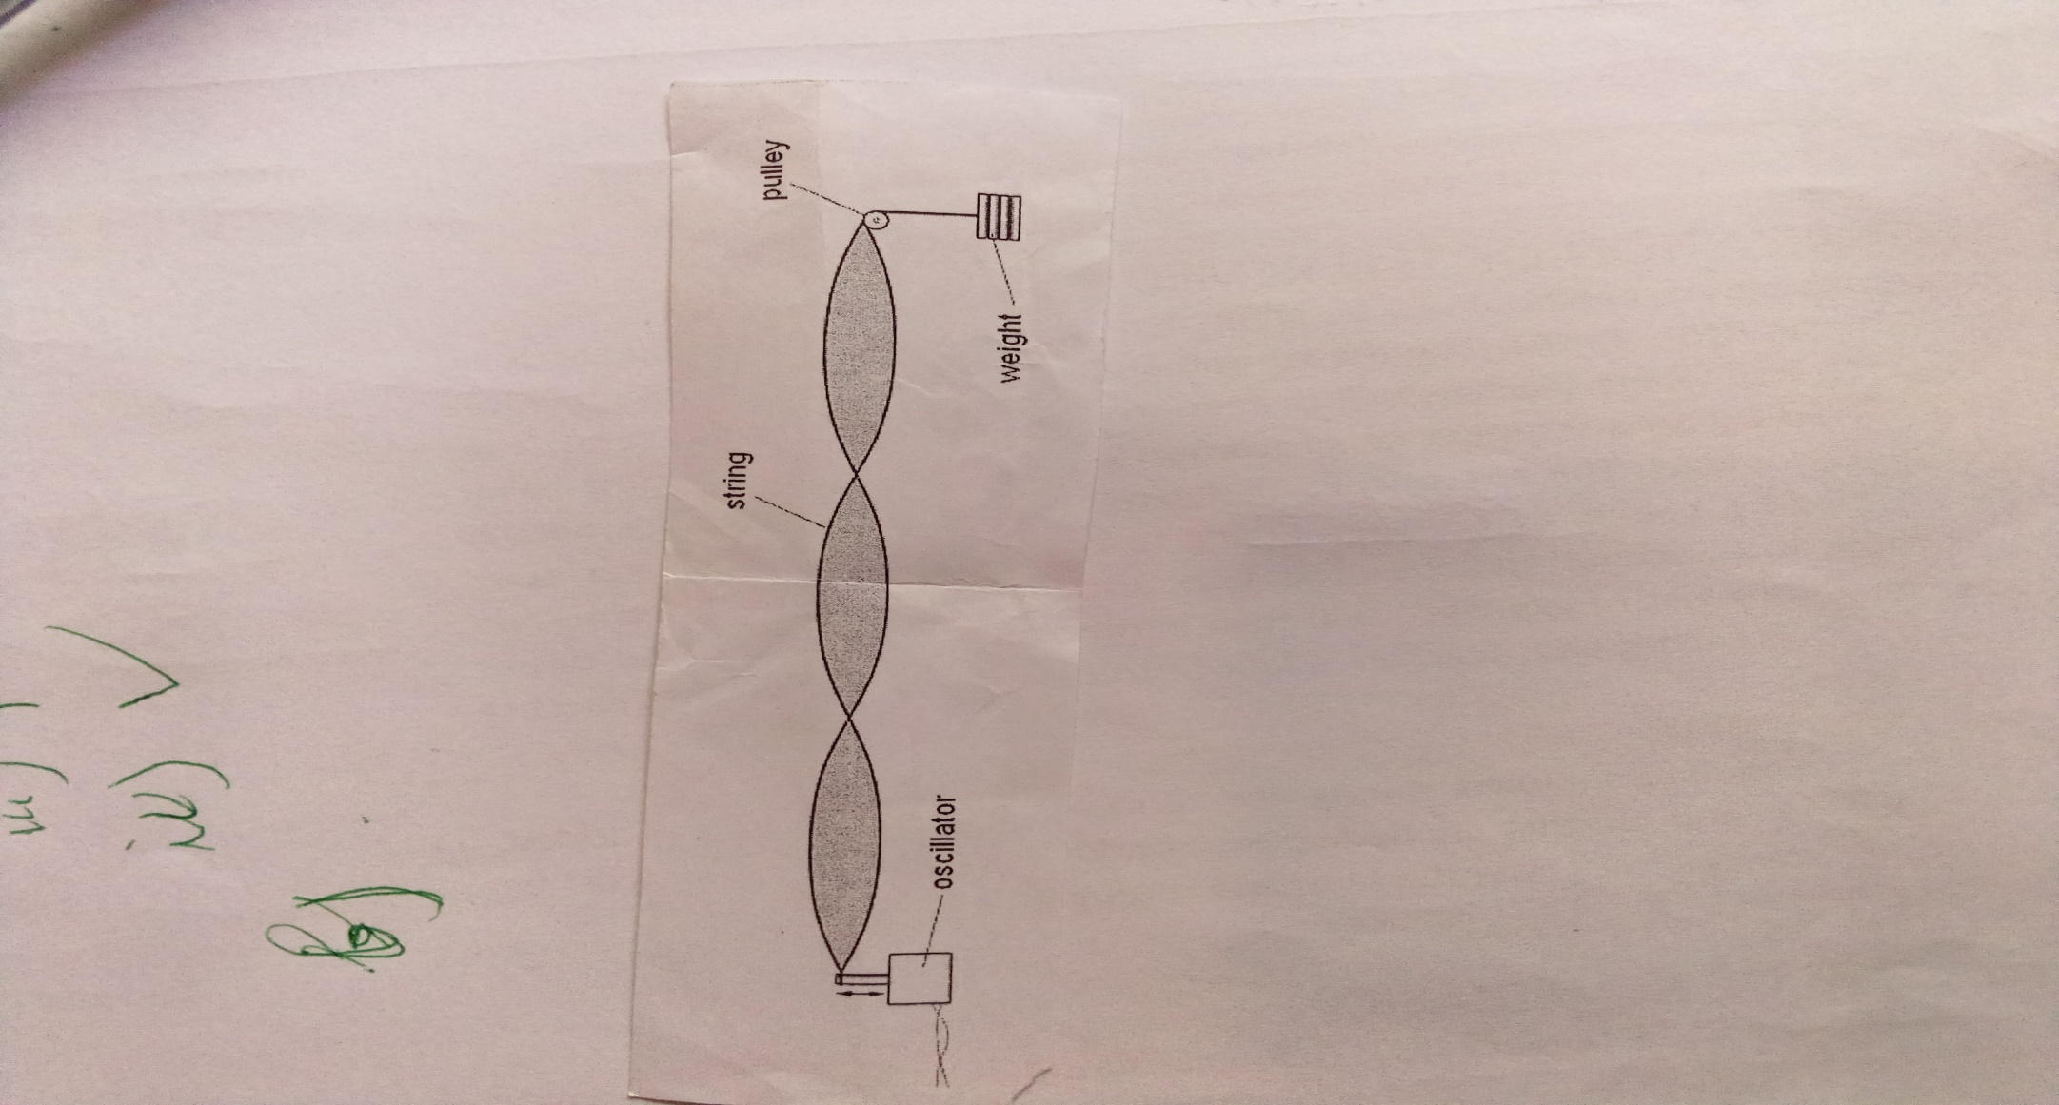

The frequency of oscillation is varied and at one value of frequency the

wave formed on the string is as shown

(i)State what is meant by the term antinode **(1 mark)**

(ii)State what is meant by the term node **(1 mark)**

(iii)Redraw the figure and label on it one node with the letter N and

one antinode with the letter A **(2 marks)**

c)A weight of 4 N is hung from the string( see figure in b) and the

frequency of oscillation is adjusted until a stationary wave is formed

on the string. The separation of the antinodes on the string is 17.8 cm

for a stationary wave of 125 Hz.

The speed v of the waves on a string is given by the expression 

where T is the tension in the string and µ is its mass per unit length

(i) Find the wavelength of the wave **(2 marks)**

(ii)Determine the length of the string between the oscillator and the

pulley. **(2 marks)**

(iii)Show that the speed v of the wave on the string is equal to

44.5 m/s  **(2 marks)**

(iv)Use the given formula to find the mass per unit length of the string.

The tension in the string is 4N as stated above. **(1mark)**

**20)** a)State

(i) Any one factor affecting photoelectric emission **(1 mark)**

(ii)Any one postulate of bohr model of hydrogen atom  **(1 mark)**

b)(i)Einstein equation for photoelectric effect is given by 

What do you understand by each of the terms hf , and EK? **(3 marks)**

(ii)The graph in the figure below shows how the energy Ek of

photoelectrons emitted from the surface of sodium metal varies

with frequency f of the incident radiation.

Planck constant h=6.62x10-34m2kg/s

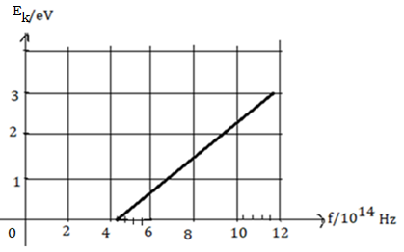

1. Find the threshold frequency **(2 marks)**
2. Calculate the work function of sodium in J or  **(2 marks)**

c)The lowest energy of a hydrogen atom are shown below

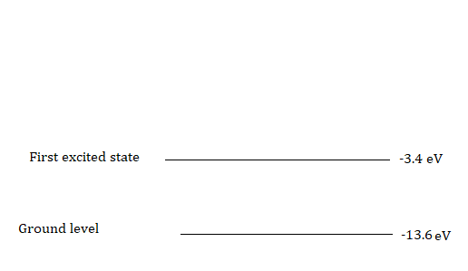

(i)Determine the energy of level n=3(second excited state) of the

hydrogen atom(**** ) **(2 marks)**

(ii)A free electron with kinetic energy collides with an atom of

hydrogen and causes it to be raised to its first excited state(n=2).

1) Determine the energy absorbed when electron jumps from

ground level n=1 to n=2 **(3 marks)**

2) Calculate the kinetic energy of the free electron in  after the

collision **(1 mark)**

**21)** a)Apparatus used to produce interference fringes is shown below.

The apparatus is not drawn to scale

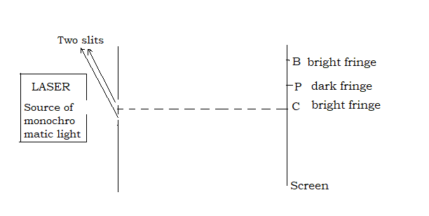

Laser light is incident on two slits. The Laser provides monochromatic light

The light from the two slits produces a fringe pattern on the screen.

A bright fringe is produced at C and the next bright fringe is at B.

A dark fringe is produced at P.

(i)Explain why one laser and two slits are used, instead of two different

lasers to produce visible fringe pattern on the screen. **(2 marks**

(ii)State the condition of interference related to the phase difference

Δθ between the waves that meet at

1) B **(1 mark)**

2) P **(1 mark)**

(iii)State the condition of interference related to the path difference δ

between the waves that meet at

1. B **(1 mark)**

2) P **(1 mark)**

b) In the given figure the distance D from the two slits to the screen is

1.8 m. The distance CB is 2.3 mm and the distance a between the slits

is 25x10-5m.

(i)Convert 2.3 mm into metres (m) **(2 marks)**

(ii)Calculate the wavelength of the light provided by the Laser.

**(2 marks)**