**COMPREHENSIVE ASSESSMENT 2021**

**S5 MARKING SCHEME OF PHYSICS**

**PART I: MULTIPLE CHOICE QUESTIONS (30 MARKS)**

**1)C (2 marks)**  h,m0 and c are constant

**2)a) (2 marks)**

**3)b)(2 marks) 4)c)(2 marks) 5)d(2 marks)**

**6) c)(2 marks) 7)a)(2 marks) 8) c)(2 marks)**

**9) b) (2 marks)**kinetic energy of the object is equal to the gravitational

potential energy



**10)d)(2 marks) 11)c(2 marks) 12)b)(2 marks)**

**13)b)(2 mark) 14)a)(2 marks) 15)c)(2 marks)**

**PART II (70 MARKS)**

**16)**a)(i) Potential energy **(1mark)**

(ii) Kinetic energy KE=ET-PE where ET is the total energy of the

system(principle of conservation of the mechanical energy)

**(1mark)**

Or 

b)(i)Amplitude A=0.2 m**(1 mark)**

(ii)The total energy is equal to maximum potential energy

ET=0.16 J (from the graph) **(1 mark)**

(iii)The kinetic energy KE= 0.16 J-0.1J=0.06 J**(1mark)**

**17)**a)(i)True **(1mark)**

(ii)True **(1mark)**

(iii)False **(1mark)**

(iv)False **(1mark)**

b)(i)The electric potential due to Q1

 **(1 mark)**



=630 V**(2 marks)**unit+value

c) **1mark** for each force x3= **3 marks**

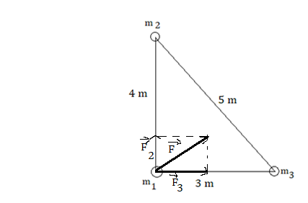

**18)**a) Length of the conductor **(1mark)**

Nature of the conductor **(1mark)** and

Cross sectional area of the conductor

b)(i)Equivalent resistance of resistors in parallel

**(1mark)**

 the R=1Ω**(1mark)**

All resistors are now in series

Total resistance Rt=1Ω+3Ω+5Ω

=9Ω**(1mark)**

(ii)The current **(1 mark)**

**=****(1mark)**

(iii)The power P=RI2**(1 mark)**

=9x22 W=36W**(1mark)**

1. Junction c or f :I1=I2+I3(eq1) **(1 mark)**

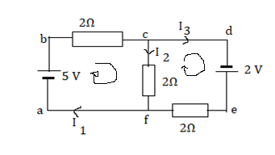

Loop abcfa 5-2I1-2I2 =0(eq 2) **(1 mark)**

Loop cdefc 2 -2I3+2I2 =0(eq 3)**(1 mark)**

Put eq 1 into equation 2

2(I2+I3)+ 2 I2 =5

4I2 +2I3 =5 (eq 4)

Eq 3 and eq 4 give I2=0.5 A **(1mark)**

Substitute I2 into eq 2 ,you obtain I1 =2 A **(1mark)**

Eq 1 gives I3 =1.5 A**(1mark)**

**19)** a)(i) True**(1mark)**

(ii)False **(1mark)**

(iii)False **(1mark)**

(iv)True **(1mark)**

b)(i) Antinode: position along the wave where amplitude of

vibration is a maximum**(1mark)**

(ii)Node: position along the wave where the amplitude is zero

**(1 mark )**

(iii)Any one node **(1 mark)** and one antinode **(1mark)**

see the diagram

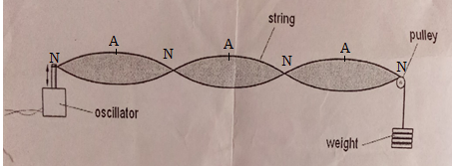

c)(i)The wavelength ** (1mark)**

λ=35.6 cm **(1mark)**

(ii)From the figure, the length of the string **(1 mark)**

 53.4cm **(1mark)**

(iii)The speed of the wave v = λf **(1 mark)**

= 35.6x10-2 x125 m/s=44.5m/s**(1mark)**

(iv)The mass per unit length 

µ = 2.0 x 10-3 kg/m**(1mark)**

**20)**a)(i)The intensity of the incident radiation**(1mark)**

The type of the metal surface

The frequency of the incident radiation

(ii)An electron moves around the nucleus in a circular motion

**(1mark)**

An electron’s angular momentum in the orbit is quantized

An electron can jump from one orbit to another higher

energy on the absorption of energy and one orbit to

another lower energy orbit with the emission of energy

b)(i) hf: energy of incident radiation **(1mark)**

 work function of the meatl **(1mark)**

EK **kinetic** energy of the emitted electrons **(1mark)**

(ii) 1) Threshold frequency f0=4.4 x1014Hz (**2marks)**

2)=hf0 **(1mark)**

=6.62x10-34x 4.4x1014J= 29.128x10-20 J **(1mark)**

Or 

c)(i)The energy of the level n=3

**(1mark)**





** (1mark)**

(ii)1)Energy used to raise the electron from n=1 to n=2

**(1 mark)**

**(2marks)**

2) Energy transferred to the hydrogen atom is

The kinetic energy of the electron after collision

**(1 mark)**

**21)** a(i)Laser provides monochromatic light of a single wavelength or

frequencyso the two slits are two monochromatic **(1 mark)** and

coherent **(1mark)**sources .Coherent sources are sources which have

a constant phase difference

These are the two conditions to produce interference of light.

(ii) 1) They must be always in phase Δθ=0**(1mark)**, 2π, 4π…..or

0°, 360°, 720°...

In general phase difference for constructive interference

Δθ=2nπ or nx360˚ where n=0, 1, 2, 3…

2) They must be out of phase: Δθ = π **(1mark),** or180˚

General condition Δθ = (2n+1) π or

(2n+1)180˚where n=0, 1, 2, 3…

(iii) 1)δ=nλ**(1mark)** where n=0,1,2,3,…..

2)δ=(2n+1) **(1mark)** where n=0,1,2,3,…..

b) (i) 2.3 mm =2.3 x10-3 m**(2 marks)**

(ii)The wavelength **(1 mark)**



=319.4x10-9 m **(1mark)**