PHYSICS
02/07/2021
8:30 am – 11:30 am

SENIOR FOUR END OF YEAR EXAMINATIONS, 2021

SUBJECT: PHYSICS THEORY

COMBINATIONS:

PHYSICS-CHEMISTRY-MATHEMATICS (PCM)
MATHEMATICS- PHYSICS- COMPUTER SCIENCE (MPC)
PHYSICS –CHEMISTRY- BIOLOGY (PCB)
MATHEMATICS –PHYSICS- GEOGRAPHY (MPG)
/100

Marks:

DURATION: 3 HOURS

INSTRUCTIONS:
- Do not open this question paper until you are told to do so.
- Answer all questions: 100 marks
- Use only a blue or black pen.

PART I: MULTIPLE CHOICE QUESTIONS (20 MARKS)
Choose the letter that corresponds to the correct answer
1) Optical instrument used to view things that are far away is
a)compound microscope b)simple microscope c)telescope d)camera
(2 marks)
2) Short sightedness/myopia can be corrected using
a) Convex lens b) convex mirror c) concave mirror d) concave lens
(2 marks)
3) A10 kg box is accelerated from 2 m/s to 4 m/s.
Use work energy theorem to find work needed to accelerate the box
a)50 J b)20 J c)60 J d)100 J
(2 marks)
4) What is the method used to produce electricity in hydroelectric power
plant?
a) By boiling the water to produce steam
b)by pushing pistons by heat energy
c)by running dynamo by kinetic energy of water
d) by heating chargeable cells (2 marks)
5) For a particle performing a uniform circular motion, the acceleration is
a)constant in direction
b)constant in magnitude but not in direction
c)constant in magnitude and in direction
d)constant in neither magnitude nor in direction
(2 marks) 6) The diagram shows the energy transferred in an electric lamp in one
second

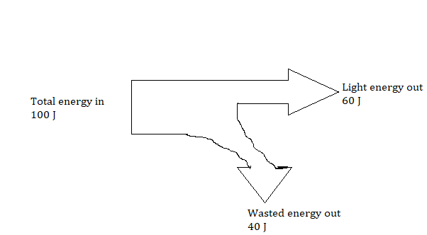
Wasted energy out is
a)electrical energy b)kinetic energy c)thermal energy d)chemical energy
(2 marks)
7) A thermodynamic process in which the pressure stays constant is
a) adiabatic process b)isobaric process c) isochoric process
d)isothermal process
(2 marks)
8) It is outer planet of the solar system
a)Saturn b) Mercury c) Venus d)Earth
(2 marks)
9) In a Carnot cycle, the working medium rejects heat at a ……………..
temperature
a)lower b)higher c)constant d)none of the mentioned
(2 marks)
10) Which path shows a possible movement of an electron in the electric
field shown below ?
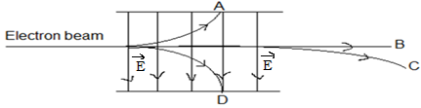

- B b) A c) D d) C (2 marks)

PART II: ATTEMPT ALL QUESTIONS (80 MARKS)
11) a) List any two defects of lenses (2 marks)
b) An object of height 7 cm is placed at a distance of 25 cm in front of
a thin converging lens of focal length 35 cm. Find
(i)the location of the image (2 marks)
(ii) the size of the image (2 marks)
(iii) any two properties of the image (2 marks)
c)(i) What do you understand by the term dispersion of light
by a prism? (1mark)
(ii) A triangular glass prism (n = 1.6) is immersed in air (n = 1)
as shown in figure below drawn not to scale.
A ray of light is incident on face AB making an angle of 20˚ with
the normal.
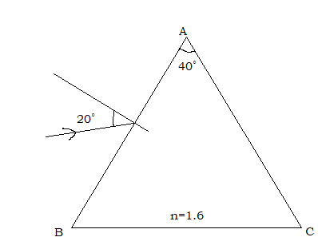
Find
1. The angle of refraction on the face AB (2 marks)
2. The angle of incidence on AC (2 marks)
3. The angle of emergence (2 marks)
12) a) State
(i) the types of static equilibrium (3 marks)
(ii) the conditions of equilibrium of a rigid body. (2 marks)
b)A uniform board with a weight of 240 N and a length of 2 m rests
horizontally on two supports as shown below.
The support A is under the left end of the board while support B
is 50 cm from the right end.

(i)Name the point where the weight of the board is applied (2marks)
(ii)Determine the location of the point of application of the weight of
the board with respect to the support A. (2marks)
(iii)Draw a free body diagram showing the direction of each of the
forces exerted on the board. (3 marks)
(iv)Use the conditions of equilibrium of a rigid body to determine
the support force F_{A} and F_{B} .Take the support point A as a
reference point (4 marks)
13) a) Explain the terms below in words as used in electricity
(i) Electromotive force of a battery (1mark)
(ii) Resistance of a conductor (1mark)
b) Analyze the following electric circuit and then answer the following
sub- questions. The battery has emf of 6 V and internal resistance r
The electric current I is 1.5 A.
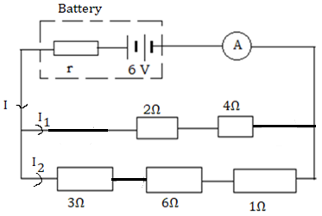

(i)Determine the equivalent resistance of all external resistors (5 marks)
(ii)Find the internal resistance of the battery (2 marks)
(iii)Calculate the terminal voltage of the battery (2 marks)
(iv)What does the symbol below represent? (1 mark)
(v)Observe the given electric circuit then determine the reading
of the measuring instrument below
(1mark)
(vi)Determine
1)the current I₁ (2 marks)
2)the current I₂ (2 marks)
14) A model rocket flies horizontally off the edge of the cliff at a velocity
of 50 m/s . The canyon below is 100 m deep.
Acceleration due to gravity g=9.81 m/s²
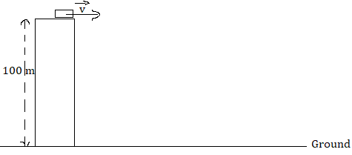
a) Determine the time of flight (3 marks)
b) How far from the edge of the cliff does the model rocket land?
(3 marks)
15) a) State any one Kepler’s law of planetary motion (3 marks)
b) (i)Define the gravitational potential (2 marks)
(ii)Explain why values of gravitational potential near to an isolated
mass are all negatives (1 mark)
c) The orbit of the Earth, mass 6x10²⁴ kg, may be assumed to be a
circle of radius 1.5x10¹¹ m with the sun at its centre as illustrated
in the figure.
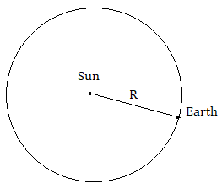
The time taken for one orbit is 3.2x10⁷s
(i)Calculate the magnitude of the angular velocity of the Earth about the
Sun (2 marks)
(ii)The magnitude of the centripetal force acting on the Earth (2marks)
(iii)State the origin of the centripetal force (1mark)
(iv)Determine the mass of the Sun.
Gravitational constant G=6.67x10⁻¹¹ m³/kg s⁻² (4 marks)
16)a)Copy and complete the following statements
(i)Unlike electric charges ………………………………each other (1mark)
(ii)Like electric charges …………………..each other (1mark)
b) Copy and draw electric field lines due to
(i) Parallel plate capacitor
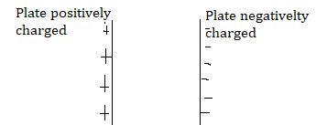
(2 marks)
(ii) Electric dipole (a pair of electric charges of equal magnitude but
opposite sign separated by a small distance )

(2 marks)
c) The figure below shows two electric charges Q₁ and Q_{2 .}
Coulomb’s constant k =9x10⁹ Nm²/C²
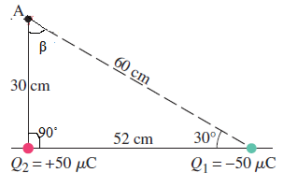
Find
(i)The magnitude of the electric field created by Q₁ at point A
(2 marks)
(ii) Copy the figure and indicate on it the directions of the electric
field vectors due to two charges at point A and the direction
of the resultant electric field (3 marks)

