**S4 MARKING SCHEME PHYSICS 2021**

**PART I: MULTIPLE CHOICE QUESTIONS (20 MARKS)**

**1)c (2 marks) 2)** **d)(2 marks) 3) c (2marks)** networkW**=**

**4) c)(2 marks) 5) b)(2marks) 6) c)(2 marks 7) b)(2 marks) 8)a)(2 marks)**

**9)a)(2 marks) 10)b)(2 marks)**

**PART II (80 MARKS)**

**11)**a) Chromatic aberration **(1mark)** spherical aberration**(1mark)**

coma, astigmatism, barrel distortion ,pincushion distortion

b) (i)Image position**(1mark)**

 , p’=-87.5 cm **(1mark)**

(ii)the size of the image **(1mark)**

**(1mark)**

(iii)Properties of the image

Image is virtual **(1mark)** p’ is negative

Image is erect (upright) **(1mark)** hi is positive

Image is magnifiedhi is greater than ho

c) (i)The process of splitting of white light into seven colours by

prism **(1mark)**

(ii)1. The angle of refraction on AB

1xsin20˚ =1.6 sinr **(1mark)**

r=12.3˚**(1mark)**

2. The angle of incidence on AC

A=r+r’ **(1mark)**

r’=40˚-12.3˚ =27.7˚(**1mark)**

3. The angle of emergence

1.6xsin27.7˚=1xsini’ **(1mark)**

i’=48˚**(1mark)**

**12)**a)(i)Stable equilibrium **(1mark)**

Unstable equilibrium **(1mark)**

Neutral equilibrium **(1mark)**

(ii)Net force is equal to zero **(1mark)** or

 Algebraic sum of x and y components of the

external forces applied to the object must be equal to 0

respectively.

Net torque is equal to zero **(1mark)**

.The algebraic sum of the clockwise torques is equal

to the algebraic sum of the counterclockwise torques.

b) (i)Centre of gravity **(2marks)**

(ii)1m from the extremity A of the board **(2marks)**

(iii)Direction of forces

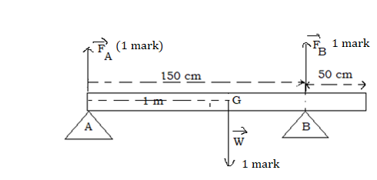

(iv)Torque is positive in anticlockwise direction and the reference

point is the support A

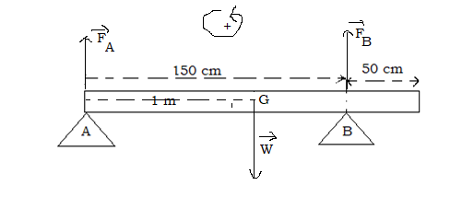

Torque of the support force  with respect to point A



Torque of the support force with respect to point A

 **(1 mark)**

Torque of the weight  with respect to point A

 **(1 mark)**



1.5 FB-240=0

FB= 240N/1.5=160 N **(1mark)**



FA+FB-240N =0

FA =240-160N=80N **(1mark)**

**13)**a)(i)Electromotive force is energy per unit electric charge that is

imparted by an energy source**(1mark)** such as electric generator

Or the work done on a unit of electric charge or the energy

thereby gained per unit electric charge

(ii)Resistance of the conductor is the opposition to the flow of

electrical current through a conductor**(1mark)**

You can also accept the potential difference across the

conductor divided by the electric current through it

b)(i)The 2 Ω and 4 Ω resistors are in series

R1 = 2Ω+4 Ω**(1 mark)**

=6 Ω**(1mark)**

The 3 Ω, 6Ω and 1 Ω resistors are in series

R2 =3 Ω+6Ω+1Ω

=10Ω**(1mark)**

The resistors having the resistances R1 and R2 are in parallel

**(1mark)**



The equivalent resistance R =3.75Ω **(1mark)**

(ii)The internal resistance E=(R+r)I **(1 mark)**



**(1mark)**

(iii)The terminal voltage V=RI **(1mark)**

=1.5 Ax3.75 Ω=5.625V **(1mark)**

(iv)Ammeter **(1mark)**

(v)The reading is I=1.5 A **(1mark)**

(vi) 1)the current **(1mark)**

**(1 mark)**

2) The current ** (1mark)**

**(1mark)**

**14)** a)The time of flight  **(1mark)**

**(1mark)**

**(1mark)**

b)The horizontal range x=vt**(1 mark)**

=50 m/s x4.5 s **(1mark)**

=225 m **(1mark)**

**15)**a)Every planet’s orbit is an ellipse with the sun at a focus

**(3marks)**

A line joining the Sun and a planet sweeps out equal areas in

equal times

The square of a plane’s orbital period is proportional to the cube of

its distance to the Sun.

b) (i)The work required to move a body of unit mass from

infinity to a givenpoint **(2 marks)**

(ii)Gravitational potential at infinity is zero hence the gravitational

forces are always attractive. So the work needs to be done against

the force in moving the body from the infinity to the given point

**(1mark)**

c)(i)The angular velocity **(1 mark)**

**(1mark)**

(ii)Centripetal force ** (1mark)**



=34.57x10**21**N **(1 mark)**

(iii)The origin of the centripetal force is gravitational potential

strength**(1mark)**

(iv)The mass M of the Sun

We know that the gravitational force is equal to the centripetal force

**(1mark)**

**(1mark)**

=1.94 x1030kg **(2 marks)**

**16)**a)(i)attract **(1mark)**

(ii)repel **(1mark)**

b)(i) **(2 marks)**

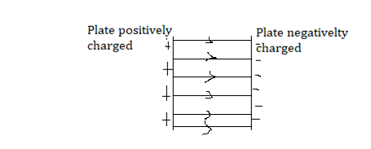

(ii)**(**2marks**)**

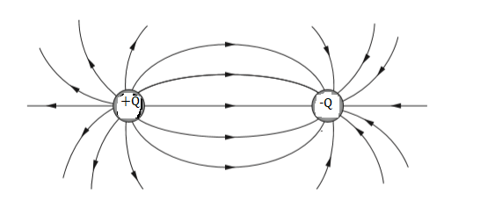

c)(i) **(1mark)**

**(1 mark)**

(ii)

