**PHYSICS**

**30/06/2021**

**8:30 am – 11:30 am**



**SENIOR TWO END OF YEAR EXAMINATIONS, 2021**

**SUBJECT: PHYSICS THEORY**

|  |
| --- |
| **/100**      **Marks:** |

**DURATION: 3 HOURS**

**INSTRUCTIONS:**

1. Do not open this question paper until you are told to do so.
2. Answer all questions: **100 marks**

3) Use only a **blue** or **black** pen.

**PART I: MULTIPLE CHOICE QUESTIONS (20 MARKS)**

Choose the letter that corresponds to the correct answer

**1)** The number of significant figures in value 9.00825 are

a) four b)six c) five d) three

**(2 marks)**

**2)** What is the initial velocity of an object which travels a distance given

by x=10t2+15t+5 along a straight line in time t?

All physical quantities are in SI units

a)5m/s b)10 m/s c)15 m/s d) 30 m/s

**(2 marks)**

**3)** A 40 Nblock exerts 20 Pa of pressure on a table.

What is the area of the block that is touching the table?

a)40 m2 b)20 m2 c)800 m2 d)2 m2

**(2 marks)**

**4)** A stone weights 450 N in air and 200 N when it is in water.

What is the weight of displaced water?

a)450 N b)200 N c) 650 N d) 250 N

**(2 marks)**

**5)** A small piston of a hydraulic press has an area of 20 cm2.If the applied

force to the piston is 75 N, what must the area of the connected large

piston be to exert a force of 6000 N ?

a)25 cm2 b)1600 cm2  c)40 cm2 d)22 500 cm2

**(2 marks)**

**6)** Magnetic keepers are used to

a) amplify magnetic flux

b) restore lost magnetic flux

c) demagnetize magnet

d) provide a closed path for magnetic flux and hence help magnet to

retain its magnetism

**(2 marks)**

**7)** The electric field intensity at a point situated 4 m from a point charge is

270 N/C. The coulomb constant k=9x109 Nm2/C2.

The electric charge of the point charge is

a) 480 x10-9 C b) 1080 C c) 67.5 C d) 9 720 x109C

**(2 marks)**

**8)** The symbol of ordinary diode is

a)  b) 

c) C:\Users\BIGIRIMANA CYPRIEN\Desktop\Untitled.png d) C:\Users\BIGIRIMANA CYPRIEN\Desktop\Untitled.png

**(2 marks)**

**9)**The density of water is 1 g/cm3 .The table below shows the masses and

volumes of 4 substances

|  |  |
| --- | --- |
| **Substance** | **Density/gcm-3** |
| Substance 1 | 2 |
| Substance 2 | 1.5 |
| Substance 3 | 5 |
| Substance 4 | 0.5 |

Which of the following substances will float on water?

a)Substance 1 b)substance 2 c)substance 3 d)substance 4

**(2 marks)**

**10)**A feather and an iron bar are dropped from the same height and at the

same time in a vacuum room without any resistance.

Which object(s)will reach the floor first?

a)both at the same time b)feather c)Iron bar d)they will not fall

**(2 marks)**

**PART II: ATTEMPT ALL QUESTIONS (80 MARKS)**

**11)** a) What do you understand by the following terms used in electricity?

(i) Battery **(2 marks)**

(ii) Voltmeter **(2 marks)**

b) Analyze the following electrical circuit.

Assume that the internal resistance of the battery is negligible

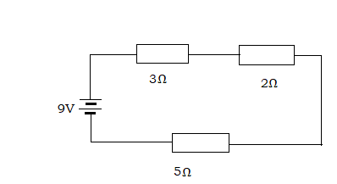

Find

(i)the equivalent resistance of the circuit. **(3 marks)**

(ii) the electric current in the circuit. **(3 marks)**

c)(i)Name any two effects of electricity **(2 marks)**

(ii) A 2.4 kW kettle is used for 30 minutes.

Determine the energy used by the kettle in joules **(3 marks)**

**12)**a)(i)What do you understand by the term reflection as applied to

mirrors? **(1mark)**

(ii) Differentiate between a concave mirror and a convex mirror

**(2 marks)**

(iii) Give any one use of convex mirrors in daily life. **(2 marks)**

b) (i) Copy the diagram below and complete it to show the path taken by

light to form an image of the given object.

The diagram is not drawn to scale

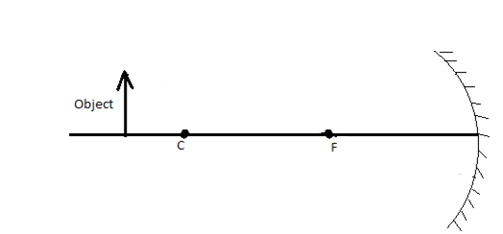

**(3 marks)**

(ii) Give any three properties of the image formed **(3 marks)**

(c) A convex spherical mirror has a focal length of 10 cm.

(i)Find the image position of the pencil placed at 30 cm from

the mirror. The sign of the focal length of convex mirror is

taken as negative. **(2 marks)**

(ii)Determine the magnification of the image **(2 marks)**

(iii) Calculate the image size if the object size is 3 cm **(2 marks)**

(iv)State any three properties of the image **(3 marks)**

**13)** a)For each of the statements below, indicate true if it is correct and

false if it is wrong.

(i) The volume of a fixed mass of a gas is inversely proportional to the

pressure when the temperature is kept constant. **(2 marks)**

(ii) The volume of a fixed mass of a gas at a constant pressure is

inversely proportional to the absolute temperature. **(2 marks)**

(iii)The pressure of a fixed mass of a gas at a constant volume is

directly proportional to the absolute temperature. **(2 marks)**

(iv)Isobaric process is a thermodynamic process in which the

the pressure of the system remains constant. **(2 marks)**

(v)Isochoric process is a thermodynamic process in which the

temperature of the system remains constant. **(2 marks)**

b) At constant pressure and 27˚C, a sample of gas occupies 4.5 liters.

(i)Convert 27 ˚C into kelvin. **(2 marks)**

(ii)At what temperature will the gas occupy 9.0 liters? **(3 marks)**

**14)** a)List any two measuring instruments of pressure **(2 marks)**

b) Analyze the following figures (a) and (b).

Why are the levels of water in all branches like that after opening

the tap?



**(2 marks)**

c) The figure below shows a measuring instrument containing mercury

(density 13 600 kg/m3) connected to a tank with methane liquid and

methane gas. Acceleration due to gravity g =10m/s2. Atmospheric

pressure Patm=76 cmHg)

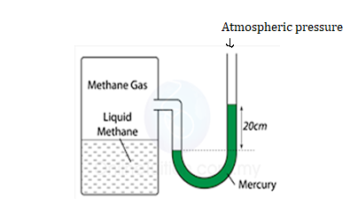

(i)Identify the name of this measuring instrument **(2 marks)**

(ii)Find the pressure of the gas supply in the units below

1)cmHg **(2 marks)**

Hg is the symbol of mercury,

2)Pa **(2 marks)**

**15)** a)What is meant by the following terms as used in Physics ?

(i) Energy **(1 mark)**

(ii) Work **(1 mark)**

(iii) Power **(1 mark)**

b) A person pushes a 10 kg cart a distance of 20 m by exerting a 60 N

constant horizontal force. The frictional force is 50 N

(i)Determine the net force/resultant force applied on the cart.

**(2 marks)**

(ii) Find the acceleration of the cart **(2 marks)**

(iii)How much work is done by each of the force below?

1)60 N horizontal force **(2 marks)**

2) 50 N Frictional force **(1mark)**

c) A 60 g tennis ball from rest at point A, completes the following

course on a frictionless surface as shown on the figure

Air resistance and friction force are negligible.

Acceleration due to gravity g=10 m/s2

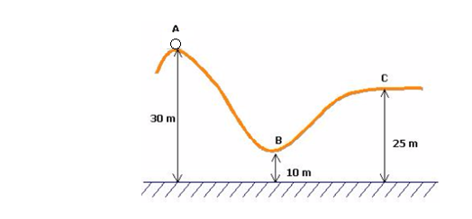

Calculate

(i) The gravitational potential energy of the ball at point A **(2marks)**

(ii)The total mechanical energy of the ball at point A just before

moving **(2 marks)**

(iii)The gravitational potential energy at B **(2marks)**

(iv)The kinetic energy of the tennis ball at B **(2marks)**

(v)The speed of the tennis ball at point B **(2 marks)**