**S2 MATH COMPREHENSIVE MARKING SCHEME.2019**

**Answer 1 (3marks)**



**answer 2 4marks**

a){1,2,3,4,5,6,7,8}

b) 

**ANSWER 3 5marks**



**Answer 4 5marks**

(5x^2+6x-3)+(2x^2-7x-9)

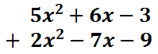

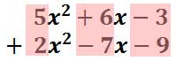

7x^2-x-12



**Answer 5 (6marks)**

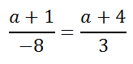

cross-multiply.

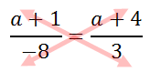

Cross-multiplying results with these two equal products.

cross-products proportion

solving linear equation from proportion

solving linear equation from proportion

solving linear equation from proportion

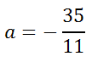

solving linear equation from proportion

**Answer 6 6marks**

x2+5x+6 = 0.

We have to take two numbers adding which we get 5 and multiplying which we get 6. They are 2 and 3.

Let us express the middle term as an addition of 2x and 3x.

x2+2x+3x+6 = 0

x(x+2)+3(x+2) = 0

(x+2)(x+3) = 0

x+2 = 0       or         x+3 = 0

x = -2          or         x = -3

therefore the roots of  are -2 and -3

Answer 7 ( 5marks)

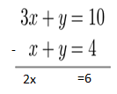

x=3

by substitution into 2

3+y=4

y=4-3

y=1

solution={3;1}

**answer 8 ( 8marks)**  
  
Let the two numbers be x and y.

x + y = 14 ………. (i)

x - y = 2 ………. (ii)

Adding equation (i) and (ii), we get 2x = 16

or, 2x/2 = 16/2 or, x = 16/2

or, x = 8  
  
Substituting the value x in equation (i), we get

8 + y = 14

or, 8 – 8 + y = 14 - 8

or, y = 14 - 8

or, y = 6  
  
Therefore, x = 8 and y = 6

Hence, the two numbers are 6 and 8.

Answer 9 **(6marks)**

segments AD bisects ∠BAC     (given)

.’. AB/AC=BD/DC                      (Angle bisector property)

Assume AC= x

.’. 15/x=6/8

.’. 15 × 8 =6 × x

.’.  x= (15 × 8) / 6 = 20.

Therefore, AC= 20cm.

**Answer 10 (6marks)**

The sides are

a=3cm , b=4cma=3cm , b=4cm

by applying the Pythagoras Theorem,

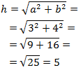

Therefore the hypotenuse of the triangle is 5cm.

**answer 11 ( 10marks)**

i)



ii)



**iii)** 



answer 12 **15marks**

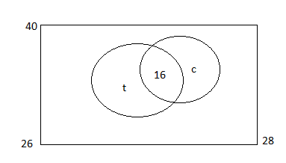

t is the number liking tea only

c is the number liking coffee only

b)i)since 26 liked tea ,and 16 liked both

t+16=26; then t=26-16=10

ii)since 28liked coffee,and 16liked both

c+16=28,then c=28-16=12

now the venn diagram is

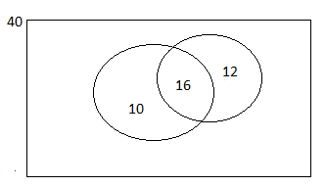

iii)the number that like neither is 40-10-16-12=2

**Answer 13 4marks**

There are 3 red balls, and 10 altogether .

The probability

P(red ball)=3/10

**answer 14 (15marks)**

a)Complete the frequency table below (8marks)

|  |  |  |
| --- | --- | --- |
| Marks , | Frequancy , |  |
| 4 | 1 | 4 |
| 5 | 2 | 10 |
| 6 | 3 | 18 |
| 7 | 8 | 56 |
| 8 | 1 | 8 |
|  | 15 | 96 |

b)the mean marks = 



c)the mode result is 7 because it has the highest frequency “8”

d)the highest result is 8

e)the lowest result is 4

f) 15 students passed the test .