**S1,MATH MARKING SCHEMES COMPREHENSIVE,2019**

**ANSWER ALL QUESTIONS/100MARKS**

**Answer1 4MARKS**

1. A = { x : 1 ≤ x ≤ 7) means that x is a positive integer between 1 and 7 inclusive. ∴ {x: 1 ≤ x ≤ 7} = {1, 2, 3, 4, 5, 6, 7} (ii) B = {x: 2 ≤ x ≤ 20, x ∈ even numbers} means all even numbers between 2 and 20 inclusive. ∴ { x : 2 ≤ x ≤ 20} = { 2, 4, 6, 8, 10, 12, 14, 16, 18, 20}.

∴ B = { 2, 4, 6, 8, 10, 12, 14, 16, 18, 20} and A = { 1, 2, 3, 4, 5, 6, 7}. Sets A and B share some members, i.e. 2, 4, 6.

**Solution 2:**

Since the number of elements is five (n = 6) then from Ns = 2n, the number of subsets is Ns = 26 = 64 i.e the set has 64 subsets. **3marks**

**Solution3( 5MARKS)**

The range of values will be: x → 2x If x = 0 → 2 × 0 = 0

x = 1 → 2 × 1 = 2 ;

x = 3 → 2 × 3 = 6

x = 4 → 2 × 4 = 8

therefore the range = {0, 2, 6, 8}

Ordered pairs: (0, 0)(1, 2)(3, 6 )( 4, 8)

**answer 4 (5MARKS)**

1. f(2)=(3x2)-2=6-2=4
2.  to find  you respect







**ANSWER 5**

If f(x) =2+x and g(x) =3-x

Calculate **(8marks)**

a)fog(x)=f[g(x))

=f(3-x)

=2+(3-x)

=5-x

b)gof(x)=g[(f(x))

=g(2+x)

=3-(2+x)

=3-2-x

=1-x

c)gof(3)=1-3=2

d)fog(-1)= 5-(-1)

=5+1=6

**ANSWER 6:**

a)  -5

b) **1marks**

 =

**1marks**

**ANSWER 7:**

 **(3marks)**



**ANSWER 8 ( 3MARKS)**

4x – 3y – 9 = 0 is equivalent to ,



Comparison with y = mx + c gives gradient, m = 4/ 3

therefor

The gradient is 

**Solution9** : 9x – (4x – 3) = 11 + 2(2x – 1)

Removing brackets: 9x − 4x + 3 = 11 + 4x − 2

Simplifying both sides: 5x + 3

= 4x + 9

Subtracting 4x and 3 from both sides: 5x – 4x = 9 − 3 i.e. x = 6

**Solution 10**

Suppose the smaller number be x. Then, the larger number is x + 18.

Sum of the two numbers = x + (x + 18).

Means . x + (x + 18) = 120

x + x + 18 = 120 2x + 18 = 120

2x = 102 ∴

x = 51 Thus, the smaller number is 51 and the larger number is

51 + 18 = 69.

**ANSWER 11** (**4marks)**

Let the number be x. Adding 55 and dividing the sum by 3 gives (x + 55) : 3 = 4x

∴ x + 55 = 12x

55 = 12x – x

55 = 11x

x = 5 Thus, the number is 5.

**Answer12 (4marks)**

**a) x** + 5 ≤ 14

Solution (a) 3x – 4 ≥ 5 ⇒ 3x – 4 + 4 ≥ 5 + 4 ⇒ 3x ≥ 9 (Dividing both sides we get

by 3) ⇒ x ≥ 3



**Answer 13 ( 11marks)**

ε =? n (basket) = 15 n (handball) = 11 n (b ∩ h) = 6

n(H) = 11 , n(b) = 15

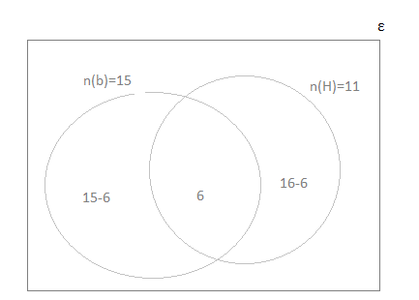

n(ε) = 15 – 6 + 6 + 11 – 6 = 9 + 6 + 5 = 20

Therefore the number of pupils in the class is 20.

**Solution 14 (9marks)**

T = {a, b, c, d, e}

Y = {a, e, i, o, u}

T ∩Y = {a, b, c, d, e} ∩ {a, e, i, o, u} = {a, e}

The Venn diagram is as shown below.

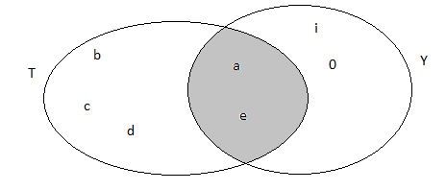

**Answer 15 6marks**

Marked price = 9 000 FRW,

Discount rate = 20%

Discount = marked price × rate of discount = (9 000 FRW × 20): 100

= 1800 FRW

Sale price = marked price – discount

=9 000 FRW -1800FRW

=7200F

**Answer 16 3marks**



Work on bracket 



Then 

**Solution 17: 5marks**

Suppose Jane gives John x FRW.

Then John has (116 + x) FRW and June has (64 − x) FRW.

116 + x is 4 times as big as 64 – x,

i.e. 116 + x = 4(64 – x)

116 + x = 256 – 4x

x + 4x = 256 – 116

5x = 140

x = 28 thus, Jane must give John 28 FRW.

**Solution18 (3marks)**

Surface area of hemisphere =  =  (**3marks)**

**Answer 19 (15marks)**

i)Complete the table below: (**8marks)**

|  |  |  |
| --- | --- | --- |
| Mass() | Frequency, |  |
| 70 | 2 | 140 |
| 80 | 7 | 560 |
| 90 | **9** |  |
| 100 | **11** |  |
| 110 | **8** |  |
| 120 | **3** |  |
|  |  |  |

**ii)Mean mass :**

=



iii)the modal mass is 100kg because it is the highest frequence

iv)the lowest mass is 70kg

V) The highest mass is 120kg