**S1 MARKING SCHEME OF PHYSICS 2021**

**PART I:**

**1)b) 3marks 2)a) 3marks 3)d) 3marks 4)b) 3marks**

**5)c 3marks 6)d) 3marks 7)c) 3marks**

**8)b) 3marks 9)d) 3marks 10)a) 3marks**

**PART II**

**11)**

|  |  |  |  |
| --- | --- | --- | --- |
| Physical quantity | Fundamental physical quantity | Symbol of S I unit | Measuring instrument |
| Time | Yes**(1mark)** | s **(1mark)** | Stop clock**(1mark),**watch |
| Length **(1mark)** | Yes |  | Ruler **(1mark)** metre rule, micrometer screw gauge ,vernier caliper, tape metre |
| Density | No **(1mark)** | **(1mark)** | Densimeter **(1mark)** lactometer, hydrometer |
| Electric current **(1mark)** | Yes | A **(1mark)** | Ammeter |
| Weight | No **(1mark)** | Newton (N) | Force meter**(1mark)** or force gauge, spring balance, newton meter |

**12)** a)(i)The passenger kicks forward when the bus stops abruptly in trying

to resist stopping due to his/her inertia **(2marks).**

He/she wants to keep on moving

(ii)Newton’s second law states that the acceleration of an object as

produced by a net force is directly proportional to the magnitude of

the net force in the same direction as the net force and inversely

proportional to the mass of the object**(2marks)**

b)(i)Weight W=mg **(1mark)**

=50kg x 10 m/s2=500 N**(1mark)**

(ii)The reaction of the table is equal in magnitude to the weight of

the box but opposite in direction

R=500 N**(1mark) .**It is oriented inupward direction **(1mark)**

c) The gravitational force between two masses **(1mark)**

The mass of body B is **(1mark)**

**13)a)** 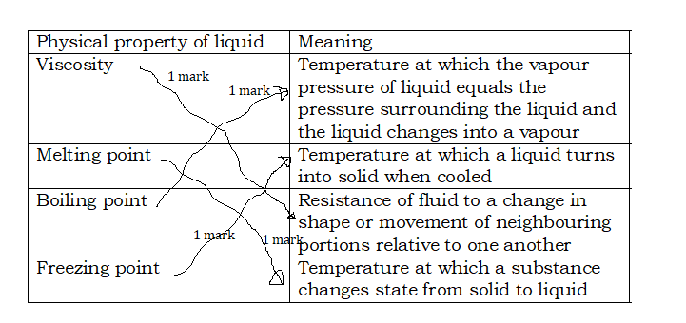

b)(i)Liquid is viscous **(2marks)**It has fixed volume **(2marks)**

It does not have fixed shape etc.

(ii)Solid is rigid (**2marks)** It has definite volume **(2marks)** definite shape

etc.

**14)** a)(i)It is a vector quantity**(1mark)**

It has both magnitude **(1mark)** and direction **(1mark)**

(ii) **(1 mark)**

**(1mark)** F=6x10-3 x3 N= 18x10-3 N **(1mark)** or 0.018 N

b) The Coulomb force **(1mark)**

 **(1mark)**

d = 3x10-2 m**(1mark)**

c) (i)

 **(1mark)**

(ii)The electric field strength  **(1mark)**

(**1 mark)**

**15)**a)(i)Any three elements **1 marksx3 =3 marks**

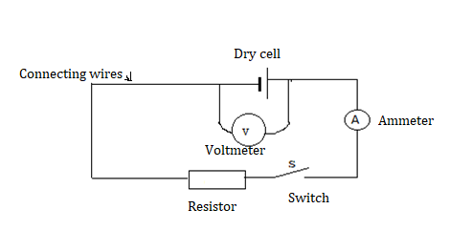

(ii)

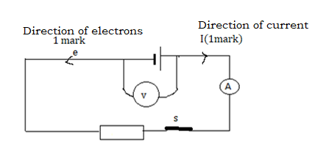

b)(i) The potential difference V=RI **(1mark)**

=5Ωx0.4A **(1mark)** =2 V **(1mark)**

(ii) t =2 min =60x2 s =120 s **(1mark)**

(iii)Energy dissipated E=VIt **(1mark)** or RI2t

=2x0.4 x120 J **(1 mark)** =96 J**(1mark)**

**16)**a)(i)

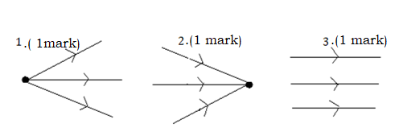

(ii) Parallel beam  **(1mark**

b)(i)B is a pinhole **(1mark)**

(ii)Image is real **(1mark)** inverted **(1mark)** smaller than the object

**(1mark)**

NB: Inverted image means image that is upside-down compared to

the orientation of the object or image that has a vertical orientation

opposite to that of the object.

(iii) m=0.2 and  **(1mark)  ,**actual size of the object

is **1mark)**

c)(i)Light reflects **(1mark)** (ii)Opaque **(1mark)**