Chemistry

02/07/ 2021 08.30 AM - 11.30 AM

S1 END OF YEAR EXAM, 2020/2021

SUBJECT: CHEMISTRY THEORY

DURATION: 3 HOURS
Instructions:
- There are 2 sections in this paper:
Section A (70 marks): Attempt all questions in this section
Section B (30 marks): Attempt 3 questions in this section.
- Do not use periodic tables
- Non-programmable calculators may be used
- Answers should be written on blank papers provided
- Use a blue or black pen only

SECTION A: Attempt all questions in this section (70 marks)

- a) Define the term ‘chemistry’. (2 marks)
b) List any four applications of chemistry by man in daily life. (2 marks)
- Explain how you can apply the acquired content and skills of chemistry to:
a) Treat dirty water in order to obtain drinking water (potable water). (2 marks)
b) Prepare the soil in the field in order to grow seeds in it. (2 marks)
- In traditional Rwanda, chemistry was applied.
Describe how any product used to be made using chemistry knowledge in traditional Rwanda. (2 marks)
- Recently, Rwanda started developing modern industries. Indicate any four industrial activities related to chemistry. (2 marks)
- List any 3 rules and regulations that a senior one student must follow during an
experiment in the chemistry laboratory. (3 marks)
- The following list contains the names of six pieces of apparatus with the letters
of each name not in order (jumbled).
Rearrange the letters to produce the name of each piece of apparatus.
NEUFNL | TEBEUTR
LAFSK | KERBEA
(4 marks)
- Define the following terms:
(4 marks)
- Matter
- Physical change
- Study the triangular diagram shown below for the changes of states of matter
- and answer the questions that follow:

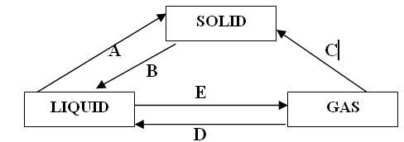

Name the changes of states labelled by letters A, B and C. (3 marks)
- Name any two substances that can undergo the change of state labelled C.
(2 marks
9. Study the following diagram and answer the questions that follow:
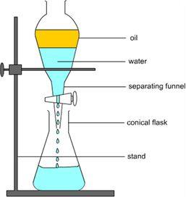

- State the name of the method of separation of mixtures does the diagram show. (1 mark)
- Give examples of two mixtures which can be separated by this separation technique. (2 marks)

- State the easiest method one could use to obtain the substance shown from the following mixtures: (3 marks)
- Diesel oil from crude oil.
- Dyes from ink
- Copper (II) sulphate crystals from copper (II) sulphate solution

11. a) Describe the term ‘element of a substance’ (2 marks)
b) The following table provides you the necessary information on sub-atomic
particles.
Copy and fill it with the missing information. (3 marks)

Particle | Symbol | Charge | Relative mass | Position in an atom
Proton | p
Neutron | n |  |  | Nucleus
Electron | e |  | 1/1840 (negligible)

12. The symbol of an element is represented by
(a) Calculate the number of neutrons in atom X. (1 mark)
(b) State the number of electrons in atom X. (1 mark)
(c) Write the electronic configuration for atom X. (1 mark)
(d) Determine the symbol for the ion which is formed by X. (2 marks)
13. The number of protons, neutrons and electrons in particles W, X, Y and Z are
shown in the table below.
Particles | Number of protons | Number of neutrons | Number of electrons
W | 6 | 6 | 6
X | 9 | 10 | 10
Y | 12 | 12 | 10
Z | 19 | 20 | 19

- Identify the particles which is: (3marks)
- A cation.
- An anion.
- Neutral.
- Write the electronic configuration of Z. (1mark)
- State the valence of Z. (1mark)
- Give the reason for your answer in (c) above. (1mark)
14. The figure below shows a part of the periodic table. The letter is not the correct
symbol of the element
I | II | III | IV | V | VI | VII | VIII
J
 |  |  | G |  | E
A |  |  |  |  |  | R | D
 | X

- Give two elements that are metals. (2 marks)
- State the element that is in group IV and period II and suggest its atomic number. (2 marks)
- Write the formula of the compounds formed between: (2 marks)
- X and R.
- J and G.
- X is in group II and in period IV of the periodic table. Give its electronic configuration. (1mark)

15. (a) Explain the phenomena (steps) which are involved in water cycle.
(2 marks)
(b) Every morning, we see water droplets on plant leaves and materials left
outdoors.
But in the course of the day, the droplets disappear. Discuss this
phenomenon. (2 marks)

(c) When it rains, surface run-off water goes in the seas, oceans and lakes.
Explain the contribution of this water to the amount of rainfall in
surrounding areas. (3 marks)
16. (a) Discuss any two effects of acidic rain. (3 marks)
(b) Discuss any two ways that can be used to prevent water pollution.
(3 marks)

SECTION B: Attempt three questions in this section (30 marks)
17. a) What is meant by “waste materials”? (2 marks)
b) Differentiate between biodegradable wastes and non-biodegradable wastes
using 2 examples in each case. (2 marks)
c) Briefly explain any 2 different sources of wastes in your school. (2 marks)
d) Many activities generate wastes in your home.
(i) List any 2 sources of the wastes in your home. (2 marks)
(ii) Explain briefly how you manage those wastes at home. (2 marks)

18.a) (i) Discuss by means of 3 examples the harmful effects of waste materials
which are not well managed depending on their various sources.
(3 marks)
(ii) Explain what you could do to minimize the dangers associated with the
wastes listed above. (3 marks)
b) Complete and balance the following chemical reactions. (4 marks)
(i)
(ii)

19. a) Classify the following among soluble salts and insoluble salts: NaNO₃ ,
CaSO_{4,} Cu(NO₃)₂, AgCl. (2 marks)

b) Draw a well labeled diagram to demonstrate the electrical conductivity of a
salt solution. (4 marks)

c) Describe the nature of particles in salt solutions that enable them to be
electrical conductors. (2 marks)
d) Describe the term ‘laboratory’. (2 marks)

20. Study the diagram below for the preparation of oxygen gas in the laboratory
using potassium chlorate and manganese(IV) oxide and answer the questions
that follow:
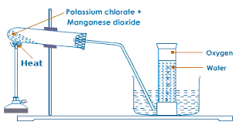

a) State the role of manganese(IV) oxide in this process. (1 mark)
b) Write the chemical equation for the reaction that takes place in the boiling
tube. (2 marks)
c) Explain the chemical test to identify the presence of oxygen. (2 marks)
d) State the method used to collect oxygen. (1 mark)
e) Discuss the dangers associated with ozone layer depletion in the atmoshere.
(2 marks)
f) State 2 uses of oxygen on a large scale. (2 marks)

……………………………………………………………………………………….

