NO4
QUESTIONS FOR EVALUATION
- a) Describe the difference between parasite and a pathogen. ( 3marks)
b) list at least one disease caused by each of the following. ( 3marks)
i) virus
ii) bacteria
iii) fungi
- Why is competition among organisms of the same species healthy? (2marks)
- a) How an acid rain is formed. ( 2marks)
b) Explain how acid rain can be prevented. ( 2marks)
- What is the effect of predation? ( 3marks)
- Each chromosome consists of two identical …………………… ( 2marks)
- Genes
- Nuclei
- Chromatids
- Bases
- Frogs are examples of ( 2marks)
- Amphibian
- Birds
- Reptiles
- Mammals
- Malaria is caused by a parasite called plasmodium. which insect transmits Malaria? ( 2marks)
- Tsetse flies
- Fruit flies
- Anopheles mosquito
- Female culex mosquito
- a) Define the term “photosynthesis “. ( 2marks)
b) Describe the conditions necessary for photosynthesis. ( 3marks)

- Differentiate between osmosis and diffusion . ( 3marks)

- The cells below belong to two different organisms

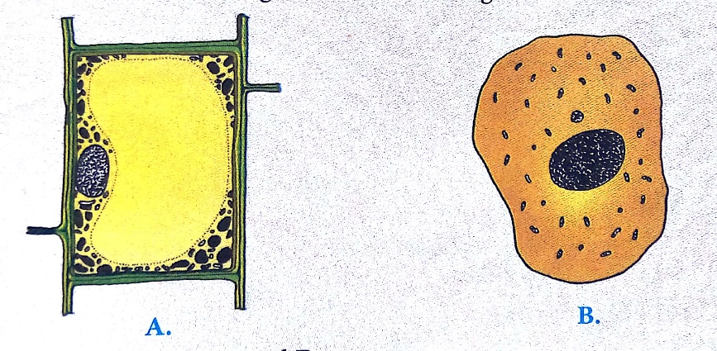

- Identify cell A and B ( 2marks)
- Compare the structure of the two cells ( 2marks)
- Indicate whether the following statements are TRUE or FALSE ( 3marks)
- Meiosis gives rise to haploid condition
- Commensalisms is a relationship between two organisms where both benefit.
- Diploid is a full number of chromosomes.
- Explain the factors that affect the rate of population growth of an organisms. ( 4marks)

