NO 2
QUESTIONS OF BIOLOGY 50 MARKS
- Write the appropriate answer required to complete the following sentences. / 4Marks
- Blood from the body ( deoxygenated blood ) enters the right side of the human heart through the blood vessel called…………
- The deoxygenated blood is pumped through the pulmonary………………….. to the lung
- The oxygenated blood from the lungs enters the heart through the blood vessel called the………………………………
- The oxygenated blood from the heart is pumped to the body through the blood vessel called………………..
- Name FOUR components found in human blood . for each named component , give one function that it carries out. / 6Marks
- Explain how body ( skin ) maintain its body temperature. / 4Marks
- a) How are hormones produced? / 1Marks
b) How do hormones move around the body? / 1Marks
c) Insulin and glucagon are hormones. Where are they produced ? / 2Marks
d) Explain the roles of insulin and glucagon in controlling sugar level. / 4Marks
5. Explain how the information about a sharp object injuring the skin reaches the human brain. /3Marks
6. Given the following diagram
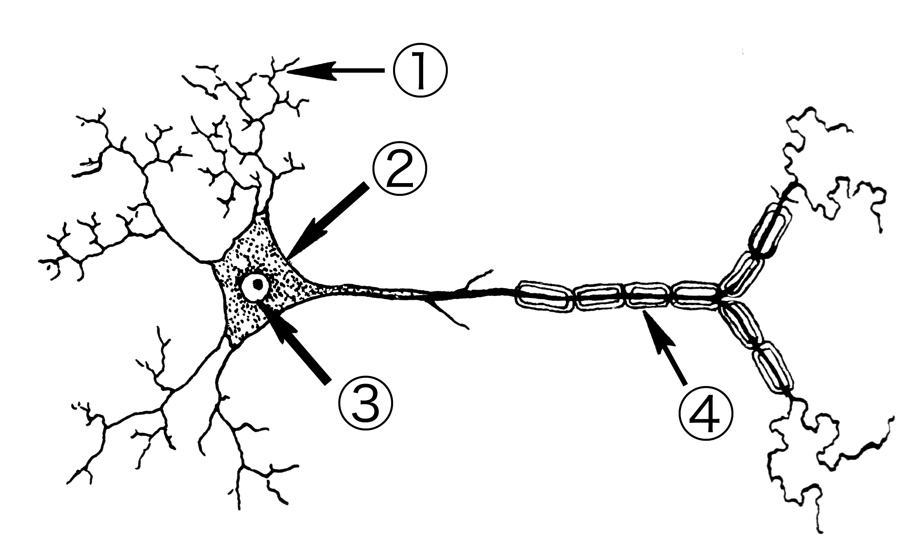
- Name part labelled 1 , 2, 3, 4. / 2Marks
- what is the function of 1 and 3 . / 2Marks
- Draw an arrow on the diagram to show the direction of nerve impulse. / 2Marks
7. State and differentiate three types of neurons. / 6Marks
8. a) what it is the meaning of Respiration . / 2Marks
b) write chemical equation of respiration . / 2Marks
c) what are the applications of anaerobic respiration? / 2Marks
9.a) Describe how oxygen is transported around the body cells. / 2Marks
b) Explain how red blood cells are adapted to carry out its function. / 2Marks
10. What are the function of the following hormones: / 3Marks
a) Anti Diuretic Hormone ( ADH )
b) Thyroxin
d) Adrenaline

