RWAMAGANA DISTRICT
G.S MUYUMBU
DATE: 16/12/2021
CLASS: S₃

FIRST TERM EXAMINATION
SUBJECT : BIOLOGY /40 MARKS
- a) Define the term parasitism . ( 1mark)
b) Differentiate between types of parasite ( 2 Marks )
c) what are the effect of parasite ? ( 2 Marks )

- Why is competition among organisms of the same species healthy? (2marks)
- a) How an acid rain is formed. ( 2marks)
b) Explain how acid rain can be prevented. ( 2marks)
- What is the effect of predation? ( 3marks)
- Each chromosome consists of two identical …………………… ( 2marks)
- Genes
- Nuclei
- Chromatids
- Bases
- Malaria is caused by a parasite called plasmodium. which insect transmits Malaria? ( 2marks)
- Tsetse flies
- Fruit flies
- Anopheles mosquito
- Female culex mosquito
- a) Define the term “photosynthesis “. ( 2marks)
b) Describe the conditions necessary for photosynthesis. ( 2marks)

- Differentiate between osmosis and diffusion . ( 3marks)

- The cells below belong to two different organisms
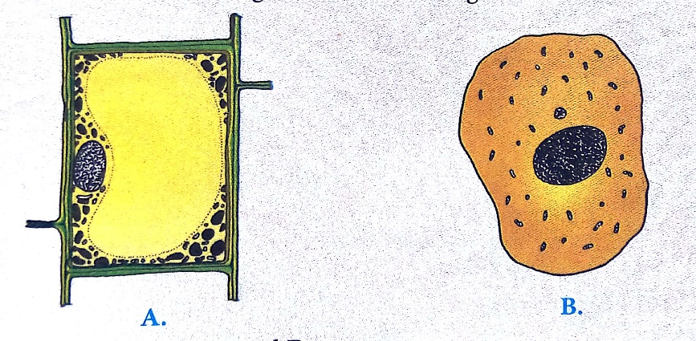
- Identify cell A and B ( 2marks)
- Compare the structure of the two cells ( 2marks)
- a) Define the term population ( 1Mark )
b) Explain the factors that affect the rate of population growth of an organisms. ( 2marks)
- What are the measures taken by Rwandan government to protect environment . ( 3 Marks )
- How can we conserve the environment better ( importance of conservation ) ? ( 2 Marks )
- Arrange the following from the smallest to the largest .( 2 Marks )
Tissue, organism , system , organelle, cell, organ
- The figure below shows one of the stage of mitosis of cell division
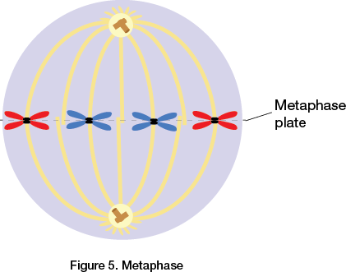

- Which stage is represented in this figure ? ( 1 marks)
- Describe behavior of chromosomes in this stage. ( 2 marks)

BEST WISHES!!!!!!!!!!!!!!!!!!!!!!!!!!!!!!

