

**Mathematics**

**18/10/2019**

**1:00 pm -3:30 pm**

**P5 END OF YEAR EXAMINATIONS, 2019**

**MATHEMATICS**

**DURATION: 2 HOURS 30 MINUTES**

/100

**MARKS:**

**Instructions:**

1. Don’t open this question paper until you are told to do so`.
2. All questions are compulsory.
3. Read each question carefully before answering it.
4. Use only a **blue** or black **pen**.

**P5 MATHEMATICS, 2019**

**ANSWER ALL QUESTIONS (100MARKS)**

1.Write the following number in words : 671 379 :…………………….. ………………………………. **2marks)**

2. Write the following in figures:

Nine hundred seven thousand one hundred and seven.: ……………………………………….. (**2marks)**

3. a) What is the place value of digit 3 in the number 235 176. **(1mark)**

b) What is the place value of 4 in the number 321 456 (**1mark)**

4. Write the following number in expanded form 776 707 (**1mark)**

5. Compare the following numbers using <, > or = (**3marks)**

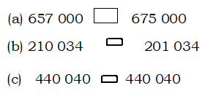

6) If one Shirt costs 10 000F . Calculate the cost of 5 shirts ? (**2marks)**

7). Workout: a) 272 142 + 203 512 + 402 123 = **(1mark)**

(b) 874 450 – 583 750 **(1mark)**

(c) 648 × 212 **(2marks)**

(d) 581 × 611 **(1mark)**

e) 858 ÷ 22 = **(2marks)**

f) (+3) + (–4) **(1mark)**

g) (–3) + (–4) **(1mark)**

8. (a) Test if 1 824 is divisible by 3? (**2marks)**

(b) Test if 56 480 is divisible by 5 (**2marks)**

9) Arrange the following integers by descending order +1, +3, –10, –2, –4, 0

**1mark)**

10) Arrange these integers by ascending order –8, –5, +2, +5, +6, +1

**1mark)**

11). Prime factorize 60. And show the prime factors using indices. (**2 marks)**

12)Write an equivalent fraction of  (**1mark)**

13) How many hours are in 5 days? (**1mark)**

14) Find the Greatest Common Factor (GCF) of 28, 42 and 56 (**2marks)**.

15) Write  as an improper fraction (**1mark))**

16) What is the Lowest Common Multiple of 6, 12 and 18? (**2marks)**

17) Workout the following **(4marks)**

a) 

b) 

c) 

d) 

18. Three children had nine sweets.

(a) What is the ratio of child to sweets? **2marks)**

(b) How many sweets are needed for 4 children? **2marks)**

19. Workout 9 h 15 min – 5 h 45 min = **2marks)**

20). A mathematics test started 8:00 a.m and ended 12:00 noon. How many

hours did the test take (**2marks)**

21. Workout

(a)  **(3marks)**

(b) Write  as a decimal fraction (**1mark)**

22.Workout : **4marks)**

(a) 4 hl – 20 dal = ___ litres

(b) 2 dam 3 m × 5 = ___ hm

(c) 300km – 4 0000 m = ............... .dam

d)400 ha +20 000m2 = …….m 2

23) Kwizera earns a salary of 150 000 Frw in a month. He spends his money

as follows:

|  |  |
| --- | --- |
| **Items** | **Costs** |
| Food | 30 000 Frw |
| School fees | 50000 |
| Transport: | 15000 |
| Water and electricity | 25 000 Frw |

He saves the remaining money.

1. How much does he spend in total each month? **(2 marks)**
2. How much does he save each month? **(2 marks)**
3. Why do you think it is important for Kwizera to save? (**2marks)**

24) Find next two terms in the sequence  (**2marks)**

25) A man’s stride is 10 dm long. He walks a distance of 10 dam. How many strides does he take to cover the distance?  **(3 marks)**

26) A shopkeeper had 112 bottles of juice. He sold each of them at 350 Frw. How much money did he get?  **(3marks)**

27) (a) Find the circumference of a circle garden whose radius is 7m.

(Take) **3marks)**

28) A rectangular tank measures 4.3 m long, 2.4 m wide and 1.5 m high. Calculate the volume of the tank. Justify your answer. (**3marks)**

29) Munezero had  litres of milk for his baby. During the day, the baby drank some of the milk. The milk that remained was  . How much milk did the baby drink (**3marks)**

30) The length of a rectangular piece of land is 48 m by 12 m. Poles were fixed at intervals of 2 m to fence it.

(a) What is the distance round the land? (**2marks)**

(b) How many poles were used to fence the land? (**2marks)**

31) Calculate the size of angles a and b in the following **(4marks)**

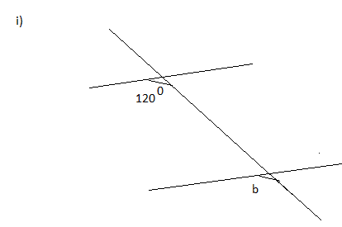

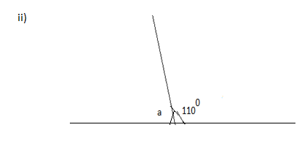

32) Study the chart below: **7marks)**

Figure shows results obtained by 5 pupils in a SST Test

(a) What is the bar chart about?

(b) How many pupils did the SST Test ?

(c) What is the highest score?

(d) Who scored the lowest mark?

(f) Who scored the highest mark?

(g) How many more marks did Julius score than Monica ?

(h) What score did Jojo get?

33) Convert 20.000FRW into

a) US dollars (USD)

b)Euros (EUR)

C)Kenya Shillings (Ksh)

Using the Exchange rate indicated below

|  |  |
| --- | --- |
| 1USD | 800F |
| 1EUR | 900F |
| 1Ksh | 8,00F |

**6marks)**