

**Mathematics**

**18/10/2019**

**1:30 am -3:30 am**

**P4 END YEAR OF EXAMINATIONS, 2019**

**MATHEMATICS**

**DURATION: 2H 30 MIN**

/100

**MARKS:**

**Instructions:**

1. Don’t open this question paper until you are told to do so`.
2. All questions are compulsory.
3. Read each question carefully before answering it.
4. Use only a **blue** or black **pen**.

**P4 MATHEMATICS 2019**

**ANSWER ALL QUESTIONS (100marks)**

1.Write the following number in words : 97 642:…………………….. (**2marks)**

2. Write the following in figures:

Twelve thousand five hundred :……………………………………….. (**2marks)**

3. a) What is the place value of digit2 in the number 14 258(**1mark)**

b) What is the place value of 1 in the number 26 318(**1mark)**

4. Write the following number in expanded form 76 709 (**1mark)**

5. Compare the following numbers using <, > or = (**3marks)**

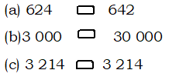

6) If one egg costs 150F .Calculate the cost of 100 eggs ? (**2marks)**

7). Workout: a) 21 650 + 32 146=**(1mark)**

b) 48 487 – 32 459=**(1mark)**

c) 620 × 25=**(2 marks)**

d) 575 × 3 =**(1mark)**

e) 54 000 ÷ 45=**(2marks)**

f) 1 476 ÷ 12=**(2marks)**

8. A class has 67 pupils. A teacher wants to form groups of 4 pupils each.

(a) How many groups were formed in the class? (**2marks)**

(b) How many students remain without a group?(**2marks)**

9)Arrange the following integer by ascending order +1, –3, –10, –2, –4, 0, +5

(**1mark)**

10) Arrange these integers by descending order –8, –5, +3, +2, 0, +5, +6, +8, +1 (**1mark)**

11). List all odd numbers less than 12 (**2marks)**

12)Write in word the following fraction : (**1mark)**

13) Workout  (**1mark)**

14) List any 4 multiples of 5 (**2marks)**

15)Compare by using <,> or = (**1mark)**



16)Find LCM of 12 and 18(**2marks)**

17) Workout the following**(4marks)**

a)

b)****

**c) **

**d) **

18. In a class there are 30 students. Two-thirds of these are girls. How many girls are in the class?**(3marks)**

19. What is the place value of the digit 5 in the number 13.56 (**1mark)**

20)Arrange the following in ascending order:3.5; 3.79; 3.42; 3.57; 3.7; 3.62.

**2marks)**

21. Workout **(3marks)**

(a) 206.1 + 223.9=

(b) 19.82 – 5.28=

(c) If a = 23.23 and b = 32.32, find the value of: a + b-a

22.Workout :**(4marks)**

(a) 76 hm+ 4 km = ................... .m

(b)30 km – 4 000 m = ............... .hm

(c) 4kg + 3hg = ………………… dag

d)25 ha +10 000m2 = ………………m 2

23) What time is it? (**3marks)**

a) 8:40 =……………………………

b)It is ……………….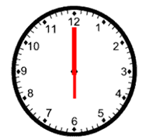

c)It is ……. 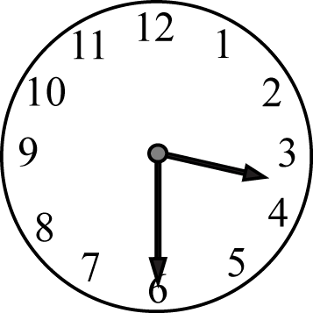

24) Four men shared 20 000 Frw equally. How much money did each man get?

(**2marks)**

25) Fill in the next two missing numbers in the following sequences

(**4marks)**

(c) 10, 20, 30, 40, 50, 60,.......,.......,

(d) 10, 13, 16, 19, 22, 25,......,.......,

26) Fill in the missing number (**2marks)**

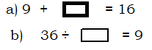

27) a) What is an acute angle: (**1mark)**

(b) What is anobtuse angle: (**1mark)**

28)A rhombus has diagonals of lengths 20m and 32 m as shown below. Calculate the area of the rhombus.**3marks)**

29) Share 450 sweets equally among 10 children.(**3marks)**

30)Find the perimeter of the following figures.(**4marks)**

a)

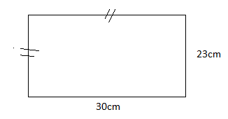

b)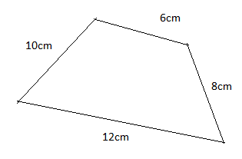

31) Annet has 1250 kg of beans and her Antony has 2000kg of beans. How many kg of beans did they have all together?**(3marks)**

32) Mutoni has a 100 000 litreswater tank.She used 40 000 litres. How much water remains in the tank? Give the answer in litre(**3marks)**

33) A triangle has an area of 100 cm2 and a base of 10 cm. What is the height of the triangle? (**3marks)**

34) Mutsinzi was given 5 000 Frw by his father as pocket money for school use. He bought a pen at 100 Frw, a book at 500F and mathematical set at 1000 F

a)How much money does he spend?**(2marks)**

b) How much money is left with him?(**2marks)**

35) The data below shows the marks obtained (out of 50) by some pupils in a English **5marks)**

test: 20; 10;25; 45;50;45; 25 ;45;50; 10

(a) How many pupils did the test?

(b) How many pupils scored 45 marks?

(c) How many pupils got 25 marks

(d) What was the highest marks scored?

(e)What was the smallest marks scored?

36) Observe the Calendar and answer to the following questions (**6marks)**

**March 2008**

|  |  |  |  |  |  |  |
| --- | --- | --- | --- | --- | --- | --- |
| SU | MO | TU | WED | THUR | FRI | SAT |
|  |  |  |  | 1 | 2 | 3 |
| 4 | 5 | 6 | 7 | 8 | 9 | 10 |
| 11 | 12 | 13 | 14 | 15 | 16 | 17 |
| 18 | 19 | 20 | 21 | 22 | 23 | 24 |
| 25 | 26 | 27 | 28 | 29 | 30 | 31 |

(a) For which year does the calendar belong?

(b) For which month of the year is the calendar?

(c) What does ‘Mo’ stand for in the calendar?

(d) On what day does the month begin?

(e)On what day does it end?

(f) How many weeks does the month have?