**P4 MATHEMATICS MARKING SCHEME, 2019**

**ANSWER ALL QUESTIONS(100MARKS)**

1.Write the following number in words : 97 642:**Ninety seven thousand six hundred forty two……………………..** (**2marks)**

2. Write the following in figures:

Twelve thousand five hundred :**12500…**…………………………………….. (**2marks)**

3. a) What is the place value of digit 2 in the number 14 258 ; **the place value of 2 is hundreds** (**1mark)**

b) What is the place value of 1 in the number 26 318 ;**the place value of 1 is tens** (**1mark)**

4. Write the following number in expanded form 76 709 : **76706=70000+6000+0+70+6** (**1mark)**

5. Compare the following numbers using <, > or = (**3marks)**

(a) 624 642**, a)<**

**(b)3 000 30 000 b)<**

**(c) 3 214 3 214 c)=**

6) If one egg costs 150F . Calculate the cost of 100 eggs ? (**2marks)**

**100eggs cost 150Fx100=F15000**

7).Workout: a**) 21 650 + 32 146=53796 (1mark)**

**b) 48 487 – 32 459= 16028 (1mark )**

**c) 620 × 25= 15500 ( 2marks)**

**d) 575 × 3 = 1725 (1mark)**

**e) 54 000 ÷ 45= 1200 (2marks)**

**f) 1 476 ÷ 12= 123 (2marks)**

8. A class has 67 pupils. A teacher wants to form groups of 4 pupils each.

**(a) How many groups were formed in the class?** **He will form 16 groups (2marks)**

**(b) How many students remain without a group? 3 students remaining without a group (2marks)**

9) Arrange the following integer by ascending order +1, –3, –10, –2, –4, 0, +5 (**1mark)**

**9)-10;-4;-3;0;-2;+1;+5**

10) Arrange these integers by descending order –8, –5, +3, +2, 0, +5, +6, +8, +1 (**1mark)**

10) **+8;+6;+5;+3;+2;+1;0;-5;-8**

11) List all odd numbers less than 12 (**2marks)**

These numbers are **1;3;5;7;9;11**

12)Write in word the following fraction :  (**1mark)**

** : forth out of five**

13) Workout  (**1mark)**

**9**

14) List any 4 multiples of 5 (**2marks)**

**Multiples of 5 are :5;10;15; 20;……**

15)Compare by using <,> or = (**1mark )**



**3/7<5/7**

16)Find LCM of 12 and 18 (**2marks)**

**12=22x3 and 18=2x32**

**LCM(12,18)= 22x32=4x9=36**

17) Workout the following **(4marks)**

a)  **a) **

**b)  b) **

**c)  c) **

**d)  d) **

a) 

b) 

c) 

d) 

18. In a class there are 30 students. Two-thirds of these are girls. How many girls are in the class?

**(3marks)**

Number of girls are  .they are **20girls**

19. What is the place value of the digit 5 in the number 13.56 (**1mark)**

The place value of **5 is tenths**

20) Arrange the following in ascending order : 3.5; 3.79; 3.42; 3.57; 3.7; 3.62. (**2marks)**

**3.42;3.5;3.57;3.62;3.7;3.79.**

21. Workout **(3marks)**

(a) 206.1 + 223.9=  **430**

(b) 19.82 – 5.28= **14.54**

(c) If a = 23.23 and b = 32.32, find the value of: a + b-a:

**23.23+32.32=32.32**

22.Workout : **(4marks)**

(a) 76 hm + 4 km = **7600m+4000m**= **11600m**

(b) 30 km – 4 000 m = **300hm-40hm =260hm**

(c) 4kg + 3hg = 400dag +30dag =**430dag**

d)25 ha +10 000dam2 =**2500 dam 2 +10.000dam2 =12500dam**2

23) What time is it? (**3marks)**

a) 8:40 =…**it is eight past forty.**

**b) it is six o’clock** ……………….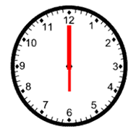

c)It is **It is a half past three** ……. 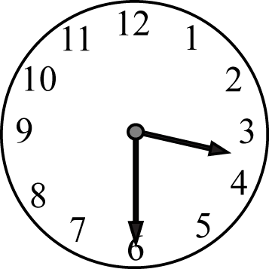

24) Four men shared 20 000 Frw equally. How much money did each man get? (**2marks)**

**One will get F 20000:4=F 5000**

25) Fill in the next two missing numbers in the following sequences (**4marks)**

(c) 10, 20, 30, 40, 50, 60,..**70.....,..80.....,**

(d) 10, 13, 16, 19, 22, 25,...**28...,...31....,**

26) Fill in the missing number (**2marks)**

a) 9 + = 16; **a)7**

b) 36 ÷ = 9 **b)4**

27) a)What is an acute angle: **it is an angle smaller than a right angle. Its size is between 00 and 900** (**1mark)**

(b) What is an obtuse angle: **it is an angle sized more 90degrees and less than 180 degrees** (**1mark)**

28)A rhombus has diagonals of lengths 20m and 32 m as shown below. Calculate the area of the rhombus.

(**3marks)**

**Area of rhombus = **



29) Share 450 sweets equally among 10 children. (**3marks)**

**One child will get 450sweets: 10 =45sweets**

30)Find the perimeter of the following figures. (**4marks)**

a)

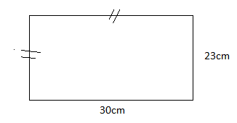

a) **P=(30cm+23cm)x2=106cm**

b)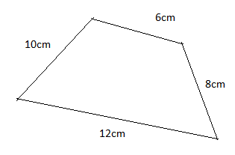

b)**P=6cm+8cm+12cm+10cm=36cm**

31) Annet has 1250 kg of beans and her Antony has 2000kg of beans . How many kg of beans did they have all together

(**3marks)**

She has **1250kg+2000kg=3250kg**

32) Mutoni has a 100 000 litres water tank . She used 40 000 litres. How much water remains in the tank? Give the answer in litre

(**3marks)**

**The remaining water in the tank is 100000litres-40 000litres =60litres**

33) A triangle has an area of 100 cm2 and a base of 10 cm. What is the height of the triangle? (**3marks)**

Solution Area = 100 cm2 and base = 10 cm

Area of triangle (A) = 







34) Mutsinzi was given 5 000 Frw by his father as pocket money for school use. He bought a pen at 100 Frw, a book at 500F and mathematical set at 1000 F

a) How much money does he spend **he spent 100F+500F+1000F=1600 F** (**2marks);**

b) How much money is left with him **He remained with 50000F-1600F=3400F (2marks).**

35) The data below shows the marks obtained (out of 50) by some pupils in a English (**5marks)**

test: 20 10 25 45 50 45 25 45 50 10

(a) How many pupils did the test? **10 pupils did the test.**

(b) How many pupils scored 45 marks? **Pupils getting 45 are 3**

(c) How many pupils got 25 marks **2 pupils got 25**

(d) What was the highest marks scored? **The highest marks is 50**

(e)What was the smallest marks scored? **the smallest marks is 10**

36) Observe the Calendar and answer to the following questions **(6marks)**

**March 2008**

|  |  |  |  |  |  |  |
| --- | --- | --- | --- | --- | --- | --- |
| SU | MO | TU | WED | THUR | FRI | SAT |
|  |  |  |  | 1 | 2 | 3 |
| 4 | 5 | 6 | 7 | 8 | 9 | 10 |
| 11 | 12 | 13 | 14 | 15 | 16 | 17 |
| 18 | 19 | 20 | 21 | 22 | 23 | 24 |
| 25 | 26 | 27 | 28 | 29 | 30 | 31 |

(a) For which year does the calendar belong? **2008**

(b) For which month of the year is the calendar? **March**

(c) What does ‘Mo’ stand for in the calendar? **Mo:** **Monday**

(d) On what day does the month begin? **Thursday**

(e)On what day does it end? **Saturday**

(f) How many weeks does the month have? **4weeks**