SECTION A: COMPREHENSION
Read the story below and answer the questions that follow in full sentences

My Dog
The name of my dog is Bobo. He is 2 years old. He is a black and brown dog. He is a tall dog and runs fast.
After doing my homework, I always play with him. He is a very brave dog. When a new person comes to our house, he barks very loudly. During the day time, we keep him in the kennel. At night, we let him loose. I love Bobo very much.

QUESTIONS / 5 marks
- What is the name of the dog? The name of the do is Bobo
- How old is the dog? The dog is 12 years old
- What color is the dog? He is a black and brown dog
- Does the dog run fast? Yes the dog runs fast
- Where do they keep him during the day? We keep him in the kennel

SECTION B
- Use a/an to complete the sentences 5 marks
- I have an orange
- Peter has a black and brown dog.
- She carries an umbrella
- Give me a pen.
- An old man is walking slowly
- Arrange the words in a correct order to make a good sentence 5 marks
- My is name Jane My name is Jane
- Brushing is he teeth his He is brushing his teeth
- Children A teacher teaches. A teacher teaches children
- In the class playing bad is. Playing in class is bad.
- Old I am years eight. I am eight years old
- Fill in the missing letters to form a correct word 5 marks
- Cla_ssroom__
- T_a_ble__
- F_a_the_r
- Te_l_ev_ision
- Bla_ckb_oar_d

- Match the animals to their young ones 5 marks
- A dog kitten
- A cat puppy
- A cow chick
- A lion cub
- A hen calf

- Choose the best answer from the brackets 5 marks
- She is a girl (is/are)
- He has a pen (have/ has)
- Every day, we go to school (go/goes)
- I am a child (is/ am)
- You did the homework well yesterday (do/did)
- What time is it? 5 marks

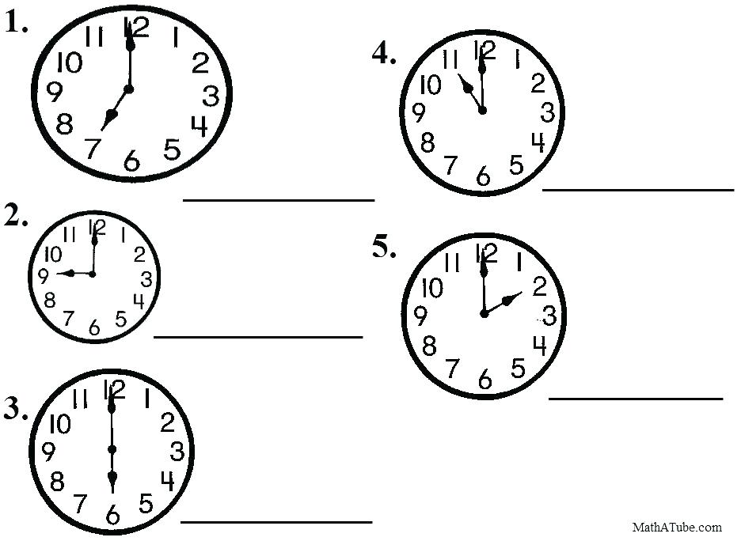

- It is 7 o’clock
- It is 9 o’clock
- It is 6 o’clock
- It is 11 oclock
- It is 2 o’clock
- Complete with: his, her, its, my, our… 5 marks
- Tom has a red car. That is his car
- Teta has a flower. It is her flower
- It has a long tail. It is its tail
- We have eggs. They are our eggs
- I have a plate. My plate is yellow.
- Re-write the sentence with the opposite of the underlined word /5
- My father has a small house.
- My father has a big house
- Close the door!
- Open the door
- I have a short ruler.
- I have a long ruler
- I am feeling cold.
- Am feeling hot
- He will give me a big piece of cake.
- He will give me a small piece of cake
- Fill the gaps with: towel , bed , garden , food , classrooms /5
- In my bedroom there is a bed in which I sleep.
- Pupils are in their classrooms
- When I want to dry my body I use a towel
- There are flowers in the garden
- Kaneza is cooking food for us.

