ENGLISH

P3 END OF YEAR EXAMS, 2019

SUBJECT: ENGLISH

Duration: 1 Hour
/60

Marks:

INSTRUCTIONS

- Don’t open this question paper until you are told to do so.
- All questions are compulsory.
- Read each question carefully before answering it.
- Answer the questions in the space provided on this question paper.
- Use only a blue or black pen.

SECTION A: COMPREHENSION
Read the story below and answer the questions that follow in full sentences

My Dog
The name of my dog is Bobo. He is 2 years old. He is a black and brown dog. He is a tall dog and runs fast.
After doing my homework, I always play with him. He is a very brave dog. When a new person comes to our house, he barks very loudly. During the day time, we keep him in the kennel. At night, we let him loose. I love Bobo very much.

QUESTIONS (5 marks)
- What is the name of the dog?
- How old is the dog?
- What color is the dog?
- Does the dog run fast?
- Where do they keep him during the day?

SECTION B
- Use a/an to complete the sentences (5 marks)
- I have ………….. orange
- Peter has ………….. black and brown dog.
- She carries …………… umbrella
- Give me ………….. pen.
- ………… old man is walking slowly
- Arrange the words in a correct order to make a good sentence
(5 marks)
- My is name Jane
- Brushing is he teeth his
- Children A teacher teaches.
- In the class playing bad is.
- Old I am years eight
- Fill in the missing letters to form a correct word (5 marks)
- Cl_ssroo__
- T__bl__
- F__th_r
- T_l_v_sion
- Bl_ck_oa_d

- Match the animals to their young ones (5 marks)
- A dog kitten
- A cat puppy
- A cow chick
- A lion cub
- A hen calf
- Choose the best answer from the brackets (5 marks)
- She ……….. a girl (is/are)
- He …………… a pen (have/ has)
- Every day, we …………….to school (go/goes)
- I ……….. a child (is/ am)
- You ……. The homework well yesterday (do/did)
- What time is it? (5 marks)

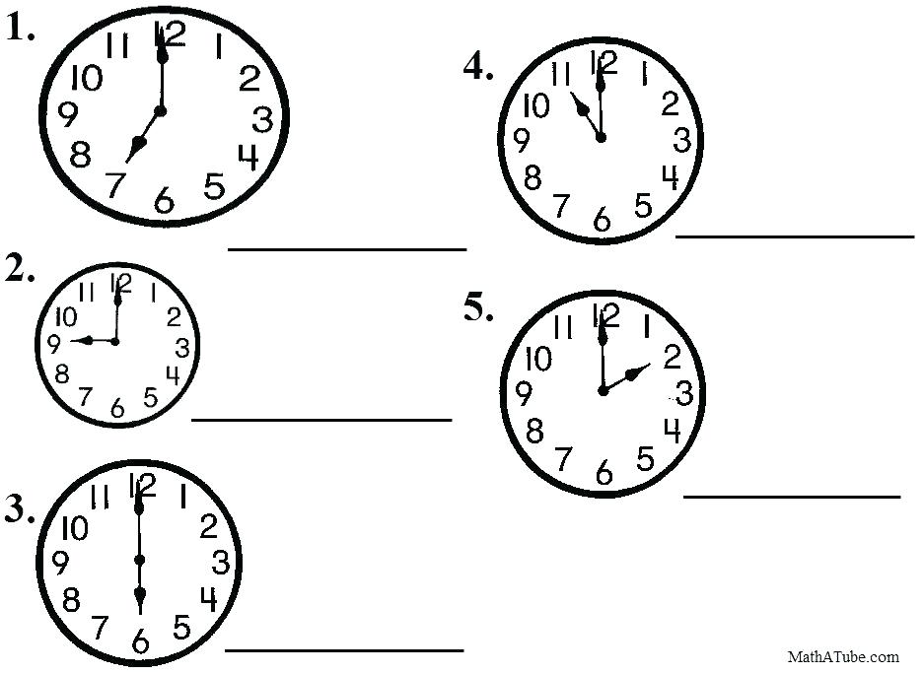

- Complete with: his, her, its, my, our… (5 marks)
- Tom has a red car. That is ………….car
- Teta has a flower. It is …………..flower
- It has a long tail. It is ………….. tail
- We have eggs. They are ……….eggs
- I have a plate. …………… plate is yellow.
- Re-write the sentence with the opposite of the underlined word
(5 marks)
- My father has a small house.
- …………………………………………………………………………………………………………………
- Close the door!
- …………………………………………………………………………………………………………………
- I have a short ruler.
- …………………………………………………………………………………………………………………
- I am feeling cold.
- …………………………………………………………………………………………………………………
- He will give me a big piece of cake.
- …………………………………………………………………………………………………………………
- Fill the gaps with: towel , bed , garden , food , classrooms (5 marks)
- In my bedroom there is a …………………………… in which I sleep.
- Pupils are in their ………………………………………………………
- When I want to dry my body I use a …………………………………………………
- There are flowers in the …………………………………………
- Kaneza is cooking ……………………………………………… for us.

