

**IMIBARE**

**21/10/2019**

**9:00 am -11:00 am**

**IKIZAMINI GISOZA UMWAKA WA KABIRI W’AMASHURI ABANZA, 2019**

**IMIBARE**

**Igihe kimara: Amasaha abiri (2h00)**

/100

**Amanota:**

**Amabwiriza:**

1. Ibisubizo bigomba kuba bifututse kandi byuzuye.
2. Gusiribanga no guhindagura ibisubizo bifatwa nko gukopera.
3. Ukurikize amabwiriza ari ku bibazo.
4. Koresha gusa ikaramu y’**ubururu** cyangwa iy’**umukara**

**ISUZUMA RISOZA UMWAKA WA KABIRI,2019 (AMANOTA 100)**

**A) IBARA N’AMATEGEKO YARYO (AMANOTA 60)**

1.Andika mu mibare **(amanota 2**)

(a) Magana akenda na mirongo ikenda na gatanu:…………………..

(b) Magana arindwi na karindwi …………………………….

2)Andika mu magambo (**amanota 3)**

(a) 997: ……………………..

(b) 864:……………………….

(c) ………………………

3) Sesengura iyi mibare mo ibinyabumwe, ibinyacumi n’ibinyajana:

**(amanota 2)**

(a) 235 : …………………………..

(b) 982:…………………………………………….

4) Andika umubare wasesenguwe **(amanota 4)**

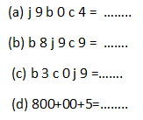

5)Gereranya imibare ukoresheje <,> cyangwa = **(amanota 3)**

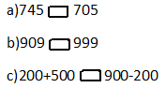

6)Tondeka uhereye ku mubare muto ujya ku munini **(amanota 4)**

(a) 851, 725, 965, 910 :

(b) 809, 930, 390, 903

7)Tondeka uhereye ku munini ujya ku muto **(amanota 4**)

(a) 871, 975, 519,718

(b) 293, 923 ,239, 932

8) Shaka igisubizo **(amanota 2**)

(a)343 + 456 =….

(b) 526 + 415 =……

9)Shaka igisubizo **(amanota 2)**

(a)896 – 543 =……

(b) 972 – 939 =………

10)Shaka igisubizo **(amanota 6)**

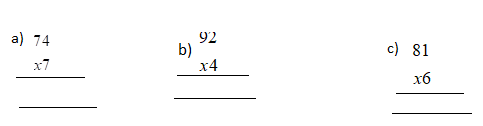

11) Shaka igisubizo **(amanota 6)**

(a) 875 : 5

(b) 792 : 3 =

(c) 448 : 4 =

12)Uzuza umubare ubura mu kazu **(amanota 2)**

(a) 99 × =990

(b) 9 × = 900

13)Itegereze uru rukurikirane rw’imibare maze wuzuze imibare ibura **(amanota 4)**

(a) 845; 840; 835 ; ; ;820

(b) 200 ;300; 400; ; ;700

14) Ikigo cyacu gifite abanyeshuri 978. Abanyeshuri 489 ni abakobwa . Hari abanyeshuri b’abahungu bangahe? **(amanota 3**)

………………………………………………………………………………

15) Muhire yaguze amakayi 96.Ashaka kuyagabanya abana be babiri mu buryo bungana.Buri mwana azamuha amakayi angahe? **(amanota 3)**

………………………………………………………………………………………………………

16) Umuyobozi w’ishuri yaguze ibitabo 840 abigabanya amashuri 4 ku buryo bungana. Buri shuri ryabonye ibitabo bingahe? (**amanota 3)**

………………………………………………………………………………………………………………………………………………………………………….

17) Agakarito kamwe karimo amakaramu 50.Udukarito 6 turimo amakaramu angahe? (**amanota 3)**

…………………………………………………………………………………………………………………………………………………………………………………

……………………………………………………………………………………………………………………………………………………………………………………

18) Abanyeshuri bakoresheje impapuro 434 mu kizamini k’imibare. Mu kinyarwanda bakoresha impapuro 565. Bakoresheje impapuro zingahe zose hamwe? **(amanota 3)**

19)Uzurisha umubare ubura mu tuzu **(amanota 4)**

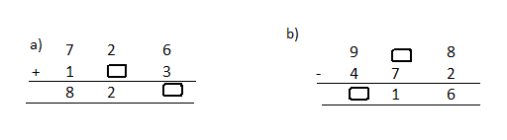

**B) IMIGABANE (AMANOTA 5)**

20) Andika mu magambo iyi migabane **(inota 1)**

a)……………………………

b)………………………………

21) **Subiza yego cyangwa oya (amanota 2)**

(a) Umubare wo hejuru ku mugabane witwa ikita.

(b) Ikizima kimwe kingana na  k’ikintu inshuro enye

(c) Umubare wo hasi ku mugabane witwa ikibara.

(d)  k'ikintu kiruta  cyacyo.

22) Geraranya imigabane ukoresheje <;> na = **(inota 1)**

a) 

b) 

23)Andika umugabane werekanwa n’ihasize ibara muri iyi shusho **(inota 1)**

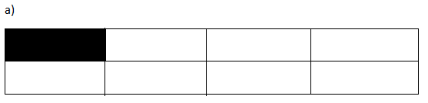

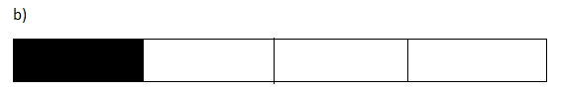

**C)INGERO N’AMAFARANGA (AMANOTA 25)**

**24) Hindura ingero (amanota 2 )**



**25) Gereranya ingero ukoresheje <,> na = (amanota 2)**

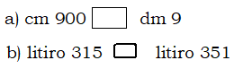

**26) Teranya ingero (amanota 2)**

a) cm 45 + dm 15 = cm……

b) litiro 317 + litiro 623 = litiro……

**27) Kuramo ingero (amanota 3)**

(a)cm 500 – dm 15 = dm …..

(b) litiro 975 – litiro 485 = litiro……

(c)kg799-kg 693=kg…………………

**28) Shaka igisubizo (amanota 2)**

a) cm 24 × 2 = cm…..

b) dm72 : 6 = cm……

c) l 31 x 6 = l……

d)kg 300:3=kg……..

29) Kamana yaguze ikizingo cy’umugozi ureshya na m 60 arashaka gucamo uduce 5 tungana. Shaka uburebure bwa buri gace muri dm. **(amanota 2)**

30) Kaliza yaguze igitambaro kireshya na m 89 adodeshaho dm 70 mo ikanzu. Ubwo yasigaranye igitambaro kireshya na desimetero zingahe? **(amanota 2)**

31) Gabanya ku buryo bungana litiro 900 z’amata ibigo by’amashuri 3. Buri kigo kizahabwa litiro zingahe? **(amanota 2)**

32) Itegereze iyi mbonerahamwe , maze usubize ibibazo bikurikira **(amanota 3)**

|  |  |
| --- | --- |
| **Ibicuruzwa** | **Ibiciro** |
| Umwembe 1 | F150 |
| Umuneke 1 | F100 |
| Isabune 1 | F500 |
| Ikayi 1 | F300 |
| Ikaramu1 | F50 |

a)Mariya yaguze umuneke 1 n’umwembe 1.Yishyuye F angahe ?

…………………………………………..

b)Mariko yaguze isabune 1 , n’ikaramu imwe.Yishyuye F angahe?

……………………………………………

d)Mugabo yaguze ikayi 1, n’ikaramu 1. Yishyuye F angahe?

……………………………………………..

**33) Andika umubare w’inoti cyangwa ibiceri biri mu mafaranga akurikira:**

**(amanota 2)**

**(**a) F1000 = Inoti …. za F500

(b) F500 = Ibiceri ….. bya F100

**34)Itegereze indangaminsi maze usubize ibibazo (amanota 3)**

**Mutarama 2017**

|  |  |  |  |  |  |  |
| --- | --- | --- | --- | --- | --- | --- |
| Kuwa mbere | Kuwa kabiri | Kuwa gatatu | Kuwa kane | Kuwa gatanu | Kuwa gatandatu | Ku cyumweru |
|  |  |  |  |  |  | 1 |
| 2 | 3 | 4 | 5 | 6 | 7 | 8 |
| 9 | 10 | 11 | 12 | 13 | 14 | 15 |
| 16 | 17 | 18 | 19 | 20 | 21 | 22 |
| 23 | 24 | 25 | 26 | 27 | 28 | 29 |
| 30 | 31 |  |  |  |  |  |

a)i)Uku kwezi ni ukwa kangahe mu mezi y’umwaka?........

ii) bakwita ngo iki mu Kinyarwanda……………..

b) Kugira iminsi ingahe?...................................

c)Itariki 29 ni kuwa kangahe……………

d)Ukwezi kuzarangira ku yihe tariki?..........

e) icyumweru cya mbere cy’ukwezi hazaba ari kuwa kangahe?...........

**C)AMASHUSHONGERO (amanota 10)**

35)Shaka umuzenguruko w’umurima ushushe nka kare ufite m3 z’uruhande

**(inota 1)**

36)Shaka umuzenguruko w’aya mashusho **(amanota 4)**

a)

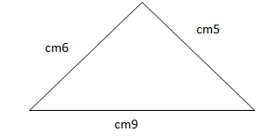

b)

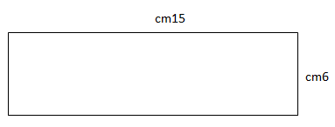

37) a) Isaha imwe igira iminota ?.................................. (**inota 1)**

b) Umunsi umwe ugira amasaha?......................... (**inota 1)**

38) Vuga igihe kerekanwa n’iyi saha **(inota 1)**

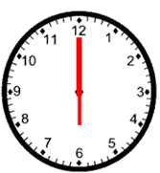

Ni saa………….

39) Vuga amoko y’imfuruka **(amanota 2)**

a)

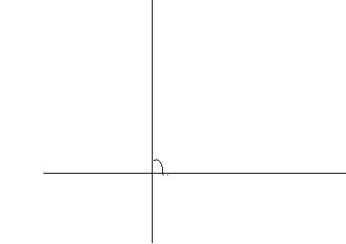

Iyi ni imfuruka ……………………………………………………

b)

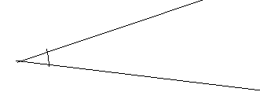

Iyi ni imfuruka …………………………………………………………..