**ISUZUMA RISOZA UMWAKA WA KABIRI,2019**

**IBISUBIZO**

**A)IBARA N’AMATEGEKO YARYO (AMANOTA 60)**

1.Andika mu mibare **(amanota 2**)

(a) Magana akenda na mirongo ikenda na gatanu:…**995**………………..

(b) Magana arindwi na karindwi : **707**…………………………….

2)Andika mu magambo (**amanota 3)**

(a) **997: Magana acyenda na mirongo icyenda na karindwi**

**(b) 864:Magana inani na mirongo itandatu na kane ……………………….**

**(c) …Bitatu bya kane** ……………………

3) Sesengura iyi mibare mo ibinyabumwe, ibinyacumi n’ibinyajana: amanota 2

(a) 235 **: j2 c3 b5**…………………………..

(b) 982**: j9c8b2**………………………………………….

4) Andika umubare wasesenguwe **( amanota 4)**

**a)j9b0c4=940**

**b)b8j9c9=998**

**c)b4c0j9=904**

**d)800+00+5=805**

5)Gereranya imibare ukoresheje <,> cyangwa = **( amanota 3)**

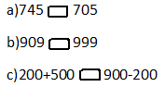

**a)>**

**b)<**

**c)=**

6)Tondeka uhereye ku mubare muto ujya ku munini **(amanota 4)**

(a) 851, 725, 965, 910 : **725;851;910;965**

(b) 809, 930, 390, 903:**390;809;903;930**

**7)Tondeka uhereye ku munini ujya ku muto (amanota** 4)

(a) 871, 975, 519,718 : **975;871;718;519**

(b) 293, 923 ,239, 932: **932;923;293;239**

8) Shaka igisubizo (**amanota 2)**

**(a)343 + 456 =…799.**

**(b) 526 + 415 =941**

9)Shaka igisubizo **(amanota 2)**

**(a)896 – 543 =353**

**(b) 972 – 939 =33**

10)Shaka igisubizo (amanota6)

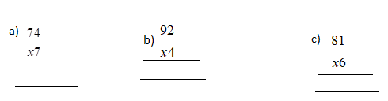

**a)518**

**b)368**

**c)486**

11) Shaka igisubizo **(amanota 6)**

(a) 875 : 5= **175**

(b) 792 : 3 = **264**

(c) 448 : 4 = **112**

12)Uzuza umubare ubura mu kazu **(amanota 2)**

(a) 99 × = 990 ; **10**

(b) 9 × = 900; **10**

13)Itegereze uru rukurikirane rw’imibare maze wuzuze imibare ibura **(amanota 4)**

(a) 845; 840; 835 ; ; ; 820 **a)840; 845**

(b) 200 ;300; 400 ; ; ; 700 **b)500;600**

14) Ikigo cyacu gifite abanyeshuri 978.Abanyeshuri 489 ni abakobwa . Hari abanyeshuri b’abahungu bangahe?....................................................................................

**(amanota 3**)

**Abahungu ni 489**

15) Muhire yaguze amakayi 96. Ashakakuyagabanya abana be babiri mu buryo bungana.Buri mwana azamuha amakayi angahe? ……………………………………….

Buri mwana azamuha amakayi 96:2= **amakayi48**….. ………………………………………………………….. ……………………….. **(amanota 3)**

16) Umuyobozi w’ishuri yaguze ibitabo 840 abigabanya amashuri 4 ku buryo bungana. Buri shuri ryabonye ibitabo bingahe? **(amanota 3)** ……………………………………

Buri shuri ryabonye ibitabo 840:4= **ibitabo 210**

17) Agakarito kamwe karimo amakaramu 50.Udukarito 6 turimo amakaramu angahe? (**Amanota 3**)

turimo amakaramu 50x6=**amakaramu 300**……………

18) Abanyeshuri bakoresheje impapuro 434 mu kizamini k’imibare. Mu kinyarwanda bakoresha impapuro 565. Bakoresheje impapuro zingahe zose hamwe?

**( Amanota 3)**

**Bose hamwe bakoresheje impapuro 434+565= impapuro 999**

19)Uzurisha umubare ubura mu tuzu **(amanota 4)**

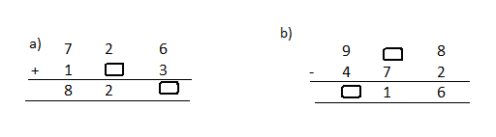

**B)IMIGABANE (AMANOTA 5)**

20) Andika mu magambo iyi migabane **(amanota 1)**

a)………: **KIMWE CYA KANE**…

b)………:**KIMWE CY’UMUNANI**…

21) **Subiza yego cyangwa oya (2marks)**

(a) Umubare wo hejuru ku mugabane witwa ikita.**OYA**

(b) Ikizima kimwe kingana na  k’ikintu inshuro enye **YEGO**

(c) Umubare wo hasi ku mugabane witwa ikibara. **OYA**

(d)  k'ikintu kiruta  cyacyo. **OYA**

22) Geraranya imigabane ukoresheje <;> na = **(inota 1)**

**a) ;>**

**b) ; <**

23)Andika umugabane werekanwa n’ihasize ibara muri iyi shusho **(1marks)**

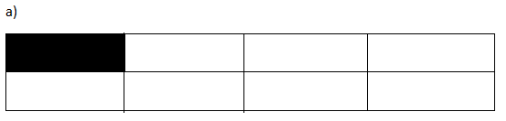

**1/8**

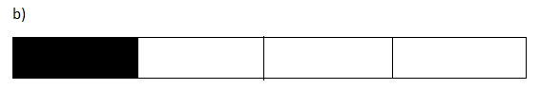

**1/4**

**C)INGERO N’AMAFARANGA (AMANOTA 25)**

**24)Hindura ingero (amanota 2 )**



**a)m20=dm200**

**b)dm150=cm 1500**

**25) Gereranya ingero ukoresheje <,> na = (amanota 2)**

a) cm 900 dm 9 ;>

b) litiro 315 litiro 351;<

d) kg 819 hg 891 ; >

**26)Teranya ingero (amanota 2)**

a) cm 45 + dm 15 = **cm195**

b) litiro 317 + litiro 623 = litiro**940**

**27)Kuramo ingero (amanota 3)**

(a)cm 500 – dm 15 = **dm35**

(b) litiro 975 – litiro 485 = litiro **490**

(c)kg799-kg 693=**kg106**

**28)Shaka igisubizo (amanota 2)**

a) cm 24 × 2 = **cm48**

b) dm72 : 6 = **cm12**

c) litiro 31 x 6 = **litiro 186**

d)kg 300:3=**kg100**

29) Kamana yaguze ikizingo cy’umugozi ureshya na m 60 arashaka gucamo uduce 5 tungana. Shaka uburebure bwa buri gace muri dm.

**(amanota 2**)

Buri gace ni **m60:5=m12**

30) Kaliza yaguze igitambaro kireshya na m 89 adodeshaho dm 70 mo ikanzu. Ubwo yasigaranye igitambaro kireshya na desimetero zingahe? (**amanota 2**)

Igitambaro yasigaranye ni m89-dm70= **dm820**

31) Gabanya ku buryo bungana litiro 900 z’amata ibigo by’amashuri 3. Buri kigo kizahabwa litiro zingahe?

**(amanota 2)**

**Buri kugo kizatwara litiro 900:3=litiro 300**

**32) Itegereze iyi mbonerahamwe ,maze usubize ibibazo bikurikira (amanota 3)**

|  |  |
| --- | --- |
| **Ibicuruzwa** | **Ibiciro** |
| Umwembe 1 | F150 |
| Umuneke 1 | F100 |
| Isabune 1 | F500 |
| Ikayi 1 | F300 |
| Ikaramu1 | F50 |

**a)**Mariya yaguze umuneke 1 n’umwembe 1.Yishyuye F angahe ?yishyuye **F100+F150=F250**

**b)Mariko yaguze isabune 1 , n’ikaramu imwe.Yishyuye F angahe? Yishyuye F500+F50=F550**

d)Mugabo yaguze ikayi 1, n’ikaramu 1. Yishyuye F angahe?**F300+F50=F350**

**33) Andika umubare w’inoti cyangwa ibiceri biri mu mafaranga akurikira: (amanota 2)**

**(a) F1000 = Inoti 2…. za F500**

**(b) F500 = Ibiceri 5….. bya F100**

**34)Itegereze indangaminsi maze usubize ibibazo (amanota 3)**

**Mutarama 2017**

|  |  |  |  |  |  |  |
| --- | --- | --- | --- | --- | --- | --- |
| Kuwa mbere | Kuwa kabiri | Kuwa gatatu | Kuwa kane | Kuwa gatanu | Kuwa gatandatu | Ku cyumweru |
|  |  |  |  |  |  | 1 |
| 2 | 3 | 4 | 5 | 6 | 7 | 8 |
| 9 | 10 | 11 | 12 | 13 | 14 | 15 |
| 16 | 17 | 18 | 19 | 20 | 21 | 22 |
| 23 | 24 | 25 | 26 | 27 | 28 | 29 |
| 30 | 31 |  |  |  |  |  |

a)i)Uku kwezi ni ukwa kangahe mu mezi y’umwaka?.NI **UKWA MBERE**

ii) bakwita ngo iki mu Kinyarwanda… **NI Mutarama…………..**

**b) Kugira iminsi ingahe? KUGIRA IMINSI 31...................................**

**c)itariki 29 ni kuwa kangahe……: NI KU CYUMWERU ………**

**d)Ukwezi kuzarangira kuwa yihe tariki?.. KURI 31....**

e) icyumweru cya mbere cy’ukwezi hazaba ari kuwa kangahe?..KU CYUMWERU

**C)AMASHUSHONGERO (amanota 10)**

35)Shaka umuzenguruko w’umurima ushushe nka kare ufite m3 z’uruhande (**1marks)**

P =m3x4=**m12**

36)Shaka umuzenguruko w’aya mashusho **(4marks)**

a)

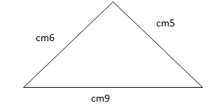

**P=cm6+cm9+cm5=cm20**

b)

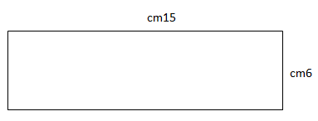

37) a) Isaha imwe igira iminota ?... **iminota60...............................** **inota 1**

b) Umunsi umwe ugira amasaha?**iminota 60.........................** **inota 1....**

38) Vuga igihe kerekanwa iyi’ saha (**inota 1 )**

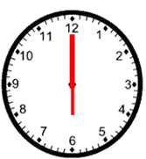

Ni saa……**kumi n’ebyiri zuzuye**

39) Vuga amoko y’imfuruka (**amanota 2)**

a)

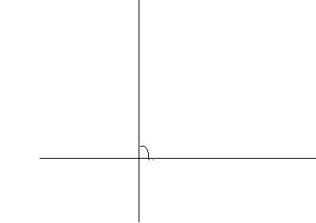

Iyi ni imfuruka …**igororotse…**………………………………………………

b)

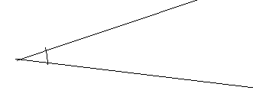

Iyi ni **imfuruka ifunganye**………………