ENGLISH EXAM
This exam is out of 60 marks.
Answer all Questions

READING /10
I read
- I have a big bed
- He has two bananas.
- Tom is a boy.
- His cup is very big.
- You are not at home.

- GRAMMAR /20
- Complete with: am / is / are /3
- You ………are……………… a teacher.
- She …………is………… a girl.
- I …………am…………… in the classroom.

- Complete with: have or has /2
- It ………has……………… a long tail.
- We …………have………… eggs.

- Complete with: go or goes /2
- I …………go……… to school with my brother.
- He …………goes…………………… to the market.

- Fill in the blanks with: my / your / our / their /4
- We have a big school. This is ……our…………… school.
- You have a long dress. It is …………your……………… dress.
- They have balls. These are ……… their……. balls.
- I have a pen. It is …………my……………… pen.

- Complete with: a or an /2
My mother buys ……a……… banana and ……an……… orange.

- Complete with: This or That /4
- ………This……………………… is a tomato.
- 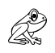……………That………………… is a frog.
- 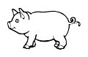 …………That………………… is a pig.
- 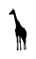 …………This…………………… is a giraffe.
- Make correct sentences /3

- Peter - is - father – called – My.
My father is called Peter.
- big – Their – is – house.
Their house is big.
- bus – by – go - I – to – school.
I go to school by bus

- VOCABULARY /20
- Fill in the blanks with: a , e , o , i , u /5
- f__o___rk 6. gl__a__ss
- g__i_ft 7. 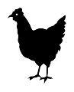 h_e___n
- b__o__y 8. f__i__sh
- cr__o__ss 9. 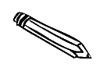p__e__ncil
- c___u_p 10. b__a__nana

Paul is eating
My brother is drinking milk.
The baby is sleeping.
They are running.
- Write the correct sentence for each picture /4

The baby is sleeping
- 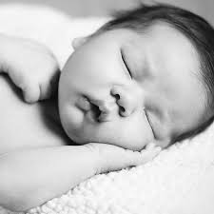
- 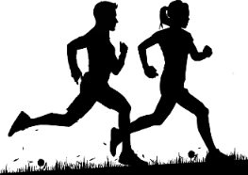 They are running
- Paul is eating. ……………………………………………………………

- 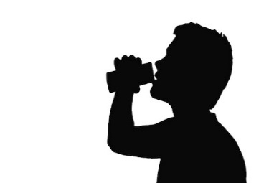My brother is drinking milk

- Read the “colour” then shade using a colour pencil /6

- Red - pink

- Green - blue

- Yellow - black

- Answer these questions /5
(make a full sentence)
      - What is your name?
………………………………………………………………………………
      - How old are you?
………………………………………………………………………………
      - How many legs do you have?
………………………………………………………………………………
      - How many fingers do you have?
………………………………………………………………………………
      - Who is the president of Rwanda?
……………………………………………………………………………….
- HANDWRITING /10
Re-write these sentences

