ENGLISH

P2 END OF YEAR EXAMINATIONS, 2019

SUBJECT: ENGLISH

Duration: 1 Hour
/60

Marks:

INSTRUCTIONS

- Don’t open this question paper until you are told to do so.
- All questions are compulsory.
- Read each question carefully before answering it.
- Answer the questions in the space provided on this question paper.
- Use only a blue or black pen.

READING (10 marks)
I read
- I have a big bed
- He has two bananas.
- Tom is a boy.
- His cup is very big.
- You are not at home.

- GRAMMAR (20 marks)
- Complete with: am / is / are (3 marks)
- You ……………………… a teacher.
- She …………………… a girl.
- I ……………………… in the classroom.

- Complete with: have or has (2 marks)
- It ……………………… a long tail.
- We …………………… eggs.

- Complete with: go or goes (2 marks)
- I ………………… to school with my brother.
- He ……………………………… to the market.

- Fill in the blanks with: my / your / our / their (4 marks)
- We have a big school. This is ………………… school.
- You have a long dress. It is ………………………… dress.
- They have balls. These are ……………………………… balls.
- I have a pen. It is ………………………… pen.

- Complete with: a or an (2 marks)
My mother buys …………… banana and …………… orange.

- Complete with: This or That (4 marks)
- ……………………………… is a tomato.
- 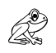……………………………… is a frog.
- 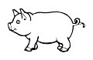……………………………… is a pig.
- 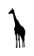 ……………………………… is a giraffe.
- Make correct sentences (3 marks)

- Peter - is - father – called – My.
…………………………………………………………………………………………………………………………………………………
- big – Their – is – house.
…………………………………………………………………………………………………………………………………………………
- bus – by – go - I – to – school.
…………………………………………………………………………………………………………………………………………………

- VOCABULARY (20 marks)
- Fill in the blanks with: a , e , o , i , u (5 marks)
- f_____rk 6. gl____ss
- g____ft 7. 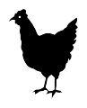 h____n
- b____y 8. f____sh
- cr____ss 9. 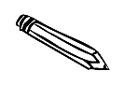p____ncil
- c____p 10. 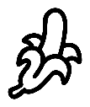 b____nana

Paul is eating
My brother is drinking milk.
The baby is sleeping.
They are running.
- Write the correct sentence for each picture (4 marks)

……………………………………………………………………………………………
- 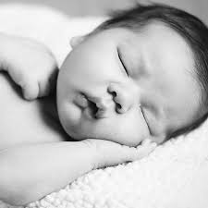
- 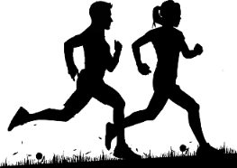 ………………………………………………………………………………………………………
- ………………………………………………………………………………………………………

- 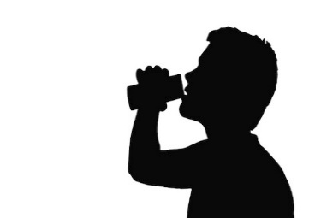………………………………………………………………………………………………………
- Read the “colour” then shade using a colour pencil (6 marks)

- Red - pink

- Green - blue

- Yellow - black

- Answer these questions (5 marks)
(make a full sentence)
      - What is your name?
………………………………………………………………………………
      - How old are you?
………………………………………………………………………………
      - How many legs do you have?
………………………………………………………………………………
      - How many fingers do you have?
………………………………………………………………………………
      - Who is the president of Rwanda?
……………………………………………………………………………….
- HANDWRITING (10 marks)
Re-write these sentences

