ENGLISH EXAM P1
- READING /5 marks
I read
- 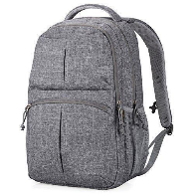a bag
- 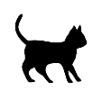 a cat
- a car
- a book
- an apple

- GRAMMAR
- Complete with: a / an /5marks
- This is a bag.
- Dad has a car.
- She has an egg.
- It is an apple.
- They have a fish.

- Fill the gaps with the missing letters /10marks
- A B C D E F G H
- O P Q R S T U V W X Y Z
- Write in capital letters /5marks
- m M
- f F
- d D
- car CAR
- bag BAG
- Complete the table /10marks
ONE | MANY
ball | balls
boy | boys
a tree | trees
a cup | Cups
a flower | flowers

- Complete with: a / e / i / u / o /10mks
- 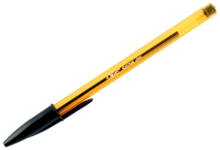 p e n 4. b o x
- 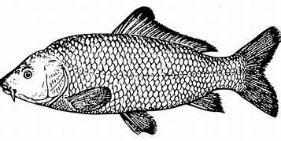 f i sh 5. 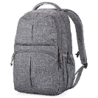 b a g
- c u p

- Complete with: on , in under , in front of , behind /10
- 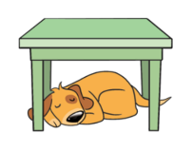A dog is under the table.
- 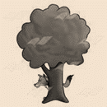A fox is behind the tree.
- Pens are in the tin.
- 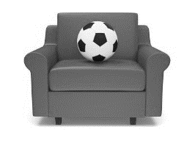A ball is on the sofa.

- She is in front of the house.

- Complete with: is , am , are /5
- I am a boy.
- She is a girl.
- We are at home.
- It is a ruler.
- You are happy.
- Complete with: have or has /5
- It has a tail.
- You have an apple.
- She has a flower.
- I have two pens.
- He has an egg.

