ENGLISH

P1 END OF YEAR EXAMINATIONS, 2019

SUBJECT: ENGLISH

Duration: 1 Hour
/60

Marks:

INSTRUCTIONS

- Don’t open this question paper until you are told to do so.
- All questions are compulsory.
- Read each question carefully before answering it.
- Answer the questions in the space provided on this question paper.
- Use only a blue or black pen.

- READING (5 marks)

I read
- 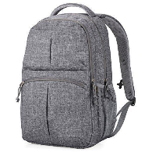a bag
- 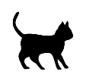 a cat
- a car
- a book
- an apple

- GRAMMAR
- Complete with: a / an (5 marks)
- This is ____ bag.
- Dad has _____ car.
- She has ____ egg.
- It is _____ apple.
- They have _____ fish.

- Fill the gaps with the missing letters (10 marks)
- A ____ _____ D _____ F ____ _____
- O ____ Q R _____ T U ____ _____ x y ____
- Write in capital letters (5 marks)
- m ………………………………………………………
- f ………………………………………………………
- d ………………………………………………………
- car ………………………………………………………
- bag ………………………………………………………
- Complete the table (10 marks)
ONE | MANY
ball | …………………………………………
boy | …………………………………………
a tree | …………………………………………
……… …………………………… | Cups
……… …………………………… | flowers

- Complete with: a / e / i / u / o (10 marks)
- 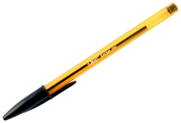 p____n 4. b_____x
- 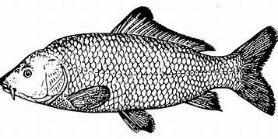 f____sh 5. 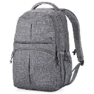 b___g
- c____p

- Complete with: on , in under , in front of , behind (10 marks)
- 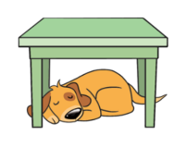A dog is ……………………………………… the table.
- 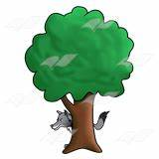A fox is ………………………………………… the tree.
- Pens are ………………………………… the tin.
- 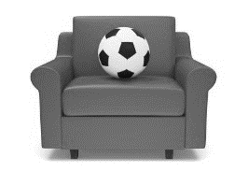A ball is ……………………… the sofa.

- She is ……………………………………… the house.

- Complete with: is , am , are (5 marks)
- I …………………………… a boy.
- She ……………………… a girl.
- We ……………………… at home.
- It ……………………… a ruler.
- You …………………… happy.

