IKINYARWANDA UMWAKA WA GATANU W’AMASHURI ABANZA
IMBONERA Y’IKOSORA
- Abanyarwanda barigereranyaga n’ikinyabuzima kiva amaraso, kuko babonaga ijuru rihinduka umutuku izuba rirenze bakabigareranya n’amaraso. (amanota 3)
- Mbibwirwa n’uko inyoni zongeye kuvuga, wa mutuzo w’ijoro ugasimburwa n’urusaku. (amanota 2)
- Nawugabanyamo ibice bitanu bikurikira: igitondo ari cyo gihe izuba ritaraba ryinshi; ku manywa igihe izuba ryumvikana cyane; ku gicamunsi, igihe rihumbye ritacyumvikana cyane; ku mugoroba igihe rirenga n’ijoro, igihe bwahumanye hatakibona urumuri rw’izuba rwazimye. (amanota 5)
- Imyitwarire y’ikirere yatangaga ibihe by’izuba n’ibihe by’imvura bidahinduka kuko byazaga mu mezi adahinduka. (amanota 4)
- Ibishashi bivugwa muri uyu mwandiko bishushanya inyenyeri (amanota 2)
- Andika amazina y’inzara avugwa mu mwandiko: Ruzagayura, Rumanurimbaba, Rwakayihura, Gakwege (amanota 6)
- Ibintu Abanyarwanda bagenderagaho bagena igihe bamaze ku isi: baheraga ku bintu byabaga byarabaye nk’ibyago [(inzara nka Ruzagayura, Rumanurimbaba, Gakwege…), ibyishimo (urwimo rw’umwami runaka, umwaduko w’abazungu wazanye imyambaro, amafaranga….), imirimo y’ubuhinzi (isarura n’ibiba ry’imyaka)] (amanota 6)
- Ugereranyije n’ibihe tugenderaho kuri ubu, izuba riba rigeze ijuru
hagati saa sita z’amanywa. Ubibwirwa n’uko uba ushobora gukandagira igicucu cyawe mu mutwe uhagaze hamwe. (amanota 3)
- Abanyarwanda bavugaga ko Nyakanga yanga amabuguma kubera ko muri Nyakanga, ubwatsi bwabaga bwarumye imisozi inyerera. Kugira ngo inka zirishe byasabaga abashumba kwirirwa bazizerereza bazijyana aho zabona ubwatsi. Muri urwo rugendo, amabuguma yashoboraga gutemba nko ku mabanga y’imisozi ntabyuke bikaba ngombwa ko bayabaga. Kwanga amabuguma ni uko kuyabuza ubuzima bayabaga kubera gutemba. (amanota 2)
- Huza ukoresheje akambi amagambo n'ibisobanuro byayo: (amanota 6)
- Kugena Ibitekerezo
- Gukakamba Igihe k'izuba ryinshi kiva muri
Kamena kikagera muri Kanama.
- Imyumvire Igihe ukwezi kuba ari uruziga
rwuzuye kubonesha cyane
- Ibuguma Kurira ikintu bikugoye
- Impeshyi Gushyiraho
- Inzora Inka ishaje cyane

- Gushyira inshinga mu zindi ndango: (amanota 3)
- Turagenda uyu munsi. Ntitugenda uyu munsi.
- Ntimukangize ibidukikije. Mwangize ibidukikije.
- Uvuge ko nagutumye. Ntuvuge ko nagutumye.
- Gukosora interuro aho yanditse nabi. (amanota 3)
Nuva ku ishuri uge kuhira za ngemwe z’ibiti twateye ejobundi.
- Ubwoko bw’amagambo atsindagiye. (amanota 10)
- Ahaaa: irangamutima ibiti: izina rusange Leta: izina bwite
- ahasigaye: inshinga itondaguye Tiku: inyigana
- Kuzurisha amagambo: ku kwezi, mu museke, mu gicuku, ijoro ryose, nijoro mu nteruro zikurikira: (amanota 5)
- Yakundaga guhanura nijoro akangutse.
- Mwene se we yakundaga guhanura mu gicuku rubanda bicuye.
- Yaraye agenda ijoro ryose bucya angezeho.
- Kuko hari ku kwezi, yabyutse bwangu akeka ko ari mu museke.
- Gusimbuza amagambo atsindagiye ayabugenewe n’utudomo amagambo akwiye : (amanota 10)
Hambere, amata iyo yabaga yakamwe bayabuganizaga mu gisabo yamara kuvura, bakayacunda akavamo amavuta yatekwaga mu biryo ari byo bitaga ibirunge cyangwa akisigwa bakayita ikimuri.
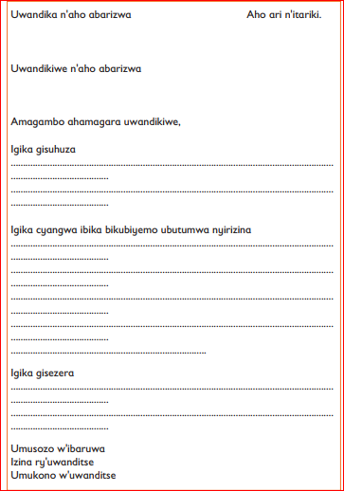
- Ibaruwa izaba iteye itya: (amanota 10)

