ECONOMICS S4 COMPREHENSIVE ASSESSMENT: MARKING SCHEME 2021

- Answer by true(T) or False(F) (4marks)
a=T, b= F, c= F, d=F
- (5marks)
MA-ICROECONOMICS MICROECOMICS | MACROECONOMICS
Individual demand, wages  individual supply, rent, profits price. | Inflation, aggregate demand, aggregate supply ;  employment level ; taxation policy.

3.a) The two features of resources that give rise to an economic problem are:
(i) Resources are limited and (1mark)
(ii) They have alternative uses. (1mark)
b) Goods purchased for consumption and investment are final goods. Example:
Machinery purchased by a factory. While good purchased for resale or for using up completely during year are intermediate goods. Example: Raw materials purchased by a factory.(distinction:2marks,examples:1mark=3marks)
4. In allocating resources in the production of goods and services, every entrepreneur faces fundamental economic questions to think about and to answer before starting to run her/his project. These questions are the following: (1mark x5= 5marks)

a) What to produce
Here the firm needs to decide on the nature of the goods to produce. The firm may decide to produce capital goods or consumer goods.

b) How to produce
The producer has to decide on the methods and techniques to be used in the production process. The producer may decide to use capital intensive techniques of production or labour intensive techniques of production. The technique of production minimizes costs while at the same time maximizes the level of output.

c) When to produce
The producer is required to decide whether to produce now or to produce in future. The producer is normally guided by the demand for the products in the market. The best time for production is when the demand for the goods or services is the highest.

d) Where to produce
The producer has to determine on the location of his or her firm or industry. The location will depend on availability of the market, the source of raw materials, security and transport and communication networks. All in all, a thorough assessment of the impact of that firm to the environment must be carried out and evaluated.

e) For whom to produce
The producer considers the target consumers that will use the goods to be produced. The producer may be for the young, the rich, the poor, the rural people or for the urban people.
Starting a production project without answering these questions first will lead to failure.

5.a) When the prices of factor inputs decreases, the cost of production decreases. Thus, it becomes more profitable to produce the commodity and so its supply will increase. (2marks)
b) When prices of other goods rise, it becomes relatively more profitable to produce these goods in comparison to the given good. This results in diversion of resources from the production of any given good to other goods. So, the supply of the good decreases. (2marks)

6.a) The consumer equilibrium is at E where the slope of indifferent curve = slope of budget line. (1mark)
b) The indifferent curve I2 is higher than indifferent curve I1 where the point C and D are lying on and so combination of commodity X and Y that lie on I2 gives more satisfaction than those that lie on I1.
The indifferent curve I2 is the highest indifferent curve in line with the income of the consumer. Father more the consumer is in equilibrium when the budget line is tangent to the indifferent curve. In our case this is at point” E”. The point C and D give lower satisfaction to the consumer and their cost are below the income of the consumers. (3marks)

c) The equilibrium quantity of X is 0X and the equilibrium quantity of Y is OY. (2marks)

7. 1mark x6= 6marks)

Endogenous factors | Exogenous factors
Fertilizers | Climate change
The size of land where rice is grown | Number of rice’s consumers
Price of rice
Number of rice’s consumers

8.a) The law of supply states that “Ceteris paribus, the higher the price the higher the quantity supplied and the lower the price the lower the quantity supplied”. However, it’s not every time that this law is obeyed. This leads to regressive supply curves which violate the law due to different factors as below.
- Fixed supply curve of land i.e. this is where the supply of land cannot change at whatever price offered. Fixed supply is mainly due to inability to change output in the market period due to difficult of varying the other factors in the short run.
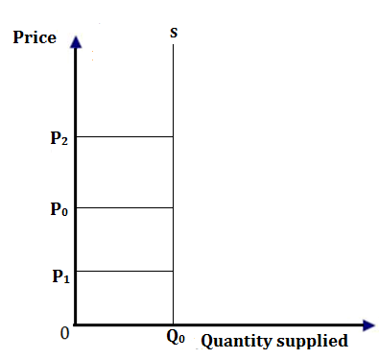
From the above illustration, even if prices increase from P0 to P2 or decrease P0 to P1 quantity supplied remain the same.
- Expectations of future price changes i.e. when the supplier expects prices to be higher in future they supply less at high prices in the market at present since they expect high profits at further high prices in future and vice versa.
- During periods of catastrophes e.g. Wars, drought, excessive rain etc. even if prices increase the supply cannot increase in such periods and vice versa.
- Ignorance of producers of the prevailing market prices thus may result into supply not increasing with increase in prices or reduce with the reducing prices.
- Seasonal changes e.g. for perishables more will be put into the market immediately after harvesting even if prices are low. If the fashion changes then the new fashion will replace the outdated one therefore the later will be put much into market even if prices are reducing.
- Backward bending supply curve of labour i.e. the supply curve of labour looks abnormal at high prices i.e. it slopes upwards from left to right for some part of the curve as shown below;
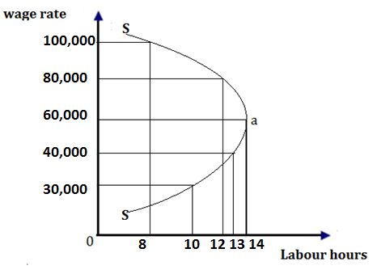
When the wage is increased from 30,000frw to 60,000frw, the supply of labour (hours worked per day) increases from 8 to 14 hours per day. Beyond wage of 60,000frw labour supply reduces to 10 hours When the wage is increased to 100,000frw. This creates a backward bending supply curve of labour. i.e. from point “a” upwards, the workers start working less hours a day therefore making the supply curve of labour regressive or abnormal.
Statement of the law of supply = 1mark, any 5 points explained each 1mark. (1 x 5marks) = (6marks).

9.i) Price is constant: As price means average revenue, so average revenue is also constant. Average revenue is constant only when marginal revenue is equal to average revenue. Thus, when a firm is able to sell more quantity of output at the same price marginal revenue is equal to average revenue. (2marks)

(ii) If more can be sold only by lowering the price, it means that average revenue falls as more is sold. Average revenue falls only when marginal revenue is less than average revenue. Thus, when a firm is able to sell more quantity by lowering the price, marginal revenue will be less than the average revenue. (2marks)

10. a) Elasticity of demand is a measure of the degree of responsiveness of quantity demanded of a commodity to changes in factors that affect demand. (1mark) While Price elasticity of demand refers to a measure of the degree of the responsiveness of quantity demanded of a commodity to changes in the price of that commodity. (1mark)

b) The relevance of the concept of price elasticity of demand to government:
(1mark x3=3marks)
- It helps government to determine commodities which it should control if demand is inelastic; government controls the marketing of the commodity to protect consumers from being exploited by private firm.
- It helps the government to decide whether to devalue the currency or not.
- It helps the government to trace the final resting of taxes (taxes incidences)
- The government can use elasticities to decide on whether to impose taxes on commodities or not.

- “As more and more units of a variable input are applied to the fixed factor in a given state of technology, the marginal product of the variable factor will eventually diminish.”

I Illustration
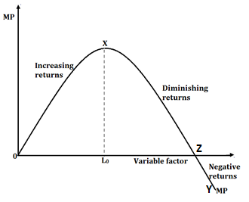
From the above illustration the law shows,
- Increasing returns: is shown by an increase in the MP which leads to the increased
utilization of the fixed factor by the variable factor.
- - Diminishing returns: this sets in after x when additional units of a variable factor, adds less and less to total product until point z when it adds on zero and thereafter MP becomes negative. Diminishing returns is due to over utilization of the fixed factor.
- We distinguish between points x and y. X is point of diminishing marginal returns beyond which MP starts declining. Point Y is the point of diminishing average returns beyond which MP starts declining.
(Statement of the law-1mark, assumptions-1mark, illustration-1mark explanation- 2marks. 5marks)

- Description of different production capacities.
- Optimum/ full capacity. This is a point of production by a firm where there is efficient and effective utilization of a fixed factor by the variable factor which results into higher returns by the firm. (1mark)
- Excess capacity refers to a situation where a firm is producing at a lower scale of output than it has been designed for. Or it is a situation where the firm is underutilizing its resources. (1mark)
- Over capacity is a point of production by a firm where the firm over utilizes the fixed factor by the variable factor. (1mark)
- This can be illustrated bellow:
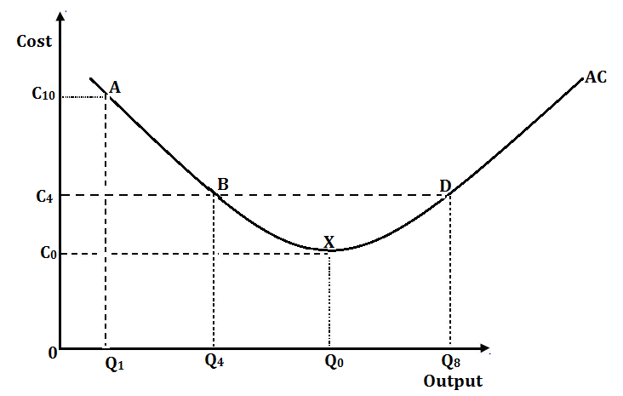 (2marks)

The figure above shows a firm’s capacity of resource utilization and the respective average costs. For example, below point “X” (points “A” & “B”) a firm underutilizes the fixed factor by the variable factor which shows excess capacity. At point “X”, the firm efficiently and effectively utilizes the fixed factor by the variable factor thus optimum or full capacity while after point “X” e.g. at point D, the firm over utilizes the fixed factor by the variable factor, thus over capacity. (2marks)
b) Why firms operate on excess:
- Use poor techniques of production.
- Poor and undeveloped market.
- Political insecurity where the firm is located.
- Limited market or less demand for the commodity.
- Inadequate skills used in production.
- Desire by the firm to restrict output and sell at a high price for profit maximization.
- A firm may be new and strategizing marketing policies.
- Poor and unfavorable government policies towards resource utilisation. Like high taxes.
- Small scale production that does not enable the firm to utilize resources efficiently.
- Limited capital to inject in business for proper exploitation of resources.
Any 8 points each 1 mark (1 x 8 = 8mks)

13. a)
= (-)÷ (1mark)
THAT IS ÷=÷= ÷% =÷=
(1mark)
EPD=-2.6 (1mark)
b) The coefficient of PED is 2.6 so the demand is price elastic, the demand responds more than proportionately to the change in price. ( 1mark)
% change in price of cake =%=-25% ( 1mark)
% change in demand for cake = =66% ( 1mark)
So the decrease in price from 80FRW to 60FRW per cake is profitable for the producer.
The 25% change in price leads to 66%change in demand. So the expectation of the producer is profitable ( 1mark)
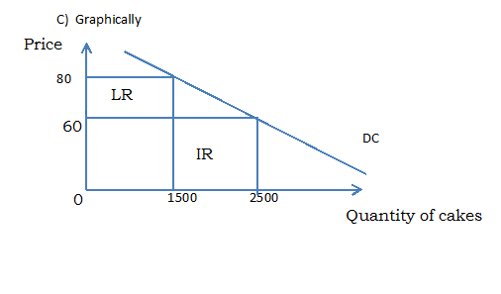
(3marks)

LR Is the area of lost revenue from the decrease of price; IR is the area of increased revenue from increased quantity of cake sold. LR <IR so the decrease of price from 80RFW to 60 FRW to increase quantity sold of cake from 1500 to 2500 cakes is Profitable. (1mark)
d) Mathematically:
- Before the decrease in price, the revenue was 80FRW x1500=120.000FRW (0.5marks)
- After the decrease of price to increase the quantity sold, the revenue will be 60FRW x 2500=150000FRW (0.5marks)
So 150000FRW > 120000FRW. The additional revenue after the decrease in price is 30000FRW. (1mark)
Lost revenue= -20FRW x15000=-30000FRW (0.5marks)
The gained revenue =60FRWx1000=60000FRW (0.5marks)
The total profit = 60000FRW -30000FRW=30000FRW.
So to decrease price to increase the quantity sold of cakes is profitable for the producer.
(1mark)
14 a) Completion of the marginal utility column (3marks)
Units consumed | Total utility | Marginal utility
1 | 20 | -
2 | 25 | 5
3 | 28 | 3
4 | 28 | 0
5 | 26 | -2
6 | 22 | -4

MU, from the 1st unit isn’t known because the TU before the 1st unit isn’t indicated. After the first unit TU is increasing but at a decreasing rate. After the 4th unit, TU declines because MU becomes negative due to disutility or negative satisfaction (utility) which sets in. For example, one can start vomiting after the 4th unit, a situation that reduces TU he/she had gained. (2 marks)

b)Relationship between TU and MU is such that: (3marks)
- When TU is increasing, MU is decreasing
- When TU is at the maximum, MU is zero
- When TU is decreasing, MU is negative. (Disutility)
c) The TU is increasing but at a decreasing rate. After the 4th unit, TU declines because marginal utility becomes negative due to disutility or negative utility which sets in. for example one can start vomiting after the 4th unit, a situation that reduces TU he or she had gained. (2marks)
d) Illustration of TU and MU curves using the information given.

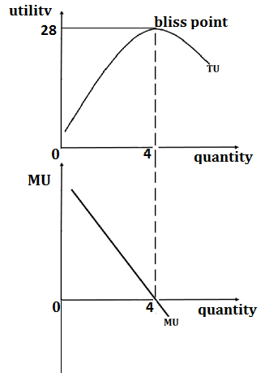
(2.5marks)

(2.5marks)

15) Price mechanism refers to a system of economic organization in a free enterprise economy where resource allocation and prices in the economy are determined by the forces of demand and supply with little or no government interference. (1mark)
Arguments for price mechanism include:
- The system is cheap because prices are automatically determined by the forces of demand and supply
- The system encourages flexibility because change in the market are guided by the price or profit signals.
- Wastage of resources are minimized because there is no under or over production.
- Consumer sovereignty is promoted i.e consumers choose what should be produced and wish to do and a variety of goods and services are produced.
- The system encourages high degree of competition which in return ensure efficiency and production of high quality
- under this system, consumer buy from cheapest source and therefore maximize utility.
- High employment opportunity are generated because high prices lead to increase in profits and increase of entry of new firms′ producers increased use of inputs or resources
- There is a wider tax base therefore increasing on the government revenue.
- Provides incentive to producers to work harder and more efficiently, hence there is efficiency in allocation of resources as well Owners of resources earn high incomes under mechanism
- Price encourages speculation i.e buying commodities when they are plenty and cheap and selling them in a period when they are scarce and at high prices .This helps to stabilize supply in future, making prices stable.
- Encourage inventions and innovations which improves on quality and quantity thus economic growth and development.
- It helps producers to know where to locate the production enterprise.
- It encourages geographical distribution of resources or arbitrage i.e commodities are taken from plenty to scarce areas regions which need to increased supply in those areas to stabilize prices and incomes as well.
Any 7 arguments for price mechanism, each 1mark. (1x7=7marks)
Arguments against price mechanism include:
- The system creates economic instability due to fluctuation in prices, income, revenue and exchange rates
- It makes economic planning difficult as the economy becomes unstable.
- It promotes income inequality because resources owners and business men become richer while other economic agents become poorer.
- Unemployment may arise especially when inefficient firms are outcompeted from industry.
- Disappearance of some vital or important commodities which are cheap and therefore not so profitable to innovate businessmen. This cause misallocation of resources.
- Emergency of monopoly firms which make a lot of profits.
- It leads to over exploitation and exhaustion of resources due to high profit motivate by the produces.
- Exploitation of consumers due to ignorance of consumers may end up paying high prices for commodities which they consume.
- Under this system private interests interfere with public interests.
- It doesn’t respond to rapid structural changes in the economy eg when there is a rapid change in demand resources may not shift accordingly as quickly as possible.
- It may sometimes result into distortion of the consumer’s choice i.e consumers buying commodities which they don’t need or which they may not need or which may not affordable through persuasive advertising and encourage impulsive buying.
- It ignores the poor and disadvantaged groups in society e. g the lame, the blind, the elderly orphans etc. who cannot compete with other in the society.
Arguments against price mechanism, each 1mark. (1x7=7marks)

16.a) An Entrepreneur is the person who takes the charge of supervising the organization of production and of framing the necessary policy regarding business. He/she is a person in charge of bringing together, organization, establishment of co-ordination and co-operation among other factors of production. i.e. land, labour and capital. (1mark)

The role of an entrepreneur includes the following.
- Initiates the business activity: He/she has to start the business activity by preparing a proper plan. The plan should deal with the type of goods or service to be produced, sources of raw material and credit, type of technology to be used, the markets where the products can be sold, etc. The plan should be detailed one covering all the aspects of the business.
- Entrepreneur organizes the factors of production: The entrepreneur has to collect all the other factors of production and combine them in the right proportion.
- Entrepreneur is a decision maker: Business involves variety of decisions to be taken relating to the purchase of productive factors and to the sales of the finished goods or services. He/she determines what to produce, how to produce, where to produce, how much to produce, how to sell and so forth (i.e. decide about the nature of product, technology, price policy, advertisement strategy, employment of labour, etc.) A proper strategy has to be adopted by him to take the right decision.
- Entrepreneur co-ordinates things effectively: A business firm consists of a number of departments. He/she has to co-ordinate various units effectively by having proper communication channels and supervision

- Management Control: An entrepreneur manages and controls the business. An entrepreneur must possess a high degree of management ability to select the right type of persons to work with him/her. However, the importance of this function has declined, as the businesses nowadays are managed more and more by paid managers.
- Division of income: An entrepreneur makes necessary arrangement for the division of total income among the different factors of production employed by him/her. Even if there is a loss in the business, he/she is to pay rent, interest; wages and other contractual income out of the realised sale proceed.
- Risk-taking and uncertainty-bearing: An entrepreneur takes risks required to produce goods or services in anticipation of their future demand. I.e. business can be faced with measurable and insurable risks (like risks of fire, loss of goods in transit, theft, etc.) and uncertainties (uninsured risks e.g., competitive risk, technical risk, changes in tastes, fashions etc.). all which are undertaken by the entrepreneur. While facing these uncertainties entrepreneur may get profit or may incur loss. Thus, risk and uncertainty bearing is one of the unique function of an entrepreneur.
- Entrepreneur tries to introduce innovations: An entrepreneur introduces innovations by introducing new products, discovering new products, introducing new technology or new methods of production, discovering new markets etc. in order to improve his/her competitive position, and to increase earnings. The entrepreneur may get profit or may incur loss.
-Entrepreneur handles budget of his/her business: The entire budgeting process is the responsibility of the entrepreneur. He/she has to mobilize resources for the implementation of the business plan. All other factors have to be paid contractual payments. He/she gets the residual income, he/she has to make provision for future investments for expansion and diversification. He/she has to maintain a balance between income and expenditure.
Definition of an entrepreneur = 1mark, any 7 points each 2markS = (2markS x 7= 14marks)

