**MARKING GUIDE FOR S4**

1. A=b ; B=b ; C=c ; D= a E= d

2. a) Final goods are Goods purchased for consumption and investment.

Example: Machinery purchased by a factory **(1mark)** .While intermediate goods are goods purchased for resale or for using up completely in the production process. Example: Raw materials purchased by a factory **(1mark)**

b) I disagree with this statement. The machine purchased is not always a final good. Whether ‘machine’ is a final good or not depends on how it is being used. **(1mark)**

- If the machine is bought by a household, then it is a final good. **(1mark)**

- If the machine is bought by a firm for its own use, then also it is a final good.

**(1mark)**

- If the machine is bought by a firm for re-sale then it is an intermediate good.

**(1mark)**

3. Basic principles of economics are useful in the daily economic life. After learning about them, my behavior in **making decisions** has **changed by changing my** **thinking pattern**. When I have to make some decisions, I try to

Compute the **utilities and opportunity costs**of each **selection. (2marks)**

For example as a student , I need ice scream and notebook, I have a limited amount of money to buy one of the two .After computing the utility of the two , I decided to buy the notebook for my studies which will help me to have income in the future and buy other things I will need. **(2marks)**

4. a) **Price of factor Inputs**: If factor input price increases, cost of production generally rises,  
accordingly producers are willing to supply less at the existing price as the profit probability decreases. This implies leftward shift in supply curve and vice-versa, keeping other factors constant.  
b) **State of Technology:** Improvement in technique of production raises productivity and generally lowers per unit cost of production, consequently the probability to earn more profit also increases and hence the producer is induced to supply more, as a result supply curve shifts towards right.  
c) **Government Taxation Policy:** If government increases taxes, it will affect the cost of production adversely and hence supply decreases. But if Government decreases the tax the cost of production will fall and the producer will be induced to increase the supply of the commodity, ceteris paribus.

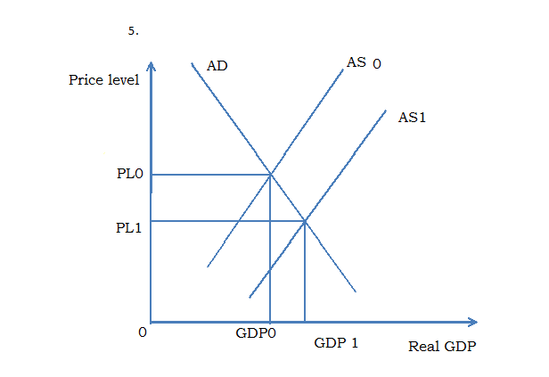 Captions: (price level ,PL0, PL1, AD, AS0, AS1, DGP0, GDP1, Real GD) =

**(2, 5marks )**

Curves (AD, AS0, AS1) = **(1.5 marks)**

Real GDP and Price level axis = **(1mark)**

6.a) **Consumers' tastes and preferences:** Assume that other things remaining  
constant, if a consumer has more taste and preference for a good than other goods, then the demand for this good will increase. On the other hand, if a  
consumer has no taste and preference for a good than other goods, then the demand for this good will decrease and even its demand should be 0 for him or her.

b)  **Future expectations**: Future expectations about the price and availability

of the commodity also affect the demand for the commodity. For instance, if

the consumer expects that there would be a shortage of the commodity in  
the future, and then he will increase the demand even at the existing price.

7. a) At equilibrium price and quantity the demand = supply **(1mark)**

So to get equilibrium price we equalize QD=Qs, from our data, Qd=200-P,

QS= 50+2P ; 200-P = 50+2P **(0.5marks)**

-P - 2P=50-200 ; -3P=-150; 3P=150; P=50.

The equilibrium price is P = 50. **(0.5marks)**

1. - Substituting P buy its value in demand equation we get equilibrium quantity of demand: Dd=200-50= 150. **(0.5 marks)**

The equilibrium quantity of demand = 150 **(0.5 marks)**

Substituting P by its value in the supply equation we get the equilibrium quantity supply. QS=50+2P; QS= QS=50+2(50) **(0.5marks)**

=QS= 50+100=QS=150.

The equilibrium quantity supply is 150. **(0.5marks)**

8.

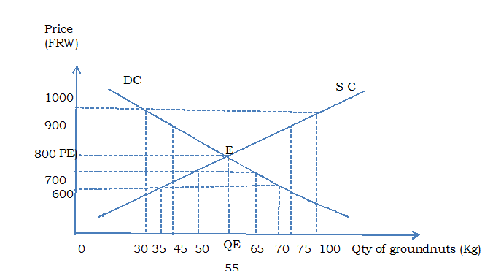

Curves DC, SC = **2marks,** (PE, QE, E) = **(1.5marks)**

The rest of diagram= **(1.5marks)**

9.a) ‘How to produce’ is the problem of choosing the technique of production.

Techniques are broadly classified into capital intensive and labour intensive. In free market economy the cost effective method of production is the one chosen.

**(2marks)**

b) With free market economy you have the following rights:

* To buy and where and what you please, if you do not like the goods and services of one business, you can go to another.
* To organize with other workers as you are a worker and through organization you can strive to improve working conditions
* To travel when and where you please in the country and out of the country.
* To express your opinion in different Medias and talking with others.

**(1mark x3 =3marks)**

10. a) Each filled number is rewarded with **0.25 marks** , the total marks for the table is **4 marks**

|  |  |  |  |  |
| --- | --- | --- | --- | --- |
| Number of workers (L) | Land (fixed in hm2) | Total product (TP) | Average product(AP) | Marginal product (MP) |
| 1 | 200 | 4 | 4 | 4 |
| 2 | 200 | 14 | 7 | 10 |
| 3 | 200 | 25.5 | 8.5 | 11.5 |
| 4 | 200 | 40 | 10 | 14.5 |
| 5 | 200 | 60 | 12 | 20 |
| 6 | 200 | 72 | 12 | 12 |
| 7 | 200 | 77 | 11 | 5 |
| 8 | 200 | 80 | 10 | 3 |
| 9 | 200 | 81 | 9 | 1 |
| 10 | 200 | 75 | 7.5 | -6 |

1. i) The point of diminishing marginal returns is where MP =20, where 5 people are employed. Beyond that point MP decreases. **(1 mark)**

ii) The point of diminishing average returns is where AP=12 where 6 workers are employed. Beyond that point AP decreases. At this point, as we know, MP= AP and AP is maximum. **(1 mark)**

11. Minimum price legislation (price floor) is the lowest price fixed by the government above the equilibrium price below which it is illegal to buy or sell commodities. Fixing price above the equilibrium market price would cause the following problems:

- High price for goods and services may result into inflation

- Prices fixed above equilibrium may be so high that they may discourage incentive to work.

- This strategy may be hard for the government to implement since sellers and buyers are willing to buy and sell at equilibrium price.

- Potential investors are likely to be scared by high minimum wages

- Surplus output due to fixed minimum prices may lead to wastage of resources invested.

- This practice interferes with the operation of price mechanism.

- Labour should claim for increasing wage and consequently cost of production is likely to increase due to the increasing price for labour.

- Government may fail to achieve the objective of minimum price legislation, due to surplus output which may force producers to accept even lower prices.

* Dumping of surplus output is possible. **(1mark x6=6marks)**

12. - Demand may be higher in the USA due to e.g. **higher incomes** in USA

**(1mark)** - The product may **be advertised** more in the USA, the product A may have fewer **substitutes** in the USA **(1mark)**

* **Difference in markets**, monopoly in USA, lower output, higher prices, greater competition in China , greater output and lower prices **(3marks)**
* **Good may be imported from china**; higher transportation costs raises price in USA **(1mark)**
* **Supply may be lower** in the USA due to e.g. higher costs of production

**(1mark)**

- The tax on the product A may be higher in the USA **(1mark)**

* The Chinese government may subsidize the production of product A

**(1mark)**

* Demand may be more inelastic in USA hence producers can charge higher price. **(1mark)**
* Diseconomies of scale in the USA lead to higher average costs and higher prices **(2marks)**
* Economies of scale in China lead to lower average costs and lower prices

**(1mark)**

- Chinese **exchange rate** has fallen, will mean difference in the price of goods imported resulting in higher costs of importing into the USA **(2marks)**

13. i) The implicit cost in the passage is noise, water and air pollution. They are implicit cost because they are social cost, they cannot be computed in the profit or in the loss of the firm, and they cannot be easily monetized. **(2marks)**

ii) The explicit costs are cost of land (15000000FRW), cost of construction

20,000, 000FRW, cost of raw material 12, 000, 000FRW, the cost of machinery 100,000,000FRW.  **(1mark)**

They are explicit cost because they are the costs of the specific cost of the firm; they are cost of input, factors of production. **(1mark)**

iii) Total fixed cost: 15, 000, 000TRW + 20,000,000FRW +100, 000, 000FRW= 135,000,000FRW. **(1mark)**

iv) The total variable cost = 12000FRW +12,000,000FRW=12,012,000FRW

**(1mark)**

v) The average variable cost= 12012000FRW÷2=6,006,000FRW **(1mark)**

vi)The average fixed cost = 135,000,000FRW÷3= 45, 000, 000FRW **(1mark)**

b.) Paul has refused to merge his firm with the John’s. His refusal has the following reasons:

**- Fear of diseconomies**: Paul may prefer to remain independent due to fear of disadvantages of large scale production which may arise with merging.

**- Paul may have fear of complexity of management of merged firms:** merging may create complex managerial problems due to combining different groups originally from different firms operating under different situation.

**- Fear of losing clients:** Paul normal has his clients, he fears to lose them after merging his firm with John’s.

- **Fear of losing independence**: Paul may not want to merge his firms with the John’s in fear to lose his independence and being dominated by the new large firm.

**- Market limitation**: Paul has a monopoly firm in the area; the market potential after merging may favour the competition rather than quasi monopoly that is why Paul prefers to remain independent.

**-Fear of unemployment:** May Paul like all his employees. He doesn’t want lose some of them after merging his firm with Johns’s.

**- Fear of high tax:** Paul fears merging his firm with john’s because of higher tax that he actually pay. Large firms face more taxes as compared to several small-scale firms.

**- Fear of heavy losses:** merging may increase the losses for a single large-scale firm as compared to a small-scale firm.

**- Government legislation:** Paul knows that government may refuse to merge his firm with John’s in order to avoid the big influence of monopoly which may arise from merging.

**- Fear of risk:** Paul has refused to merge his firm with the John’s because he fears the risks associated with the large firm. **(1mark x7=7marks)**

14. a) PED= (-)÷  **(1 mark)**

THAT IS ÷=÷= ÷% =÷=

PED=-2.6 **(1 mark)**

b) The coefficient of PED is 2.6 so the demand is price elastic, the demand responds more than proportionately to the change in price.

% change in price of cake =%=-25% **(1mark)**

% change in demand for cake = =66% **(1mark)**

So the decrease in price from 80FRW to 60FRW per cake is profitable for the producer because the 25% change in price leads to 66% increase in demand.

**(1mark)**

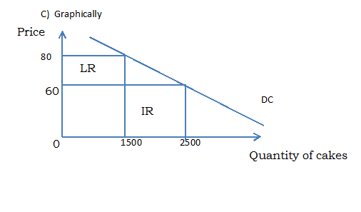

**(2marks)**

LR Is the area of lost revenue from the decrease in price

IR is the area of increased revenue from increased quantity of cake sold. LR <IR so the decrease of price from 80RFW to 60 FRW to increase quantity sold of cake from 1500 to 2500 cakes is Profitable. **(1mark)**

d) Mathematically:

- Before the decrease in price, the revenue was 80FRW x1500=120.000FRW

**(1mark)**

- After the decrease of price to increase the quantity sold, the revenue will be 60FRW x 2500=150000FRW **(1mark)**

So150000FRW >120000FRW. The additional revenue after the increased price is 30000FRW.  **(1mark)**

Or lost revenue= -20FRW x15000=-30000FRW

The gained revenue =60FRWx1000=60000FRW

The total profit = 60000FRW -30000FRW=30000FRW.

So the reduction of price to increase the quantity sold of cakes is profitable for the producer.

(The total profit is 30000FRW per week)

1. It is true that the government needs to have the knowledge of elasticity of demand, in its daily economic life government applies the knowledge of elasticity of demand as shown below : **(1mark x4=4marks)**

* The government uses the knowledge of elasticity of demand in its rationalization policies .e.g it should nationalize industries that are owned by monopolists and produce goods experiencing inelastic demand.
* The knowledge of income elasticity of demand can be used to levy excise duties on goods that are mainly consumed by wage earners. E.g excise duties can be increased by the government, on goods that are commonly purchased by employed wage earners after upward adjustment in wages.
* The knowledge of elasticity of demand is also applicable during the devaluation of a country’s currency in an endeavor to attain a better balance of payments position.
* Before devaluation government should know if both imports and exports are elastic for devaluations to be successful.
* In order to increase tax revenue, the government should tax more commodities with inelastic demand.
* Price elasticity of demand helps the government to determine the tax induces which helps the government to know if it is up the consumer to bear or if is up to consumer. For example if demand is elastic the tax burden is shared by both consumer and producer.

15. GAFARANGAZI‘s firm production process organization is driven in specialization and division of labour. In this economic situation, laborer concentrates in the production of one or very few commodities. Each worker is assigned a task she or he is most effective and efficient. This has the following advantages:

- Efficiency and ability of labour are increased because there is repletion of task which results into efficiency at operation of that single task.

- Time is saved: time that would have been wasted in moving from one job to another is converted into another productive quality activity.

- Increased production: When a worker concentrates on production of a given product, his or her productivity increases. This increases output thereby reducing cost of production.

- More employment opportunities are created: many occupations and tasks are created for the different diverse skills.

- Better quality commodities are created: well performed labour in his task produces high quality product.

- Gafaranga’s production is competitive on international market because of its high quality and father more his products should have better comparative advantages.

- Gafaranga’s firm contributes to economic development because it produces for the market.

-In this firm cost and time of training are reduced: training on a single task takes a low time at low cost, the training is simple.

- Increased Occupation mobility of Gafaranga’s firm labour, executing the same task, labour become professional in their tasks and this increases their mobility.

- The use of machine is simple because the job is divided into series of occupations and machines are specialized in their nature.

**This production process has also disadvantages:**

Repeated tasks lead to monotony and boredom. This reduces pleasure on the job, leads to job dissatisfaction, reduces efficiency and affects production.

* In this production process leads to interdependence which results into delays in production, inefficiency and losses in case of a breakdown in the process of production for example if a worker is sick.
* In the Gafaranga’s firm each worker is over specialized in one tasks and this increases the risk of unemployment if the worker is laid off.

- Workers in the Gafaranga’s firm loss creativity and responsibility. Because of division of tasks for one product, if the production is not up to the required quality, none of the workers is held responsible since it is a product of the responsibility of everybody.

- Gafaranga’s workers have little mobility because they can handle only part of the whole task. It is difficult to found elsewhere they can perform the same tasks they perform in Gafaranga’s firm.

- Gafaranga’s firm should overproduce due to specialization. , if the market is limited, Gafaranga should incur losses.

- Gafaranga may incur losses even close the firm’s door because of introduction of other firms producing the same products with new fashion in line with new people’s taste.

16. a.i) Gakire’s firm enjoys the external economy of scale which is growing of maize nearby the firm. **(1mark)**

ii) The use of software technology is the internal economy of scale enjoyed by the firm. **(1mark)**

1. Gakire ‘s firm , after 2012 was able to reduce the price of maize flour without making a loss because of the following reasons :

* The firm had enough clients for its production
* The firm has increased production of its product to satisfy the high market demand.
* Since the raw material is produced nearby the firm the cost of transport became very low.
* As a monopolist, Gakire should fix the price of maize as raw material in his favor. In this case Gakire is able to reduce the price of maize flour without making a loss.
* The use of the software technology to facilitate the stock control, transport and distribution of his product makes his business efficient and this increases the returns. **(1mark x5= 5marks)**

1. The profits made by Gakire should play the following role in his production :

* Profits should help Gakire to allocate efficiently his resources

* Profits made are a reward for Gakire and helps him to undertake risks insurance and uncertainties in his business. With profits he can produce more maize flour or undertake himself the production of raw materials which is maize.
* With the profit, Gakire can buy efficient machine in order to produce effecientry.
* Profit can help Gakire to expand his firm and make more profits
* Profits can help Gakire to make innovation and creativity in Maize flour production and make more and more profits which may act as incentive for technological progress and then Gakire’ s firm may contribute to economic growth of his country.
* Profits can help Gakire to sell his product where it is more profitable.
* Profits can help Gakire to ensure the welfare of himself and of his family so that he can work efficiently.
* Profits can act like a bonus to Gakire for coordination and combination of factors of production in the right ways so as to minimize costs and maximize output.
* More profits for Gakire imply more capacity of paying tax. So the government has the duty to protect his business and subsidize it if necessary. **(1mark x8= 8marks)**

**The following are the answers for the questions reserved to blind Candidates:**

**5. a) Government policy may influence the supply of commodities: Government policy may encourage or discourage supply .Government policy in form of taxes, incentives and legislation may encourage or discourage the supply of commodity.** :

- Reduction of taxes encourages investment hence increases supply while overtaxes discourage investment hence deceases supply of a commodity,

**(1mark)**

- If government gives incentive to the production of a commodity, it encourages its production hence increased supply of it. **(1mark)**

- Government may discourage the supply of commodity by applying a ban on a commodity completely reduces its supply to zero. It may limit the supply of a commodity by limiting the number of licensed producers and suppliers and hence limit supply. **(1mark)**

b) The level of technology may influence the capacity of the producers and suppliers:

- Modern technology helps to increases output and supply of commodity while backward and inefficient technology results into low output and hence low supply of commodity.  **(2marks)**

8. a.i) In last 10 years the price of rice per kg increased from 500 FRW to 750FRW. While the supplied quantity increased from 50 kg to 100kg.

i) PED= $=\frac{\% change in quantity supplied }{\% change in price }$ **(0.5 marks)**

$=\frac{∆QS X Y }{∆P x QS}$ = $\frac{(100-50)500}{\left(750-500\right)50}$ = $\frac{50 X 500 }{250 x 50}$ = 2 **(1.5marks)**

The price elasticity of supply is 2.

ii) The obtained answer shows that the supply is elastic, PES is greater than 1.

**(1mark)**

b i.) **Competitive supply** occurs when different products are produced using the same resources. An increase in the supply of one would mean less resources available to the other and so a reduction in its supply.

**(1mark)**

ii) **Joint supply** is when two or more commodities are produced together such that the production of one leads to the production of the other. Example Beef and hides **(1mark)**

14. a) PED= (-)÷  **(1 mark)**

that IS ÷=÷= ÷%

=÷=

PED=-2.6 **(1 mark)**

b) The coefficient of PED is 2.6 so the demand is price elastic, the demand responds more than proportionately to the change in price.

% change in price of cake =%=-25% **(1mark)**

% change in demand for cake = =66% **(1mark)**

So the decrease in price from 80FRW to 60FRW per cake is profitable for the producer because the 25% change in price leads to 66% increase in demand.

**(1mark)**

d) Mathematically:

- Before the decrease in price, the revenue was 80FRW x1500=120.000FRW

**(0.5marks)**

- After the decrease of price to increase the quantity sold, the revenue will be 60FRW x 2500=150000FRW **(0.5marks)**

So150000FRW > 120000FRW. The additional revenue after the increased price is 30000FRW.  **(1mark)**

Or lost revenue= -20FRW x15000=-30000FRW

The gained revenue =60FRWx1000=60000FRW

The total profit = 60000FRW -30000FRW=30000FRW.

So, the reduction of price to increase the quantity sold of cakes is profitable for the producer.

(The total profit is 30000FRW per week)

1. **(4marks)**

|  |  |
| --- | --- |
| Fixed inputs | Variable inputs |
| Machinery (ovens , mixers and slicers) | Law materials (wheat flour , salt , water , sugar, eggs , milk ) |
| Factory premise | Labour (bakers , potters |

1. It is true that the government needs to have the knowledge of elasticity of demand, in its daily economic life government applies the knowledge of elasticity of demand as shown below : **(1mark x4=4marks)**

* The government uses the knowledge of elasticity of demand in its rationalization policies .e.g it should nationalize industries that are owned by monopolists and produce goods experiencing inelastic demand.
* The knowledge of income elasticity of demand can be used to levy excise duties on goods that are mainly consumed by wage earners. E.g excise duties can be increased by the government, on goods that are commonly purchased by employed wage earners after upward adjustment in wages.
* The knowledge of elasticity of demand is also applicable during the devaluation of a country’s currency in an endeavor to attain a better balance of payments position.
* Before devaluation government should know if both imports and exports are elastic for devaluations to be successful.
* In order to increase tax revenue, the government should tax more commodities with inelastic demand.
* Price elasticity of demand helps the government to determine the tax induces which helps the government to know if it is up the consumer to bear or if is up to consumer. For example if demand is elastic the tax burden is shared by both consumer and producer.