BIOLOGY

22/11/2019 08.30 AM - 11.30 AM

28/11/2017 08.30 AM - 11.30 AM

S5 END OF YEAR EXAM, 2019

SUBJECT: BIOLOGY

COMBINATIONS: - PHYSICS-CHEMISTRY-BIOLOGY (PCB)
-MATH- CHEMISTRY-BIOLOGY (MCB)
- BIOLOGY-CHEMISTRY-GEOGRAPHY (BCG)
DURATION: 3 hours.
Marks: 100
INSTRUCTIONS TO CANDIDATES:
- Do not open this question paper until you are told to do so.
- Section A: Attempt all questions .( 70 marks )
- Section B: Attempt any three questions of your choice. ( 30 marks)

SECTION A: Attempt all questions (70 marks)

- The figure below shows part of a tropical rainforest. Tropical rainforests have a higher biodiversity.
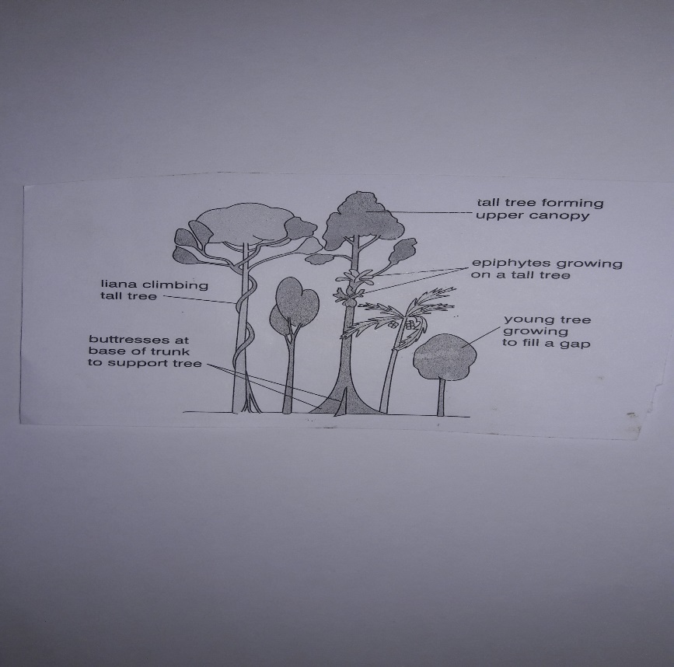

- Explain what is meant by Biodiversity? (2 marks)
- Suggest why tropical rainforests have a high biodiversity. (2 marks)
2) Suggest why active transport is affected by changes in oxygen
concentration but diffusion is not. (2 marks)
3 a) Distinguish between a nucleoside and a nucleotide. (2 marks)
4) The figure below shows a cell at various stages in the Mitotic cell cycle.

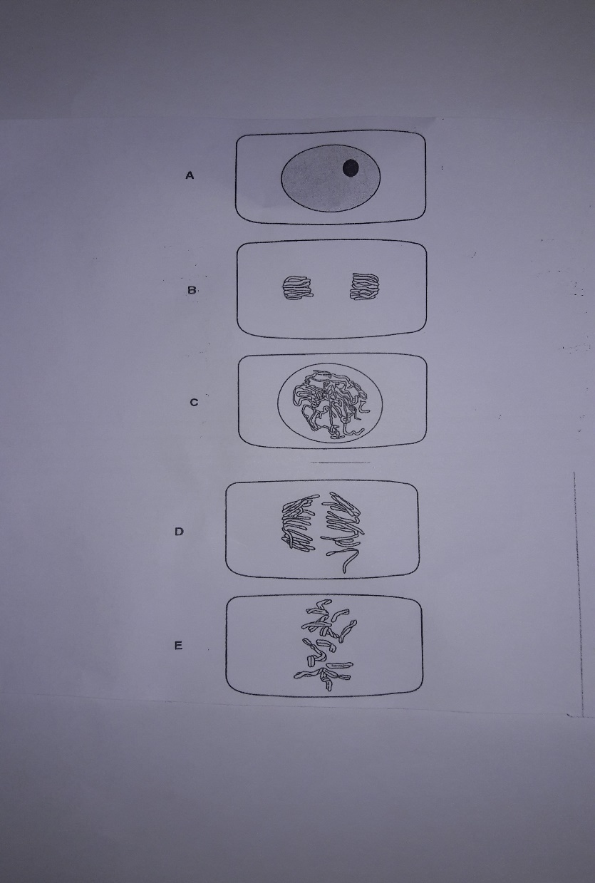
- Arrange the letters in order in which these stages occur during Mitotic cell division. The first stage has been entered for you.

A (1 mark)

- Explain what is happening in stage D. (2 marks)
- Describe what happens to DNA in the nucleus during stage A.
(3 marks)
5 a) State precisely where the dark stage of photosynthesis occurs in plant
cells. (1 mark)
b) Describe how carbon dioxide is fixed in the dark stage of
photosynthesis. (2 marks)
c) Explain how the products of photophosphorylation are used in the
Calvin cycle (Dark Stage). (2 marks)
6) The enzyme amylase catalyses the following reaction.
Starch + Water Maltose
The progress of this reaction may be followed by measuring either the starch concentration or the maltose concentration at intervals of time. State the chemicals you would use to detect the disappearance of the substrate and appearance of the product, in order to follow the progress of the reaction.
Disappearance of Substrate……………………………………............................
………………………………………………………………………………… (2 marks)

Appearance of Product…………………………………………………………………..
…………………………………………………………………………………… (2 marks)
7 a) Haemoglobin is a globular protein with quaternary structure.
Explain. (2 marks)
b) Explain why people who have a deficiency of iron in their diet are
lacking in energy and feel tired (2 marks)
8 a) Nicotine is the drug in tobacco smoke. State two effects of nicotine
on the cardiovascular system. (2 marks)
- People who have smoked cigarettes for many years are at risk of
developing lung cancer. Describe how cigarette smoke is responsible for
the development of lung cancer. (2 marks)
9 a) Sometimes a gene has more than two alleles, termed multiple alleles.
The ABO blood group system in human is controlled by a gene with
three alleles, I^{A}, I^{B} and I^{O}. Alleles I^{A} and I^{B} are codominant and I^{O} is
recessive to both. The AB group is the result of codominance. Explain
what is meant by codominance. (2 marks)
b) In humans, a gene that codes for the production of a protein called
factor VIII, is located on the X chromosome. The dominant allele
for this gene produces more factor VIII, but the recessive allele does
not produce factor VIII. A person who is unable to make factor VIII
has Haemophilia in which blood fails to clot properly.
Explain why a man with haemophilia can not pass haemophilia to his
son but may pass it to his grandson. (2 marks)

10 a) The steroid hormone Oestrogen and Progesterone are secreted by
the ovary. State exactly the sites of secretion of each.
Oestrogen…………………………………………………………………………
Progesterone………………………………………………………… (2 marks)
b) In girls, the first menstrual cycle occurs at puberty. Outline the
roles of progesterone in human menstrual cycle (3 marks)

11 a) Glucose is a respiratory substrate. The table below shows the
yield of ATP for other substrates.
Respiratory Substrate | Number of TP Molecules produced per mole of substrate
Alanine(an amino acid) | 15
Glycogen | 39
Lactate | 18
Palmitic acid(a fatty acid) | 129

(i) Explain the different yields of ATP from glycogen and palmitic acid.
(2 marks)
(ii) Describe the circumstances in which Alanine and Lactate are used
as respiratory substrates.
Alanine………………………………………………………………………………..
Lactate………………………………………………………………… (2 marks)
b) Outline the roles of oxygen in aerobic respiration. (2 marks)
12) The table below shows concentration of some compounds in the fluids of
a glomerulus, a renal capsule and a collecting duct of kidney.

Compound | Concentration/g*100 cm⁻³
Water | 90 | 90
Proteins | 8.0 | 0.0 | 0.0
Glucose | 0.1 | 0.1 | 0.0
Urea | 0.03 | 0.03 | 2.0

With reference to the table:
(i) Explain why proteins occur in the blood entering the glomerulus but not in the filtrate in the renal capsule. (2 marks)
(ii) Explain why there is glucose in the filtrate but not in the urine.
(2 marks)
(iii) Explain the differences in the concentration of Urea between the
Filtrate and the Urine (2 marks)

13) Fill in the spaces with the appropriate biological terms.
Enzymes act as biological…………………………. They are
……………. proteins that have a specific shape within which there is a
functional portion known as the ………………….. Enzymes lower the
…………………… of the reaction allowing it to proceed at a lower
temperature than it would normally. (4 marks)
- ) a) Suggest reasons for pregnancy prevention. (2 marks)
b) Abstinence is the most efficient method for young people to avoid
pregnancy. How do you think this method is efficient?
- marks)
- a) An ecosystem may be as small as a pond or as large as a forest.
Some scientists consider that the whole biosphere is an ecosystem.
Give a detailed definition of the term “ecosystem”. (3 marks)
b) In 1978, the American ecologist published a book with a title ‘Why
Big Fierce Animals are rare?’. What could have happened to these
animals? (3 marks)
- a) Measles is an infectious disease, while Lung cancer is not.
- Explain why Lung cancer is sometimes referred to as a ‘Lifestyle disease’ (2 marks)
- State the type of pathogen that causes Measles and its mode of
transmission.

Pathogen................................................................................
Transmission............................................................. (2 marks)

SECTION B: Attempt any three questions (30 marks)
17) Liver is a vital organ. Justify this statement with respect to glucose
Metabolism. (10 marks)
18) People are aware of the dangers of Malaria and yet it has persisted.
Using your knowledge of biology, suggest to your relatives how they can
eliminate malaria. (10 marks)
19 a) What is meant by the term conservation of nature? (2 marks)
b) How can we conserve our Forests? (8 marks)
20) Explain how the amount of water in your body is regulated. (10 marks)
21 a) Outline the causes of Water pollution. (5 marks)
b) What are the effects of water pollution? (5 marks)

