

**Biology and Health sciences**

**25/10/2019**

**8h30 am -11h30am**

**SENIOR TWO END OF YEAR EXAMINATIONS, 2019**

**SUBJECT: BIOLOGY AND HEALTH SCIENCES**

|  |
| --- |
| **/100**  **Marks:** |

**DURATION: 3 HOURS**

**INSTRUCTIONS:**

1) Do not open this question paper until you are told to do so.

2) Answer all questions in section A. **(70 mark)**

3)Answer three questions in section B. **(30 marks)**

4)Use only a **blue** or **black** pen.

**SECTION A: Attempt all questions (70 marks)**

1. Name **one characteristic** feature common to fish, reptiles and birds but not found in mammals. **(1mark)**

2) Glycogen is **(1mark)**

1. a polysaccharide found in animal cells.
2. an energy-storing lipid molecule.
3. a molecule in which plants store sugars.
4. a polysaccharide found in plant cell walls.

3) Animals and plants carry out common life processes like exchanging gases and excretion.

Copy and complete the table to name or describe processes common to all animals and plants.

|  |  |
| --- | --- |
| **Name of the life process** | **Description** |
|  | Living things produce offspring |
|  | Living things get bigger and develop |
|  | Living thing change the position of their body, or part of their body |
| Respiration |  |
| Feeding or nutrition |  |
|  | Detects and respond to changes in the environment. |

(**6marks)**

4 a)Give a classification of each of the following under the following taxa: **phylum** and **class.**

(i) Spider **(**ii) Toad (iii**)**Elephant.

**USE** the table below to answer the question:**(3marks)**

|  |  |  |
| --- | --- | --- |
| **ANIMAL** | **PHYLUM** | **CLASS** |
| i) spider |  |  |
| ii)Toad |  |  |
| **iii) Elephant** |  |  |
|  |  |  |

b) State three characteristics that are used to divide the arthropoda phylum into classes.

**(3marks)**

5) The diagram shows the human breathing system

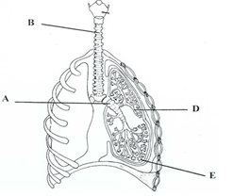

1. Name the parts labelled A, B, C, D, E. (**4 marks)**
2. Where do cilia occur in this system? What is their function? (**2marks)**

(iii) State precisely the events that take place at E. How

is E adapted for these events?(**2marks)**

6) Ebola is a viral disease which is spread through direct contact with infected body fluids. For

instance,blood, stool, sweat, vomit, urine, semen, or breast milk. Suggest four measures that

might limit the spread of this disease. **(4 marks)**

7 a) What is an enzyme? **(2marks)**

b) Describe the characteristics of enzyme.**(4 marks)**

c) What role is played by enzymes in the germination of maize?**(3marks)**

d**)** The reaction below illustrate an enzyme catalyzed reaction

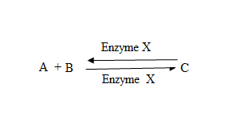

Give any 3 factors that affect the rate of enzyme activity**(3marks)**

8) The diagrams below represent types of cells.

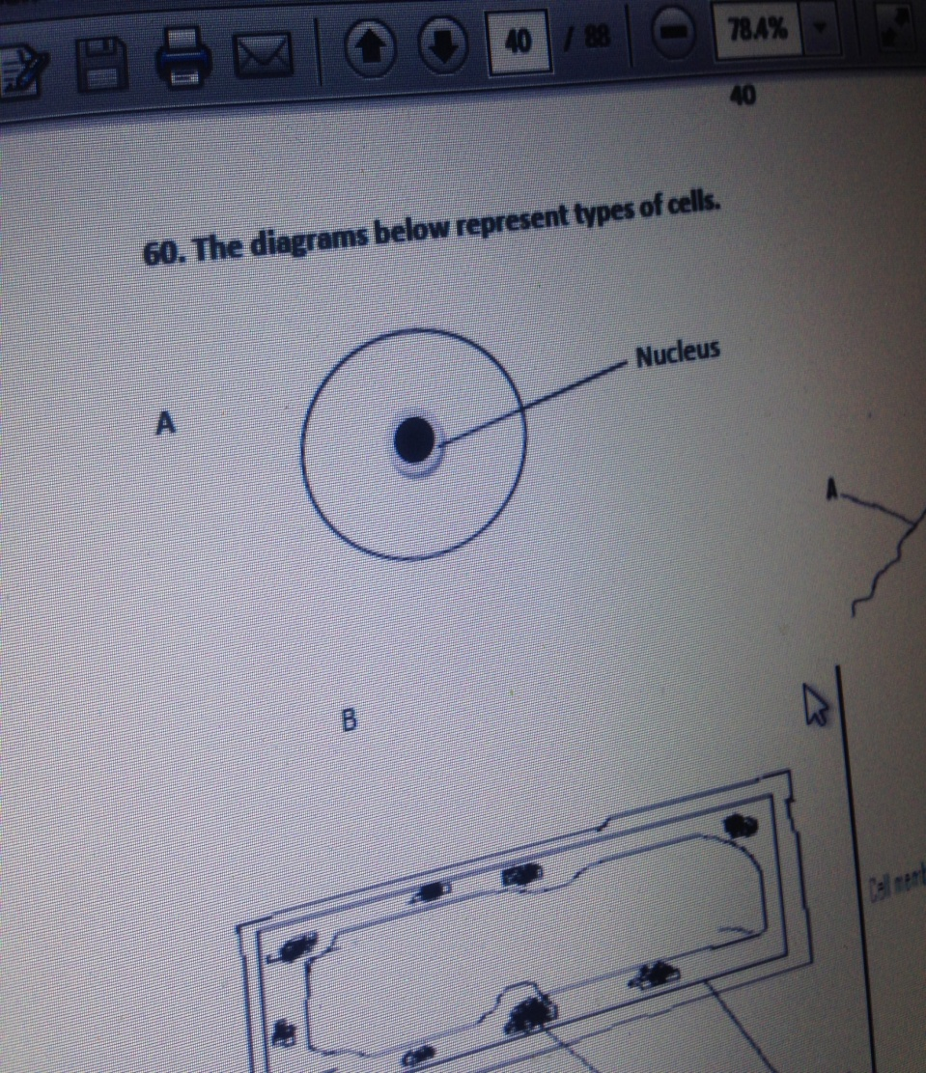

A



C D

a) Which diagram A, B, or D shows a plant cell? Explain your answer.**(2marks)**

b**)**What is synovial joint? (**1mark)**

c) What function does each of the following have in a joint.

(i) A tendon **(1mark)**

(ii) A ligament. **(1mark)**

(iii) Synovial fluid. **(1mark)**

(iv) A cartilage.**(1mark)**

9 a) The diagram below shows part of the system that controls the amount of water in the body.



(i) Name and give the function in each part named A, B and C. **(3marks)**

(ii) For each organ below give its excretory product **(3marks)**

|  |  |
| --- | --- |
| **ORGAN** | **EXCRETORY PRODUCT** |
| **Kidney** |  |
| **Skin** |  |
| **Lungs** |  |

10) Study the following food web.

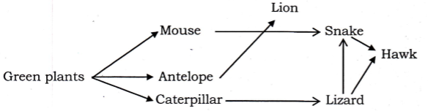

a) Give a name of one secondary consumer. **(2 marks)**

b) What would happen if the lions were attacked by a strange disease and died in large

numbers?(**2marks)**

11) Some students set up the equipment below to investigate osmosis.



a) Define Osmosis. **(2marks)**

b) What will happen to the water level in the capillary tube during investigation of Osmosis?

(**2marks)**

c) Use your knowledge of osmosis to explain why this happens. **(5marks)**

d) A red blood cell when is put in a beaker containing pure water eventually bursts but a plant

cell never burst in pure water. Using your knowledge of osmosis explain why this happens.

**(6marks)**

**SECTION B:Attempt any three questions (30 marks)**

12)The diagram shows the inside of a leaf.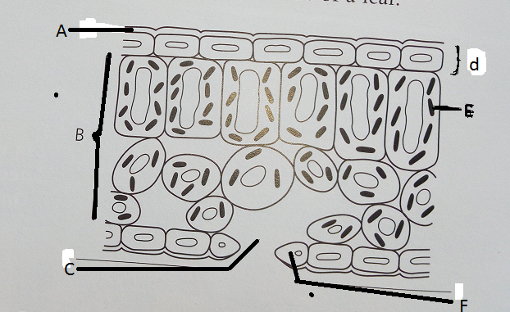

1. List the letters A-F and write the correct label beside each one from the words below.

**Chloroplast, waxy cuticle, guard cell, leaf tissue, upper epidermis,stoma.(3 marks)**

1. Copy the list of descriptions and write the correct part from the list above alongside each one.

Descriptions:

* + - 1. Cells that make food by photosynthesis. **(1 mark)**
      2. Makes the leaf water proof. **(1mark)**
      3. Hole that lets gases in and out of the leaf.**(1mark)**
      4. Has chlorophyll inside.**(1mark)**

1. Why are leaves able to:

(i) Absorb lots of light?**(1 mark)**

(ii) Get gases to the cells easily?**(1mark)**

(iii) Get water in and sugar out?**(1mark)**

13) An investigation was carried out into the effects of PH on the action of the enzyme amylase

on starch. Eight test tubes were set up at different PHS and incubated in water bath at 300 C

for one hour. The amount of reducing sugar (product) was estimated. The results are shown

in the table below.

|  |  |  |  |  |  |  |  |  |
| --- | --- | --- | --- | --- | --- | --- | --- | --- |
| **pH** | 4.0 | 5.0 | 6.0 | 6.5 | 7.0 | 8.0 | 9.0 | 10.0 |
| **Amount of reducing sugar products** | 1 | 12 | 26 | 32 | 33 | 27 | 13 | 5 |

1. Plot a graph to show these results(3 **marks)**
2. Explain the effect of PH for enzyme in this investigation. **(**2 **marks)**
3. What is the most suitable PH for enzyme amylase in this investigation?**(2 marks)**
4. Suggest other factors (Not in this investigation) that affect the action of an enzyme such as amylase.**(**3 **marks)**

14) a) Define the term transpiration **.(1 mark)**

b) Name three types of transpiration.**(3 marks)**

c) Explain three environmental factors that affect the rate of transpiration.**(6marks)**

15) Describe the role played by each of the following in human beings:

a) proteins (**2marks)**

b) carbohydrates **(2marks)**

c) lipids **(2 marks)**

d) vitamins **(2 marks)**

e) water **(2marks)**

16 a)Describe the different types of carbohydrates giving examples of each type.**(6marks)**

b) You are provided with a solution, which is suspected to contain reducing sugar.

Describe the possible tests you can carry out to confirm that it is a reducing sugar.

**(4marks)**