Biology and Health sciences
25/10/2019

8h30 am -11h30am

SENIOR ONE END OF YEAR EXAMINATIONS, 2019

SUBJECT: BIOLOGY

/100

Marks:

DURATION: 3 HOURS

INSTRUCTIONS:
1) Do not open this question paper until you are told to do so.
2) Answer all questions in section A. (70 mark)
3)Answer three questions in section B. (30 marks)
4) Use only a blue or black pen.

BIOLOGY AND HEALTH SCIENCES END OF YEAR EXAM, 2019

SECTION A: All questions are compulsory.
1) Choose the best answer (5marks)
A) Which statement below does not describe a bacterium?
(i) All live in colonies (ii) All live singly
(iii) They have nuclear material (iv) cell wall is surrounded by a tough coat.
B) Buds in plants can lead to the formation of:
(i)Stem (ii) roots
(iii) Flower (iv) branch
C) What is the use of a cover slip?
(i) To prevent specimen from drying (iii) to allow easy focus

(ii) To allow entry of light (iv) to magnify specimen
D) A functional unit formed by a group of specialized tissues is known as:
(i) An organ system (iii) An organelle
(ii)A tissue (iv) An organ

E) Select the correct statement from the following.
(i) Boys start puberty earlier than girls (iii) Girls mature faster than boys
(ii) Boys and girls matures at the same time (iv) Boys and girls who mature
late cannot reproduce
2 a) A motorcar can move, take in Oxygen and gives out Carbon dioxide,
consumes fuels but nevertheless is not a living organism. In what ways
does it not qualify as living thing? (1.5marks)
b) Name the kingdom to which each of the following organisms belongs:
(i) Grass: ………………………
(ii) Yeast: ……………………….
(iii) Amoeba: …………………….
(iv) Vibrio cholera: ………….. (2marks)
c) Give two characteristics of the Kingdom Monera (Bacteria). (2marks)

3 a) A student wrote the scientific name of blackjack as bidens Pilosa.
i) Identify the mistakes that the student made. (1.5marks)
ii) Identify the genus name for blackjack? (1mark)
b) What is the importance of classification of living things? (2marks)
c) What first aid could you provide to someone bitten by a snake? (1.5marks)

4) Animals and plants carry out common life processes like exchanging gases
and excretion.

Copy and complete the table to name or describe processes common to all
animals and plants.
Name of the life process | Description
 | Living things produce offspring
 | Living things get bigger and develop
 | Living thing change the position of their body, or part of their body
Respiration
Feeding or nutrition
 | Detects and respond to changes in the environment.
(3marks)
5 a) Classify the following diseases by placing them in the table below:
(2marks)
cancer, malaria, diabetes, typhoid, Ebola, albinism, tuberculosis and
marasmus.
Communicable diseases | Non-communicable diseases
b) Ebola is a viral disease which is spread through direct contact with infected
body fluids. For instance, blood, stool, sweat, vomit, urine, semen, or breast
milk. Suggest three measures that might limit the spread of this disease.
(3marks)
6 a) If a nucleus measures 100 mm on a diagram with a magnification of
X10 000. What is the actual size of the nucleus? (1.5marks)
b) Kalisa used a microscope to observe a specimen. The eye piece had a
magnification of x15 while the objective lens had a magnification of x5.
After mounting the specimen, he observed nothing.
(i) What went wrong? (1mark)
(ii) Calculate the magnification of the microscope used. (2marks)

7 a) How are red blood cells (RBC) adapted to their function in the body?
(2marks)
b) Name any six structures of a neurone (nerve cell) (4 marks)

8 a) Fill in the following blankets.
(i) Gestation period in a woman is .………….
(ii) Ovum is produced in the …………….. .It is fertilized in the ………….. and
develops in the ………………………. (2marks)
b) Describe the four differences in physical changes in both boys and girls at
puberty in terms of secondary sexual characteristics. (2marks)
c) Briefly explain the main events in the process of menstruation cycle in
females. (2marks)

9) Give three differences between a plant cell and an animal cell. (3 marks)

10 a) State four reasons why food is important to the body. (2marks)
b) A team of researchers went to a village near Rubavu and found a five-
year-old boy with the following symptoms: -loss of appetite,
Irritability, Bleeding gums.
(i) Suggest a disease the boy might be suffering from? (1mark)
(ii) What deficiency caused the disease? (1mark)
(iii) What advice do you think the researchers gave to the parents of the
boy? (2marks)
11 a) Which of the sets below consists of respiratory gases only? (1mark)
(i) Oxygen and argon
(ii) Oxygen and Carbon dioxide
(iii) Hydrogen and argon
(iv) Carbon dioxide and hydrogen
b) (i) Name any four parts of human breathing system. (2 marks)

(ii) Where do cilia occur in this system? What is their function?
(2 marks)
(iii) How is this system adapted for its functions. (2marks)

12 a) What is tropism? (1mark)
b) Define phototropism. (3 marks)
c) How do roots and shoots respond in gravitropism and phototropism?
(1mark)
13 a) What is a balanced diet? (1mark)
b) Name the extra chemical element which is found in all proteins but not
in any other food material. (1mark)
c) Fill in the following table.
Food substance lacking in the diet | Deficiency disease
Calcium | …………………………….
…………………………… | Scurvy
………………………….. | Night blindness
B1 | ……………………………..
Iodine | ………………………………
Iron | ………………………………
………………………….. | Pellagra
Vitamin D | ……………………………….
(4marks)
SECTION B: Answer any three questions/30 marks
14) Describe the structure of human female reproduction system. (10 marks)

15) Malaria is a killer disease in Africa especially south of the Sahara.
(a) What spread Malaria? (2marks)
(b) Suggest possible measures you would use to eradicate malaria in your
village. (4marks)
(c) What steps that the government of Rwanda taken to reduce the infection
of malaria? (4marks)
16) a) Name at least five parts of a green plant. (3marks)
(b) Describe three ways in which leaves are suited to their functions.
(3marks)
(c) Give any 2 functions of roots (2marks)
(d) Give any 2 types of modified stems (2marks)

17 a) Describe the different types of carbohydrates giving examples of each
type. (3marks)
b) Give a function of carbohydrate. (2marks)
c) You are provided with a solution, which is suspected to contain
reducing sugar.
Describe the possible tests you can carry out to confirm that it is
reducing sugar. (5marks)

18) Observe the following types of leaves and construct a dichotomous key to
classify them. Show the steps followed.
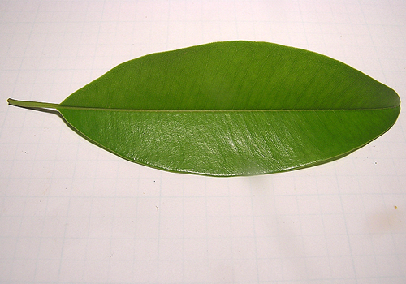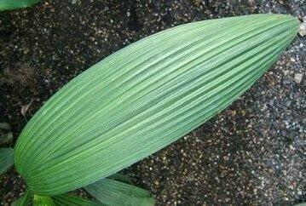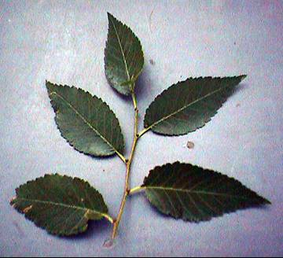
A B C
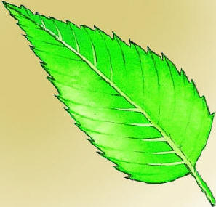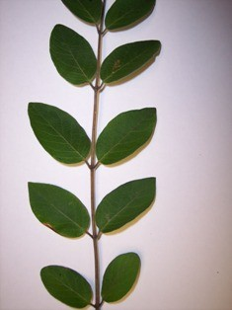
D E (10marks)

