**UNIT1. CLASSIFICATION OF KINGDOM ANIMALIA**

* 1. **General characteristics of animals**

The main features used to classify animals include:

• **Presence or absence of appendages** (An appendage is a projection from the body of an organism), their type and number.

• **The body form**;( whether segmented or unsegmented).

• **Presence of skeleton and its type**;( exoskeleton or endoskeleton).

• **Type of body symmetry**;( whether bilateral or radial)

**Animals have the following general characteristics:**

1. They are multicellular organisms.

2. They have eukaryotic cells.

3. Their cells are differentiated into tissues and organs.

4. They are all heterotrophic, meaning they depend on other organisms for food.

5. Their cells lack cell walls, cell sap and chloroplasts. They only have cell membranes and this makes their cell to be irregular in shape.

6. Most animals are able to move the whole body from one place to another (locomote).

7. Reproduction in most animals takes place through fusion of gametes.

8. They respond to external stimuli.

* 1. **Phylum Chordata**

**The main characteristics of organisms in phylum Chordata are:**

1. Presence of a chord like structure called notochord.
2. Presence of a vertebral column which forms part of an internal skeleton.
3. Presence of a nervous system which is connected to a hollow nerve tube
4. Bilateral symmetry: this means that the body can be divided along one plane into two equal halves

There are 5 different classes of Chordata .

These are:

• Pisces (fishes)

• Amphibia

• Reptilia

• Aves (birds)

• Mammalia

**CLASS PISCES**

The class consists of all type of fish such as: • Tilapia • Nile perch • Cod fish • Shark • Ray fish • Mud fish

**Main characteristics of animals in class Pisces**

1. All fishes are aquatic. They live in places such as seas, lakes, oceans, rivers and dams.
2. The skin of the fish is covered with scales
3. Fish have gills which are used for gaseous exchange
4. Fish have fins that aid in movement.
5. Fish are poikilothermic: Their body temperature is dependent on environmental temperature because they cannot regulate their own body temperature
6. Fish exhibit external fertilization
7. Fish have a lateral line on their body for sensitivity.
8. Fish have a single circulatory system with a two chambered heart.

**The following features enable fish to survive in water**.

1. Gills Fish use gills to breathe under water.
2. Streamlined body
3. Fins and tails. Fins and tails allow fish to move through water.
4. Lateral lines. The lateral line allows fish to detect vibrations in water, alerting them of predators.
5. Huge number of eggs. A single fish can lay more than a million eggs, which can all be fertilised.

**CLASS AMPHIBIA**

This class of chordates can live both on land and in water.

Examples of amphibian : Salamander , Frog , toad and newt

**Main characteristics of animals in class Amphibia**

1. They have mucus glands under the skin to keep it moist.

2. The skin has no scales

3. Adult amphibians use the lungs, moist skin and mouth cavity for gaseous exchange

4. The adult female amphibians always lay their eggs in water.

5. They exhibit external fertilisation.

6. They have two pairs of limbs.

**CLASS REPTILIA**

Examples of reptilia are; snakes, turtles, tortoises, crocodiles and lizards

**Main characteristics of animals in Class Reptilia**

1. They have a dry scaly skin
2. They are mostly terrestrial with a few being partially aquatic.
3. They undergo internal fertilisation.
4. Most of them have two pairs of legs except the snake.

**CLASS AVES (BIRDS)**

Animals in this class consist of birds such as the humming bird, ostrich, hawk, eagle,……

**Main characteristics of Class Aves**

1. Their bodies are covered with feathers.

2. Their legs are covered with scales.

3. Their front limbs are modified to form wings.

4. They have hollow bones that make them light for flight.

5. They have toothless jaws covered by a horny beak or bill.

6. They lay eggs with a hard shell made of calcium.

7. They carry out internal fertilisation.

**Adaptations of birds to their environment**

1. The forelimbs of birds are modified to form wings for flight.
2. Flight birds are light in weight.
3. Birds lay eggs with hard calcareous shells to avoid drying out.
4. The beaks of birds are modified for different modes of feeding,

for example:

• **Seed eaters** – like sparrows have short thick conical bills for cracking seeds.

• **Flesh eating birds** – like hawks have sharp curved beaks for tearing meat.

• **Nectar eating birds** – like humming birds have long slender beaks to probe the flowers.

• **Insect eaters** – like bee-eater have thin pointed beaks.

1. Birds have different types of feet to adapt them to their different environments. These include:

• **Feet for grasping** – like those of a kingfisher

• **Feet for scratching** – like those of chickens.

• **Swimming birds** – like ducks

• **Perching feet** – like that of a robin

• **Feet for running** – like those of ostrich.

**CLASS MAMMALIA**

The term Mammalia is derived from the Latin word ‘mammalis’ which means ‘mammal’ or ‘mamma’ which means milk secreting organ of female mammals.

**Main characteristics of animals in Class Mammalia**

1. They have mammary glands.
2. Their bodies are covered with fur, hair or wool.
3. They give birth to young ones
4. They have external ears
5. They exhibit internal fertilisation.
6. They are Homeothermic. Their body temperatures do not depend on the environment. It is maintained constantly.
7. They have differentiated teeth (i.e incisors, canines, pre-molars and molars) each with different function.
   1. **PHYLUM ARTHROPODA**

The word arthropod comes from two words ‘Arthros’ meaning ‘jointed’ and ‘poda’ meaning ‘leg’ or ‘foot’. Therefore arthropods are animals with jointed appendages.

**arthropods are useful in many ways,**

**for example:**

• Butterflies and bees act as pollinators of flowering plants.

• Bees make honey.

• Lobsters are used as food.

**Some arthropods are harmful to other living organisms,**

**for instance**:

• Ticks transmit diseases in animals.

• Mosquitos transmit malaria.

• Tsetse flies transmit trypanosomiasis.

• Aphids destroy crops such as maize, coffee and cassava

**Main characteristics of organisms in phylum Arthropoda**

1. They have jointed legs (appendages).

2. They have a tough coat or covering made of chitin.

3. They have bilateral symmetry.

4. Muscles for movement are attached on the cuticle or exoskeleton, for example in insects.

5. They have a fluid filled body cavity called haemocoel for example in earthworms.

6. Their bodies are segmented.

The 5 classes of phylum Arthropoda are:

1. Insecta b. Arachnida c. Crustacea d. Diplopoda e. Chilopoda

**CLASS INSECTA**

This is the largest class in the phylum Arthropoda.

**Main characteristics of organisms in class Insecta**

1. They have three distinctive body parts; head, thorax and abdomen.

2. They have a pair of long antennae.

3. They have three pairs of jointed legs, which are attached to their thorax.

4. They have a pair of large compound eyes.

5. Some have one or two pairs of wings that are attached to the thorax.

6. They breathe by means of spiracles

**CLASS ARACHNIDA**

This class of arthropods includes spiders, mites, ticks and scorpions.

**Main features of organisms in class Arachnida**

1. The body is divided into two parts: cephalothorax and abdomen.

2. They have four pairs of jointed legs attached to the cephalothorax.

3. They have simple eyes about 8 in number.

4. They do not have antennae.

5. They posses a pair of poison glands called chelicerae.

**CLASS CRUSTACEA**

This class includes crab, wood louse or water flea

**Main characteristics of organisms in class Crustacea**

1. Their body is divided into two parts: the cephalothorax and the abdomen.
2. They have different types of appendages.

3. They have two pairs of antennae.

4. They have a pair of compound eyes at the end of stalks.

5. They have ten or more legs

6. They breathe by use of external gills

**CLASS DIPLOPODA**

**Main characteristics of organisms in class Diplopoda**

1. They have elongated and cylindrical bodies.
2. Their bodies are divided into two main parts; the head and a segmented trunk
3. Each body segment has two pairs of legs except the first thoracic segments that have one pair of leg each.
4. They have a pair of antennae.
5. They may have simple or compound eyes, or in some cases no eyes are present.
6. They breathe through spiracles
7. Millipedes roll their bodies when disturbed

**CLASS CHILOPODA**

This class is composed of centipedes.

**Main characteristics of organisms in class Chilopoda**

1. They have flat bodies
2. They have a pair of legs in each segment.\
3. Their body is divided into a head and a segmented trunk
4. They are carnivorous
5. They are carnivorous
6. They breathe through spiracles

**Some arthropods are useful to us in many ways. They include**:

• Butterflies and bees act as pollinators of flowering plants.

• Bees make honey.

• Lobsters and prawns are used as food.

**However, most arthropods are harmful to other living organisms.**

**For instance:**

• Ticks transmit diseases in animals; for example East Coast Fever

• Mosquitos transmit malaria.

• Tsetse flies transmit trypanosomiasis in human beings and Nagana in cattle.

• Aphids destroy crops such as maize, coffee and cassava

* 1. **Other Phyla belonging to Kingdom Animalia**

Apart from the two phyla; Chordata and Arthropoda, Kingdom Animalia comprises of other lower level organisms that belong to different phyla. These phyla include:

• Platyhelminthes • Nematoda • Annelida • Mollusca • Coelenterata

• Cnidaria • Porifera/sponges • Echinodermata

The different phyla, their main characteristic and examples of organisms in each.

|  |  |  |
| --- | --- | --- |
| **Phyla** | **Main characteristics** | **Examples** |
| Platyhelminthes | • Have a mouth but no anus.  • bilateral symmetry.  • Mainly hermaphroditic. | Tapeworm, liver flukes, flat worms and planaria |
| Nematoda | • Rounded unsegmented body  • Body covered with thick elastic cuticle.  • Have a simple alimentary canal | Round worms, hook worms, ascaris spp |
| Annelida | • The bodies have segments  • They lack legs; | Earthworms, lung worms, leeches |
| Mollusca | • The dorsal side of the body is covered by a hard external shell  • Have sensitivity structures called tentacle | Octopus, slugs, squids, snails and oysters |
| Coelentreate (cnidarian) | • Have a sac-like body cavity that also acts as a gut.  • The body has radial symmetry  • Possess tentacles. | The sea anemone , hydra and jelly fish |
| Porifera | • They are sessile. They attach themselves on rocks.  • They lack a nervous system.  • They have a simple body made of a cavity | Sponges |
| Echinodermata | • The skin has calcareous exoskeleton and spines.  • Body of the larva has bilateral symmetry while adult body has a five-way radial symmetry (pentaradiate).  • The mouth is located on the lower side while the anus is located on the upper side. | Sea cucumbers, sea urchins and the starfish |

**UNIT 2. INTRODUCTION TO ENVIRONMENTAL BIOLOGY**

* 1. **Concepts of ecology**

**Ecology** : is The scientific study of relationships between organisms and their environment .

**Terms used in ecology .**

• **Ecosystem**: This is a stable unit of nature consisting of all communities interacting with each other and their surrounding physical environment.

Examples of ecosystem include a pond, a grassland and desert.

• **Biosphere:** This is the part of the Earth and its atmosphere capable of supporting life

• **Producer:** This refers to all green plants which manufacture their own food by the process of photosynthesis.

• **Habitat**: An area in which an organism lives.

• **Community**: A combination of different species of organisms living together in an area.

• **Population:** This is the total number of organisms of the same species living together in a specific area at a certain time.

• **Biotic factors**: These are the living components of an ecosystem. These may be plants, animals, fungi,….

• **Abiotic factors**: These are the nonliving components of an ecosystem. They include pH, sunlight intensity and temperature.

• **Niche:** This is the position that an organism occupies in a habitat

• **Carrying capacity**: The maximum size of a population that a given area can support without straining.

• **Environment:** This is a combination of all factors that affect the life of an organism.

• **Biodiversity**: This is the variety of life in the world or in a particular habitat or ecosystem.

• **Biomass:** This is the total mass of organisms in a given area or volume.

• **Biome :** is a large ecosystem where plants , animals , insects and people live in a certain type of climate. Ex: forest, desert ,marine ,….

**ECOSYSTEMS**

Ecosystems are also known as **biomes**. They are made up of both the living component (biotic factors) and the non-living component (abiotic factors).

Ecosystems are broadly subdivided into two**: terrestrial** and **aquatic ecosystems**.

**Aquatic ecosystem**

they are classified into two: marine and fresh water ecosystem.

1. Marine ecosystems: these are made up of water with high salt concentration. Eg : Oceans and seas
2. Freshwater ecosystems: These are made up of water with a less salt concentration. eg: Lakes, wetlands and rivers

**Terrestrial ecosystems**

This is the land ecosystem. They include savanna grasslands, deserts, temperate grasslands and forests.

**The abiotic factors in an ecosystem include the following (**The environmental conditions that affect a community ) are:

* temperature,
* light,
* pH,
* wind,
* salinity
* humidity
* and atmospheric pressure.
  1. **Energy flow in ecosystems**

The primary source of energy is the sun. Energy enters ecosystems in form of sunlight

**Autotrophs ( producer** ) : are organisms ( green plants ) that can make their own food by photosynthesis . green plant obtain energy from sun light

**Heterotrophs ( consumer )** : organisms that feed on green plant, they can no manufacture their own food .

Some consumers called the **detrivores** derive their energy from non-living organic material such as feaces and fallen leaves.

**Herbivores:** organisms that feed on plants directly

**Omnivorous:** organisms that can feed on both plants and animals.

**Carnivores:** organisms that feed on herbivores

**saprophytic organisms** : organism that only get food from dead materials. Ex: bacteria , fungi

In ecology, a **trophic level** refers to the position an organism occupies in a food chain.

Green plants form the first trophic level known as the producers.

The table below gives a summary of organism we expect in each trophic level.

|  |  |  |
| --- | --- | --- |
|  | **Trophic level** | **Composition of organism** |
| Producers | First trophic level | • Green plants  • Photosynthetic bacteria  • Algae • Phytoplankton (All are autotrophic) |
| Consumers | Second trophic level( Primary consumers)  Third trophic level ( Secondary consumers)  Fourth trophic level ( Tertiary consumers)  Fifth trophic level ( Quaternary consumer ) | • These are plant-eating organisms.  • They depend on plant materials.  Small carnivores like insectivores , spider, small fishes, lizards, frogs, chameleons etc.  Large carnivores such as lions, leopards, hyena and sharks, …..  Carnivorous that eat tertiary consumers. An example is the hawk that eats owls. |
| Decomposers | • All are saprophytic.  • Most are fungi and bacteria.  • They can only get food from dead materials. | |

**Food chain**

**A food chain** is a linear representation of how organisms eat each other

an example of food chain : Grass Grasshopper Bird Mongoose Wild dog

**food web** : in the network of interconnected food chains

**Tertiary** **consumers** Lizard snake

**Secondary consumers** praying mantis spider frog

**Primary consumers** Locust aphids caterpillar mouse

**producer** Grass

The arrows in the food chain indicate **eaten by** or **the flow of energy from the food web**.

Factors that brings about the loss of energy at each trophic level

• Respiration

• Part of the energy is lost as undigested food matter.

• The rest is lost as excretory products.

* 1. **Ecological pyramids**

**Ecological pyramids** are diagrams that show how important factors in an ecosystem such as energy, biomass and population size change at each trophic level.

they are 2 types of ecological pyramids:

- pyramid of biomass

- pyramid of number

**Pyramid of biomass**

This is a diagrammatic representation of mass or weight of organisms in each trophic level in a food chain.

Ex:

Eagle ( 1 kg square unit area )

Rats ( 2 kg square unit area )

Maize ( 500 kg square unit area )

It is always hard to construct a pyramid of biomass because of the following reasons

• Measuring biomass often means death of the organism.

• Organisms may belong to more than one trophic level in an ecosystem

**Pyramid of numbers**

This is a diagramatic representation of numbers of organisms in each trophic level in a food chain.

Ex: One hawk

four mice

grass plants

Sometimes the pyramid is not upright, for instance,

if you were to construct pyramid of numbers using the tree as a habitat. It would be the only producer and the consumers such as caterpillars and birds would be many

secondary consumer

primary consumer

producer ( tree )

fig. **Inverted pyramid of numbers**

**UNIT 3: PASSIVE MOVEMENT OF SUBSTANCES ACROSS A CELL MEMBRANE**

There are three main physiological processes by which substances move in and out of cells.

* Diffusion
* Osmosis
* Active transport.

**3.1 Diffusion of gases and solutes**

**Diffusion** is a movement of particles (ions or molecules) from a region of high concentration to a region of low concentration.

Factors that affect the rate of diffusion

1. Temperature
2. Concentration gradient
3. Size of molecules
4. Diffusion distance
5. Surface area to volume ratio

**Importance of diffusion in plants and animals**

1. Plants absorb water, mineral salts and oxygen from the soil through the root hairs by diffusion.
2. Digested food such as glucose and amino acids move from the small intestine into the blood of animals by diffusion
3. Cells and unicellular organisms such as Amoeba get rid of waste substances by diffusion.
4. Diffusion is involved in exchange of gases in stomata, skin of frogs and in the lungs of animals.

**3.2 Osmosis**

**Osmosis** is the movement of water molecules from a region of high water potential (dilute solution) to a region of low water potential (concentrated solution) through a partially permeable membrane.

Types of solutions

* **A dilute solution( Hypotonic)**  has more water molecules compared to solute molecules .
* **concentrated solution ( Hypertonic)**  has more solute molecules than water molecules.

Solute + Solvent = Solution

 Semi-permeable membrane

Solute molecules

Beaker

Water molecules

Fig: Movement of water molecules through a semi-permeable membrane

**Isotonic, is**  When two solutions of equal concentration are separated by a semi-permeable membrane, the net movement of water out of a cell balances water movement into the cell.

**Water relations in plant cells**

1. **Plant cells in hypotonic solutions**

If a plant cell is surrounded by a hypotonic solution, water molecules move from the surrounding fluid to the vacuole by osmosis.

As it receives water, the vacuole, swells and pushes the cytoplasm and nucleus outwards against the cell wall until the cell become turgid.

A point will reach when no more water can enter the plant cell. At this point, the wall pressure is equal to turgor pressure.

1. **Plant cells in hypertonic solutions**

A plant cell that is surrounded by a hypertonic solution will lose water.

the cell membrane and cytoplasm shrink away from the cell wall. The cell will be plasmolysed.

**Role of osmosis in plants and animal cells**

Osmosis enables :

1. Uptake of water by roots
2. Opening and closing of stomata
3. Movement of water from cell to cell in tissues
4. Feeding in insectivorous plants

**UNIT 4. ACTIVE TRANSPORT**

* 1. **Active transport and its importance**

**Active transport** is the movement of particles through the cell membrane from a region of low concentration to a region of high concentration using energy.

The difference between passive and active transport

|  |  |
| --- | --- |
| **Passive transport** | **Active transport** |
| Transport occurs from a high concentration of molecules and ions to low concentration | Transport occurs from a low concentration of solute to high concentration of solute |
| Does not require cellular energy. | Requires cellular energy. |
| Involves osmosis and diffusion processes. | Involves endocytosis and exocytosis processes. |
| Transports anything soluble water, oxygen and carbon dioxide. | Transports proteins, ions, large cells and complex sugars. |

**The role of proteins in active transport**

Carrier protein molecules have binding sites for the molecules. They pick up molecules of a substance from one side of the cell membrane and transport them across.

**Role of active transport in living organisms**

1. Through active transport, root hair cells in plants absorb mineral salts and ions from the surrounding soil
2. The cells lining the human small intestines absorb food molecules by active transport.
3. Enable the nerve cells to maintain concentrations of sodium ions and potassium ions.
4. The useful substances are reabsorbed into the blood by active transport.
5. Active transport is involved in accumulation of substances in the body of some organisms

**Factors that affect active transport**

1. Concentration of oxygen
2. Concentration of glucose
3. Temperature
4. Enzyme inhibitors
5. pH
   1. **Endocytosis and Exocytosis**

**bulk transport** isThe movement of macromolecules such as proteins or polysaccharides into or out of the cell **.**

There are two types of bulk transport:

-exocytosis and

- endocytosis

**Endocytosis**

**Endocytosis** is the process of capturing a substance or particle from outside the cell by engulfing it with the cell membrane, and bringing it into the cell.

Endocytosis takes place in two ways:

* **phagocytosis** and
* **pinocytosis**.

1. **Phagocytosis**

Phagocytosis means ‘**cell eating**.’ This is a process by which plasma membrane extend to form a depression.

1. **Pinocytosis**

Pinocytosis means ‘**cell drinking**.’ This process is similar to phagocytosis only that the cells take in materials in liquid form.

**Exocytosis**

This is the process by which materials are removed from the cells.

Examples of exocytosis:

• Secretion of digestive enzymes by pancreas.

• Secretion of milk from mammary glands.

• Secretion of mucus by salivary glands.

**UNIT5. IDENTIFICATION OF FOOD COMPONENTS**

* 1. **Components of food substances.**

Food contains mainly two classes of nutrients;

-**Organic nutrient** : include proteins, carbohydrates, lipids and vitamins.

- **inorganic nutrients** : include mineral salts like calcium, phosphorous and others like water.

**5.2 Testing for starch and reducing sugars**

Food testing is the process that is carried out to determine the food components in a food sample.

**A) TEST FOR STARCH**

Starch is a polysaccharide comprising of glucose monomers linked together. Starch is insoluble in water. It does not have a sweet taste

Some foods containing starch include sweet potatoes and cassava.

Starch is the storage form of glucose in plants

**Requirements**

• Iodine solution (brown) • Test tubes • Droppers • Water • Starch solution (sweet potato, or plantain extracts) • Measuring cylinder

**Procedure**

1. Using the measuring cylinder, measure about 2 cm3 of starch solution and put into test tube
2. Heat
3. Cool the mixture
4. add a few drops of iodine solution

**observation**

The colour of Iodine turns from brown to blue-black ( dark blue )

**Conclusion**

Iodine reacts with starch and turns it into dark blue

**B) TESTING FOR SUGARS**

Based on their reaction with Benedict’s solution sugars are grouped into two.

• Reducing sugars • Non-reducing sugars

**Testing for reducing**

Example of reducing sugar : Glucose , lactose , fructose and galactose

**Requirement** : glucose , water, benedict solution , test tube, beaker , source of heat .

**Procedure:**

1. put 2 cm3 of glucose solution ( glucose + water ) in a test tube
2. add 2 cm3 of benedict solution
3. heat while shaking

**observation :** solution change from blue –opaque-green-yellow – red .

**conclusion** : change from blue to red indicate presence of simple sugar ( reducing sugar )

**TESTING FOR NON REDUCING SUGAR ( SUCROSE )**

**Requirement :** sucrose , water, benedict solution , test tube, beaker , source of heat , dilute Hcl , Sodium hydroxide ( NaOH)

**Procedure :**

1. put 2 cm3 of sucrose solution ( sucrose + water ) in a test tube
2. add 2 cm3 of dilute Hcl
3. heat
4. cool
5. add NaOH ( to neutralize the excess acid )
6. add 2 cm3 of benedict solution
7. Heat ( boil )

**Observation :** solution change from blue –opaque-green-yellow – red .

**Conclusion :** dilute Hcl hydrolyses sucrose into simple sugar ( glucose )

* 1. **TESTING FOR PROTEINS**

**Testing for proteins using Biuret’s test**

**Requirement :** egg albumen , dilute NaOH , 1% Cupper sulphate solution ( Biuret reagent ) , test tube

**Procedure :**

1. Put 2cm3 of egg albumen in a test tube
2. Add 1cm3 of NaOH
3. Add Cupper sulphate drop by drop
4. Shake

**Observation :** Colour turn from blue to purple

**Conclusion** : purple colour indicate presence of protein

* 1. **TESTING FOR LIPIDS**

**requirement :** cooking oil , filter paper , source of heat .

**procedure :** 1. Place a drop of oil on filter paper

1. warm the paper gently

**observation** : a translucent mark is formed on the paper .

**conclusion** : a translucent mark ( spot ) indicate presence of oil or fat .

* 1. **TESTING FOR VITAMIN C**

**Requirement** : DCPIP ( Dichlorophenol indophenol ) , test tube , ascorbic acid ( orange juice )

**Procedure** : 1. Put 2 cm3 of DCPIP solution

2.add drops of orange juice

**Observation** : DCPIP decolourises ( blue colour disappears )

**Conclusion** : solution which decolourise DCPIP contain vitamin C

**UNIT 6 . ENZYMES**

**Enzymes** are biological catalysts that are protein in nature. They speed up or slow down the rate of chemical reactions in the body

* 1. **Types of enzymes**

Types of enzymes based on the cell they act on :

**-intracellular enzymes:** are enzymes that are used within the cells that produce them. for example, respiratory enzymes

**-** **extracellular enzymes :** are enzymes which are transported from the cells that produce them to be used in other cells. examples : enzymes secreted into the alimentary canal to help with digestion

There are also different types of enzymes based on the foods they act on,

for example:

• Peptidases: Break down proteins

• Lipases: Break down lipids

• Carbohydrases: Break down carbohydrates

* 1. **Characteristics of enzymes**

1. Enzymes are protein in nature: all enzymes are made up of proteins.

2. Enzymes are affected by temperature

3. Enzymes work best at specific pH.

4. Enzymes remain unchanged after catalysing a reaction.

5. Enzymes catalyse reversible reactions.

6. Enzymes are substrate-specific.

7. Enzymes work rapidly.

8. Enzymes are efficient.

* 1. **Factors that affect enzyme activity**

1. **pH**: different enzymes have their optimum PH at which they work best . Extreme pH causes enzymes to denature
2. **Temperature:** The temperature at which enzymes work best is called optimum temperature.

Temperatures lower than the optimum cause enzymes to be **inactive.** Therefore they work at a slow rate.

Higher temperatures than the optimum temperature destroy enzymes. enzymes are therefore said to be **denatured**

1. substrate concentration,
2. enzyme concentration,
3. presence of inhibitors and co-factors
   1. **Mode of enzyme action**

Enzymes are very specific in nature. This means that they can only catalyse a specific reaction.

The 'groove' in an enzyme where the substrate fits during the reaction is called **active site**. When the substrate fits into the active site, an enzyme-substrate complex is formed.

This reaction complex can be explained by a **key and lock mechanism**.

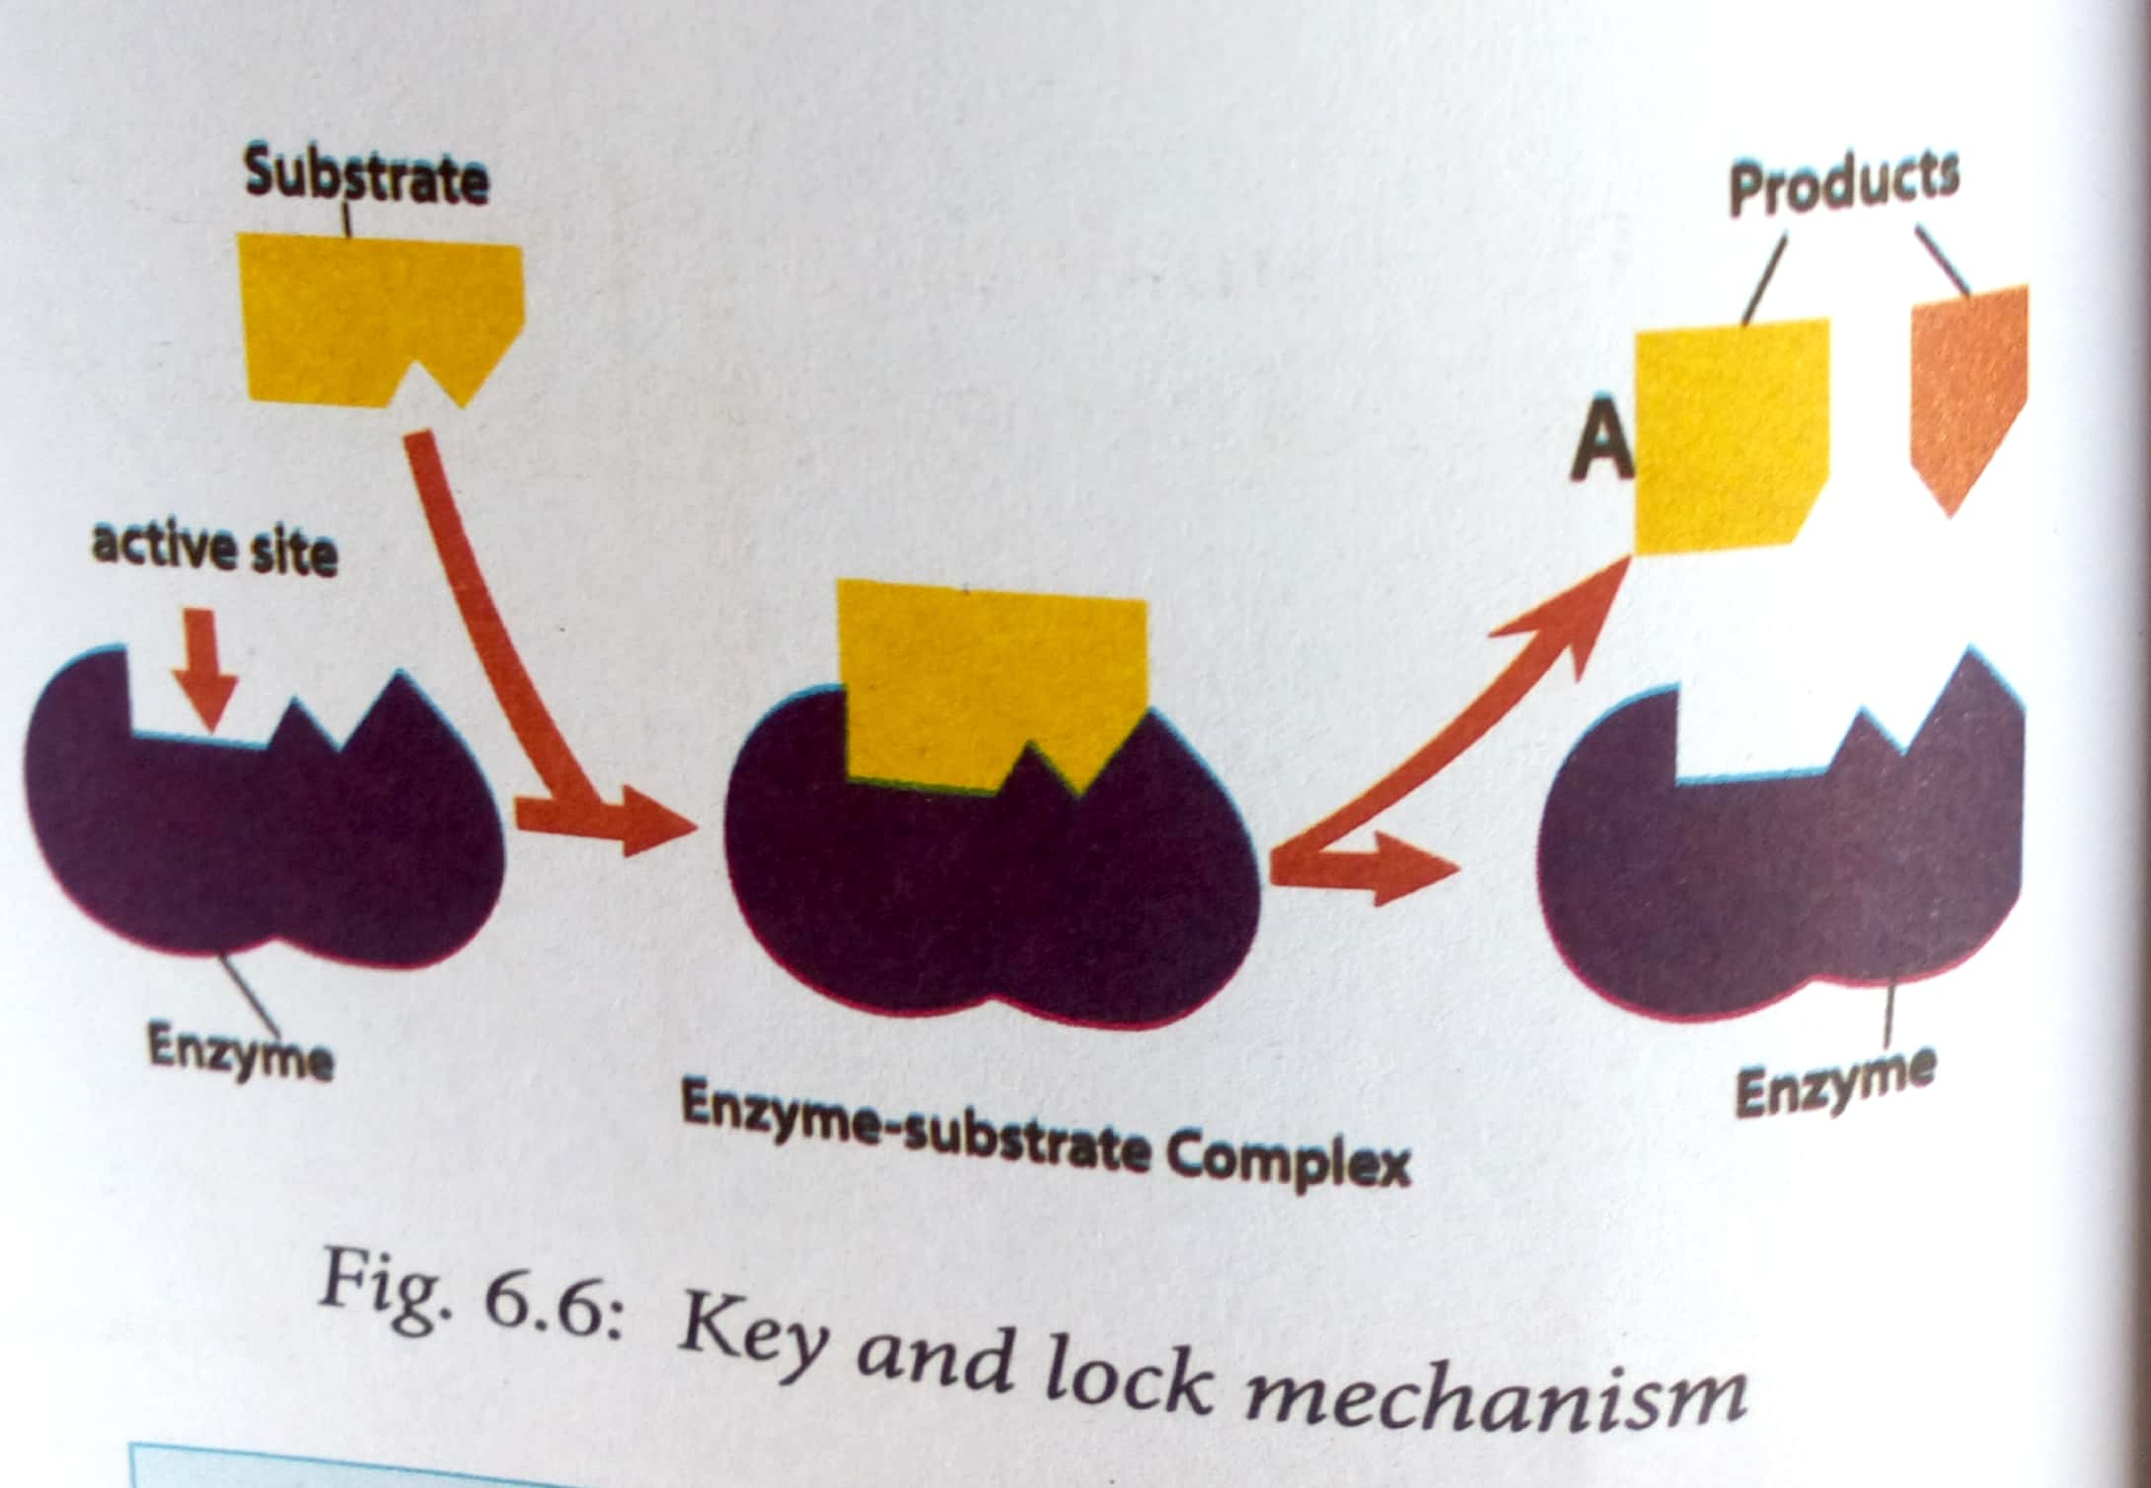

**UNIT 7. PHOTOSYNTHESIS**

**Photosynthesis** is a process by which green plants make their own food using carbon dioxide and water in presence of sun light and chlorophyll .

**The overall photosynthesis equation is**

chlorophyll

Water + Carbon dioxide glucose + oxygen

Sunlight

chlorophyll

6H2O + 6CO2 C6H12O6 + 6O6

Sunlight

**Chlorophyll** is a green pigment, present in all green plants responsible for the absorption of light to provide energy for photosynthesis.

The chlorophyll are found in chloroplasts.

**Chloroplast** It is the organelle in a plant cell where photosynthesis takes place.

**Necessary** **conditions For photosynthesis to take place :**

• Light energy

• Carbon dioxide

• Water

• Chlorophyll

raw materials required for photosynthesis to occur :

- Carbon dioxide

- water

- sunlight energy

**End products of photosynthesis**

**Glucose:** This is the main product. It is used in respiration to release energy. Excess glucose is stored as starch or oil.

**Oxygen:** Some of the oxygen is used during respiration while the rest is released to the atmosphere during gaseous exchange.

* 1. **Limiting factors of photosynthesis**

A limiting factor is a variable which limits the rate of photosynthesis.

Some of these factors include :

1. **Light intensity**: In darkness, plants cannot photosynthesise at all. In low light intensity, the rate of photosynthesis is low. But as light intensity increases, the rate of photosynthesis also increases.
2. **Carbon dioxide concentration :** Increase in carbon dioxide increases the rate of photosynthesis. But this continues only to a certain point where rate of photosynthesis does not increase
3. **Temperature :** If temperatures are low, plants photosynthesise very slowly; but as temperature increases, the rate of photosynthesis also increases. Rate of photosynthesis is highest at optimum temperature
4. **Water**
   1. **Internal structure of the leaf and its adaptaions to photosynthesis**



**Palisade cells** absorbs most carbon dioxide during the day

**role of cuticle in photosynthesis**, is to allow light to penetrate the leaf ( it is thin )

**spongy mesophyll** have many air spaces between for photosynthesis ,

**importance of shape of stomata ,** they are bean-shaped to allow opening and closing of stomata

**The following are some of the adaptations of the leaf to photosynthesis** :

• The leaf blade is broad and flat to provide a large surface area for absorption of sunlight and carbon dioxide.

• Most leaves are thin

• Leaves have vascular bundles that contain structures (xylem and phloem) which supply the cells with water and mineral salts.

• The leaf cuticle and epidermis are transparent and thin to allow easy penetration of light.

• Presence of stomata on the leaves allows easy diffusion of carbon dioxide

• The leaves are well arranged to avoid overlapping and overshadowing

• The spongy mesophyll layer has cells that are irregular in shape and have large air spaces between them.

• Palisade cells are closely packed and They contain many chloroplasts hence

* 1. **Importance of photosynthesis**

- is a source of energy

-Provides oxygen in air

-Makes carbon available to plants and animals

-Prevents accumulation of carbon dioxide in the air

-It is responsible for the energy stored in coal and petroleum

* 1. **Mineral requirements for plant growth**

Plants require essential mineral ions such as **magnesium** and **nitrate ions** for proper growth.

1. **Magnesium ions**

-Magnesium ions are required for the synthesis of chlorophyll,

-They are also needed for activation of many enzymes involved in the energy transfer processes.

Deficiency of magnesium ions affects plant growth. Leaves start to change colour from green to yellow.

1. **Nitrate ions**

Nitrate ions are required by plants for protein synthesis.

Deficiency of nitrate ions results to poor synthesis of chlorophyll hence leaves become yellowish.

**Uses and dangers of nitrogen fertilisers**

Fertilisers add plant nutrients such as nitrogen, phosphorus, and potassium that are lacking in the soil.

**Harmful effects of nitrogen fertilisers to the environment**

- weeds and non-native plants grow more readily

-Excess nitrogen in the soil creates an imbalance of nutrients.

-High amounts of nitrates in the soil results to increased acidity

- high amounts of nitrates enter into water bodies resulting to eutrophication.

**UNIT 8 TRANSPORT OF WATER, MINERALS AND ORGANIC FOODS IN PLANT**

* 1. **Transport system in plants**

In plants, the transport system is made up of specialised tissues called **vascular bundles**.

The vascular bundles contain two types of tissues: **xylem** and **phloem**.

Substances that need to be transported in plants are:

• Water • Mineral salts • Organic substances

**Phloem tissues** transport food substances such as glucose and amino acids from the leaves to other plant tissues

**The xylem tissues** transport water and mineral salts absorbed by the roots to different parts of the plant.

**The root hair**

**Function** : absorb water and mineral salts .

**Adaptations of the root hair cells**

(i) They are numerous so as to increase the surface are

ii) They are thin and fine

**Absorption of water**

Root hair cells absorb water from the soil by osmosis

Theories or processes which explain the movement of water in plant They include

-capillarity,

- root pressure,

-transpiration pull

- cohesion tension theory.

**8.2 Transpiration**

Transpiration is the evaporation of water from the plant surface mainly through the leaf.

ways through which plants can lose water. They include;

**- stomatal transpiration**: This is the loss of water through stomata. Most water in plants is lost through this way

**-Lenticular transpiration:** This is the loss of water through the lenticels found in woody stems.

**-Cuticular transpiration:** This is the loss of water through the cuticle in herbaceous stems.

**Factors that affect the rate of transpiration**

• Temperature • Wind • Humidity • Light intensity

Transpiration is measured using an instrument known as a **photometer**

* 1. **Adaptations of plants to different environmental conditions**

Plants that grow in dry areas are called **xerophytes**, whereas others that grow in or near water are called **hydrophytes**.

Plants that grow in areas that are neither too dry nor too wet are called **mesophytes**,

whereas plants that grow in saline habitats, for example, sea or ocean are called **halophytes**

1. **Xerophytes**

Xerophytes are plants that have characteristics suited to areas with very little water and very high temperatures

**Adaptations of xerophytes to their habitat**

**1.** Their roots are usually more developed to absorb water from the soil

**2.** They have water storage tissues

3. Xerophytes reduce water loss through transpiration in many ways:

- They have a thick waxy cuticle which prevents excessive water loss

- Many xerophytes have small leaves

- Some xerophytes have very few stomata which are located on the lower epidermis

4. Some xerophytes have life cycles that enable them to evade dry seasons, for example, some shed their leaves during the dry season

1. **Mesophytes**

Mesophytes are plants that grow under average conditions of water supply and temperature.

**Adaptations of mesophytes to their habitats**

1. They have thin leaves
2. They have broad and flat leaf blades
3. Presence of stomata on the upper and lower leaf epidermis
4. Mosaic arrangement of leaves on the plant
5. Their leaves have cells with chlorophyll so that photosynthesis takes place.
6. They have thick transparent cuticles to prevent water loss.
7. They have a well developed root system
8. **Hydrophytes**

Hydrophytes are plants that live in water or in very wet places.

There are three types of water plants:

1. **Emergent plants** – they have roots and part of stem under water. While their leaves are above water
2. **Floating plants** – they float on the water surface with roots in water.
3. **Submerged plants** - these are found completely under water,

**Adaptations of hydrophytes**

1. Their cuticle is thin or lacking
2. their roots are not well developed.
3. The presence of many air spaces in the stem and leaf tissue;
4. They contain little xylem and support tissue
5. **Halophytes**

These are plants that grow in salty places such as rocky shores, seas and sand dunes

**TRANSLOCATION**

The products of photosynthesis are called **photosynthates**.

Photosynthates are produced by **sources** and are translocated to **sinks**

**Translocation :** is the movement of organic products of photosynthesis from leaves to other parts of the plant

**UNIT 9 GASEOUS EXCHANGE IN HUMANS AND PLANT**

**9.1 The concept of respiration and respiratory surfaces**

**Respiration** is the process where food is broken down to produce energy.

**Gaseous exchange is**: (i) Exchange of respiratory gases in animals. (ii) Exchange of photosynthetic and respiratory gases in plants.

**respiratory surfaces**: is special surfaces over which gaseous exchange takes place.

Examples of specialised structures or organs for gaseous exchange in animals include the following:

• Cell membrane

• Tracheal system in insects

• Buccal cavity in frogs

• Skin in frogs

• Gills in fish

• Lungs in mammals, birds, reptiles and amphibians

**characteristics that make respiratory surface efficient for gaseous exchange.**

1. Thin walls for faster diffusion of gases across it.
2. It is moist to dissolve gases as they diffuse across it.
3. It has a large surface area for maximum gaseous exchange.
4. Has a rich supply of blood capillaries to quickly transport gases to and from the cells.

**9.2 The mechanism of breathing in humans**

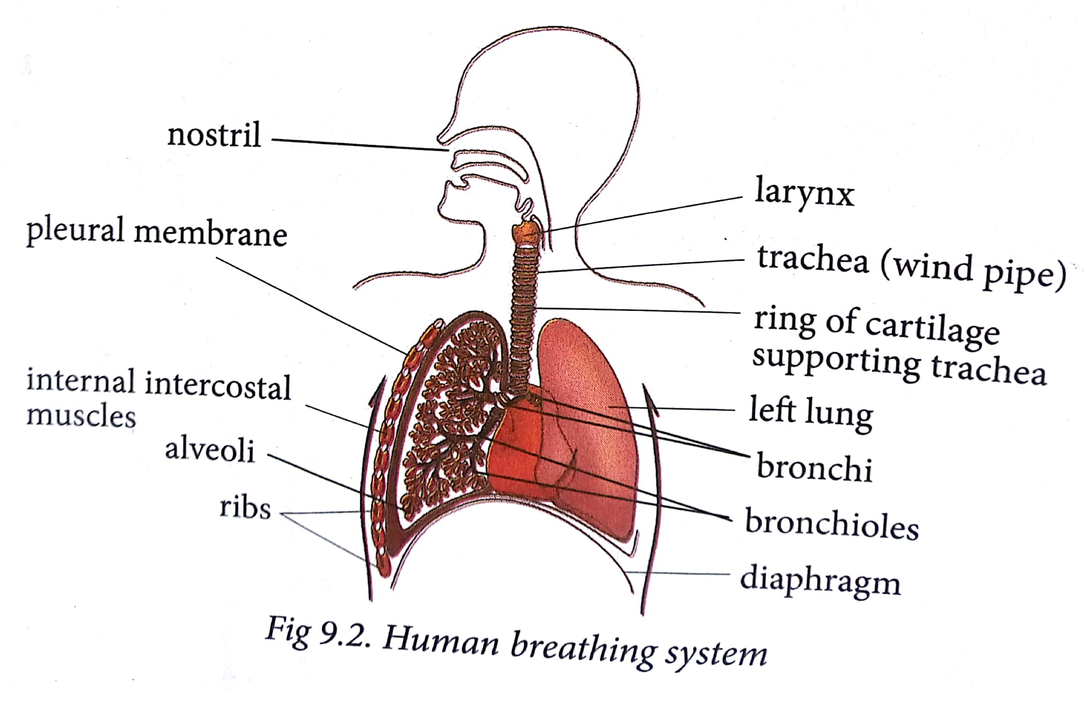

**Breathing** : is the process that brings air into the lungs and removes it again

They are two phases of breathing :

- inhalation

- exhalation

a) **Inhalation (breathing in)**

Inhalation is also known as inspiration. This is the active phase of breathing which draws air into the lungs.

1. **Exhalation (breathing out)**

Exhalation is also known as expiration. This is the phase of breathing, which expels air out of the lungs

Differences between inhalation and exhalation

|  |  |
| --- | --- |
| **Inhalation** | **Exhalation** |
| External intercostal muscles contract. Internal intercostal muscles relax. | External intercostal muscles relax. Internal intercostal muscles contract |
| Rib cage moves upwards and outwards. | Rib cage moves downwards and inwards. |
| Diaphragm muscles contract | Diaphragm muscles relax |
| Volume of the thoracic cavity increases. | Volume of the thoracic cavity decreases. |
| Lungs inflate | Lungs deflate |

**Gas exchange in the alveoli**

Air passes the **nose** or mouth as it moves down **the trachea**. The trachea is divided into the left and right **bronchi**. Each bronchus is divided into smaller **bronchioles** and each bronchiole is in turn attached to numerous **alveolar sacs**.

**The alveolus is a suitable point for gaseous exchange because:**

• It is supplied with blood which carries the gases being exchanged.

• It has a very thin wall

• It is lined with a thin film of moisture to dissolve the diffusing gases.

• A ventilation process brings in and takes away air containing the gases being exchanged.

• It has a very large number of alveoli to increase their surface area for gaseous exchange.

Gas exchange between the air within the alveoli and the pulmonary capillaries occurs by **diffusion.**

A diffusion gradient is essential for rapid gaseous exchange in the alveolus. The following factors contribute towards maintaining this diffusion gradient.

1. **Lung ventilation**
2. **Blood flow**
3. **Haemoglobin which combines with oxygen**

*Composition of inhaled and exhaled air*

|  |  |  |
| --- | --- | --- |
| **Component of air** | **Inhaled air (%)** | **Exhaled air (%)** |
| Oxygen | 21 | 15 |
| Carbon dioxide | 0.04 | 4 |
| Nitrogen | 79 | 79 |
| Water vapour | Variable | Saturated |

The most common respiratory diseases are :

• Tuberculosis • Asthma • Pneumonia • Bronchitis

• Whooping cough • Common cold • Influenza

1. **Asthma**

asthma can be caused by **allergens** such as pollen grains, some type of proteins in milk, pet hairs, dust and even flavours in food. It can also caused by stress and anxiety. In some families the disease is inherited.

**Symptoms of asthma**

• Difficulty in breathing.

• Wheezing sounds when breathing.

**Prevention and treatment**

-Asthma is treated by two types of medication:

long-term control and quick-relief medicines

- People with asthma should avoid contact with allergens.

- Asthma patients are advised to carry inhalers that contain a drug which pacifies the condition.

**2. Bronchitis**

This is an infection of the inner walls of the bronchi. It is caused by bacteria or air pollutants such as smoke

**Symptoms of bronchitis**

• Secretion of excess mucus

• Coughing

• Difficulties in breathing

**Prevention and treatment**

• Acute bronchitis is treated by getting plenty of rest, drinking lots of fluids and taking a cough syrup.

• People with chronic bronchitis should take antibiotics every time they have a cold with a fever.

• A doctor should be consulted at the early stages of bronchitis.

• Avoid smoking whether directly or passively.

• Avoid polluted air.

**3. Emphysema**

This results from long untreated bronchitis where the bronchioles in the lungs become blocked.

**4. Pneumonia**

Pneumonia is an infection of the lungs. It is caused by bacteria called *Pneumococcus*

It can also be caused by a virus or a fungi.

**Signs and symptoms**

• Sudden chills and high fever.

• Rapid shallow breathing and sometimes wheezing.

• Cough with yellow, greenish colour or mucus with some blood.

• Chest pains

**Prevention and treatment**

• Overcrowded places should be avoided

• Bacterial and fungal pneumonia are treated with drugs while viral pneumonia clears by itself.

**5. Tuberculosis**

Tuberculosis (TB) is caused by bacteria called *Mycobacterium tuberculosis*.

**Signs and symptoms**

- dry cough

- spitting of blood,

- fever and

- sweating at night.

- loss in weight

**Prevention and treatment**

• The patient should consult a doctor for adequate treatment.

• avoid Overcrowding

• Avoid taking raw milk.

• Immunisation with B.C.G. vaccine in children.

• Isolating patients

**6. Whooping cough**

Whooping cough is caused by bacteria called *Bordetella pertussis*.

**Signs and Symptoms**

• Whooping cough starts like a cold with fever, running nose and cough.

**Prevention and treatment**

1. Patients should consult a doctor for adequate treatment.
2. Patients should be isolated from contact with other people.
3. Immunisation with vaccines against whooping cough.

**7. Common cold**

A common cold is an illness caused by a cold virus infection located in the nose.

**Signs and symptoms**

1. -Sneezing
2. -Runny nose
3. -Nasal obstruction
4. -Sore or scratchy throat
5. -Cough

**Prevention and treatment**

1. -Wash hands after contact with cold

-Keep fingers out of the eyes and nose.

- Avoid having cold patients cough and sneeze on you

1. **8. Influenza**

Influenza or 'the flu' is a highly contagious disease caused by infection from influenza type A or B (or rarely C) virus.

**Signs and Symptoms**

The symptoms of influenza can include:

1. -fever
2. -dry cough

-muscle and joint pain

-tiredness or extreme exhaustion

-headache

-sore throat

-Stuffy nose

1. **Prevention and treatment**
2. -uncomplicated flu is managed by simply resting in bed, drinking plenty of fluids

- Antiviral medications

- Good hygiene

- You can reduce the risk of infection by getting vaccinated.

**Effect of smoking on the respiratory system**

- Tobacco smoke paralyses the cilia in the respiratory tract

- tobacco smoke increases the production of mucus in the air passages.

- smoke particles interfere with the uptake of oxygen in the air sacs.

- In some cases, **lung cancer** also develops.

**9.4 Gaseous exchange in plants**

The principal gaseous exchange surfaces for plants are the **leaves**.

Stomata are the main structures for gaseous exchange in leaves of plants.

**Stomata** are tiny openings found in the epidermis of leaves.

Stomata allow:

• Entry of carbon dioxide into the leaf for photosynthesis.

• Exit of oxygen.

• Evaporation of water

**UNIT** 10 **EXCRETION IN HUMANS**

**10.1 Need for excretion**

**Excretion** is the process by which organisms remove waste products of metabolism from the body.

Through excretion, organisms control **osmotic pressure** and promote **homeostasis** ( the balance of the organism’s internal body environment).

it is necessary that waste products be eliminated from the cells. Because the waste products are toxic which cause illness and eventually death.

Unlike plants, animals have difficulty getting rid of waste substances for several reasons:

(For these reasons, animals have a more complex excretory system than plants.)

• Animals are more active than plants.

• Animals do not put most of their waste products to other uses like it happens in plants.

• Animals take in certain substances in their food in excess of their needs.

**10.2 The role of the liver in excretion**

*Excretory organs and their waste products*

|  |  |  |  |
| --- | --- | --- | --- |
| |  | | --- | | **Excretory organ** | | |  | | --- | | **Excretory product** | |
| |  | | --- | | Skin | | |  | | --- | | Urea, lactic acid, excess salts and excess water in form of sweat. | |
| |  | | --- | | Kidney | | |  | | --- | | Excess salts, excess water and nitrogenous wastes in form of urine. | |
| |  | | --- | | Lungs | | |  | | --- | | Carbon dioxide and excess water in form of water vapour | |
| Liver | |  | | --- | | Bile pigments |  |  | | --- | | Nitrogenous compounds such as ammonia, urea, uric acid and trimethylamine oxide. | |

The liver is the second largest organ in the body after the skin.

liver has many functions including

* maintenance of a constant internal environment (**homeostasis)**
* and excretion.

The excretory functions of the liver are :

**(a) Deamination :** is a process by which Surplus amino acids are broken down in the liver

**(b) Detoxification :**The liver removes harmful substances such as drugs and hormones from the blood.

**(c) Elimination of Haemoglobin:** Haemoglobin from old worn out red blood cells is broken down by the liver cells into pigments.

**(d) Elimination of sex hormones and cholesterol:**

After sex hormones have performed their functions, some are modified chemically by the liver cells

Excess **cholesterol** is also excreted in bile.

**10.3 Structure of the human urinary system**

The human urinary system is made up of two **kidneys**, **urinary bladder**, two **ureters** and a single **urethra**.

**The main purpose** of the urinary system is to remove urine from the body.

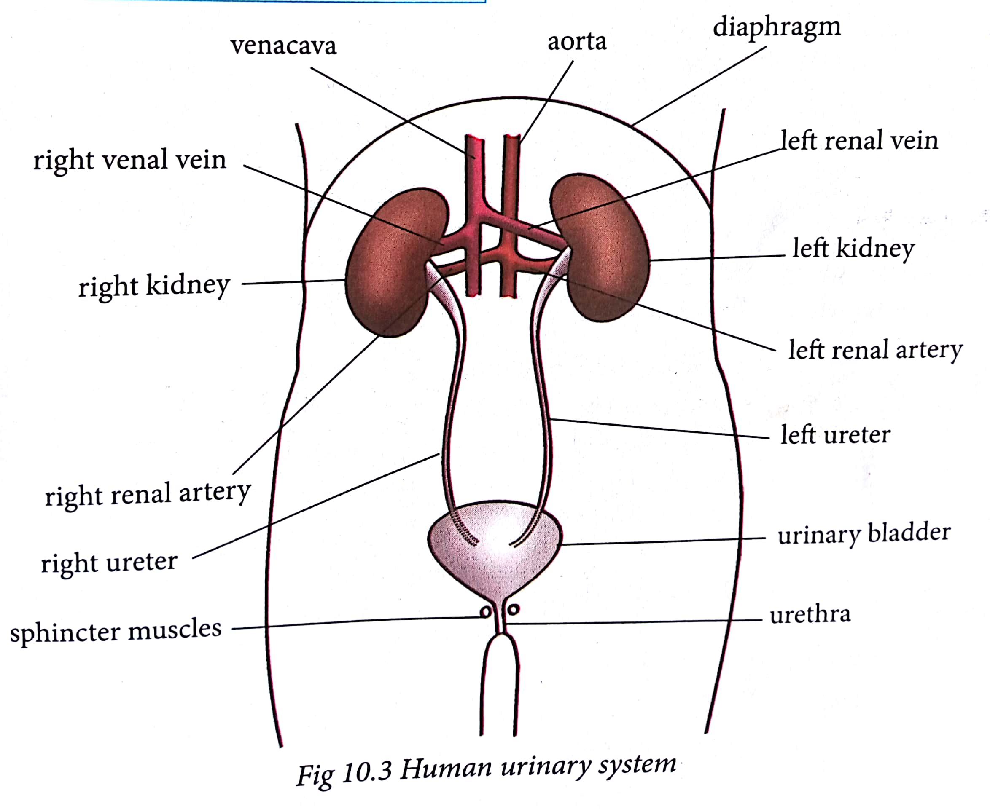

**Function of parts of the urinary system**

**The kidneys**

* Remove waste from the blood in the form of urine.
* Keep substances stable in the blood.
* Make erythropoietin, a hormone which helps make red blood cells.
* Make vitamin D active.
* Regulate blood pressure

**Ureter**

* carries urine from the kidney to the bladder.

**Bladder**

* store urine

**Sphincter muscle**

* help keep urine from leaking

**Urethra**

* allows urine to pass outside the body.

**THE KIDNEYS**

Kidneys are bean-shaped and are red-brown in colour.

The kidney is supplied with blood from the general circulatory system via the **renal artery** which branches off from the aorta.

Blood from the kidney goes back to the general circulation through the **renal vein**

**Internal structure of the kidney**

kidney has three main regions.

* The outer part called **cortex**,
* inner part called **medulla**
* and the **pelvis**.

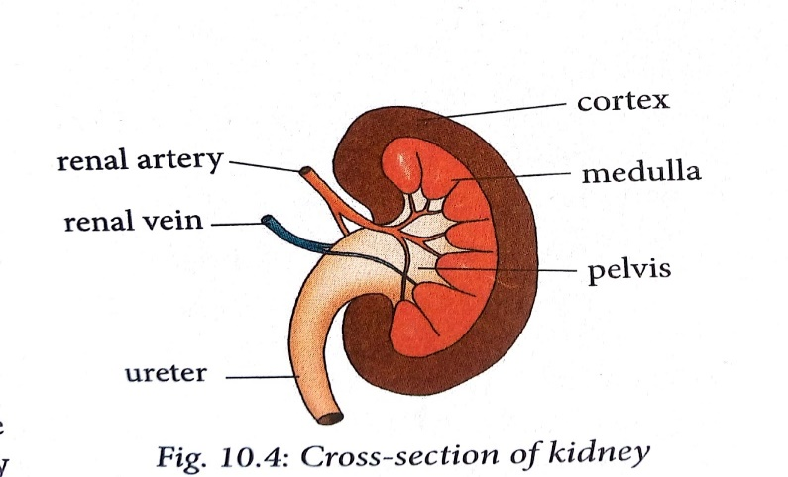

**1. Cortex**

This is the outer part which is dark in colour. It contains a dense network of blood capillaries that form the **glomeruli of nephrons**.

**2. Medulla**

This part is pale red in colour and lies between the cortex and the pelvis. It contains several cone-like extensions called **pyramids.**

**3. Pelvis**

This part is white in colour. It narrows to form the ureter.

**NEPHRON**

**Nephron** is the functional unit of the kidney.

The most important function of the kidney as an excretory organ is to filter wastes from the blood. This takes place in tiny units called nephrons or renal tubules.

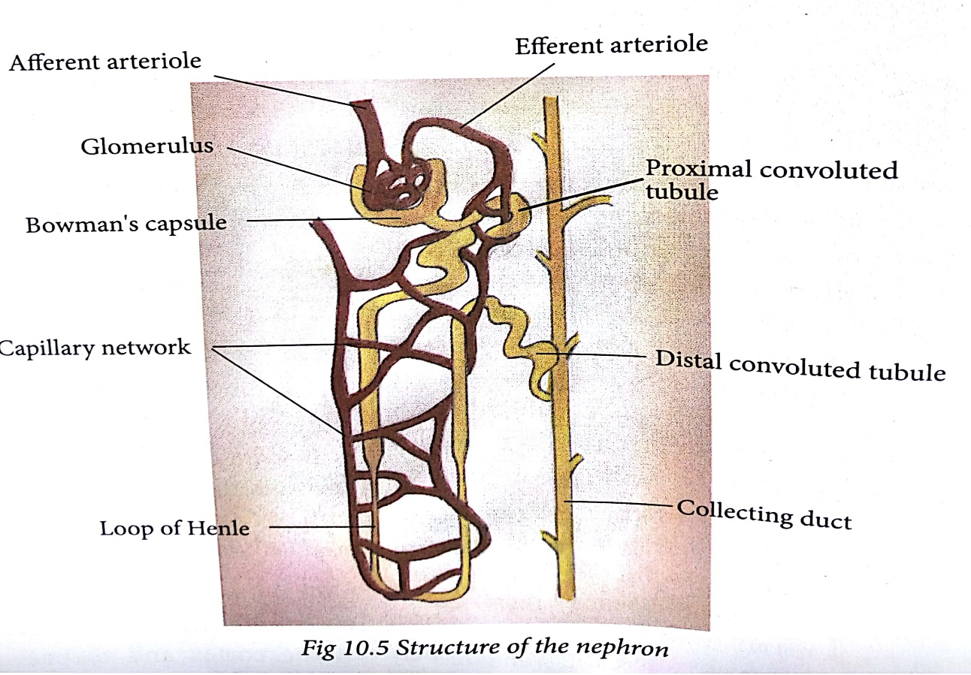

**URINE FORMATION**

Excretion in the nephron is carried out in two stages: **ultrafiltration** and **selective reabsorption**.

**(a) Ultrafiltration**

Ultrafiltration takes place in the glomerulus.

Blood coming into the kidney from the artery contains both waste substances ( **Urea** ) and useful substances(**amino acids** , **glucose , salt and water )** .Both substances must enter the nephron, where separation takes place by **ultrafiltration**.

**(b) Selective reabsorption**

useful substances must be taken back into the blood so that they are not lost. This process is known as **selective reabsorption**.

• All **amino acids** and **glucose** are reabsorbed by active transport

• Some **salts** and **water** are reabsorbed depending on how much of them the body still needs.

By the time the filtrate from the glomerulus (**glomerular filtrate include;**

**water, mineral ions** , **glucose, amino acids** and **urea**) completes its movement down the nephron, it has a high concentration of **urea, some salts** and **water**. The liquid is now called **urine**.

**Factors that affect urine production**

1. **Amount of fluids taken**

Large intake of fluids lead to the production of large amounts of dilute urine

**2. Amount of salt taken**

Intake of a salty meal leads to the production of coloured, little and smelly urine.

**3. Weather**

In hot and dry weather conditions, the body tends to lose a lot of water through sweating

resulting in production of coloured, little and smelly urine.

During cold weather the frequency of urination increases because sweating is so minimal.

**4. Physical activity**

During an exercise ,The kidney reabsorbs more water resulting in little, coloured and smelly urine.

**5. Diseases**

Certain diseases lead to production of large or small amounts of urine.

An example is diabetes insipidus.

**10.4 Practices that maintain healthy urinary system**

(i) Drinking a lot of water, at least 10 glasses of water a day

(ii) Exercising regularly to keep fit.

(iii) Avoid taking too many drugs. especially pain killers.

(iv) Visit a doctor (**urologist**) regularly to check the health of the urinary system.

(v) Eat healthy by avoiding junk food. Eat more fresh fruits and green vegetables.

(vi) Avoid smoking and alcohol intake

**UNIT** 11 . **JOINTS AND MOVEMENT**

**11.1 Types of joints**

A joint is a point where a bone meets another bone or bones.

joints allow movement and provide mechanical support.

**Bone** – is a hard, tough connective tissue composed of mineral salts such as calcium and phosphate.

**Cartilage** – this is a skeletal connective tissue which is softer than a bone.

**Ligament**-this is a fibrous tissue which join one bone to another

**Tendon** –a tough connective tissue which attaches a muscle to a bone.

**Muscle**- this is a contractile tissue specialised for contraction and relaxation.

Joints are classified **structurally** or **functionally**

**i. Structural classification**

**(a) Cartilaginous joint**- the bones are connected by cartilage.

**(b) Fibrous**- the bones are connected by dense fibrous tissue rich in collagen.

**(c) Synovial**- there is a space between the bones called synovial cavity that is filled with a fluid known as synovial fluid

**ii. Functional classification**

**(a) Movable joints**- allow some degree of movement. There are two categories;

• Those which allow slight mobility.

• Those which are freely movable.

**(b) Immovable joints-**permit very little or no mobility.

**Fixed or immovable joints**

These are joints that do not allow any movement, for example, joints in the cranium commonly known as **sutures.**

**Movable joints**

These are joints that allow movement of body parts to take place.

There are several movable joints which include:

**(a) Gliding joints**

They occur between the vertebrae.They are also found in the wrist and ankle.

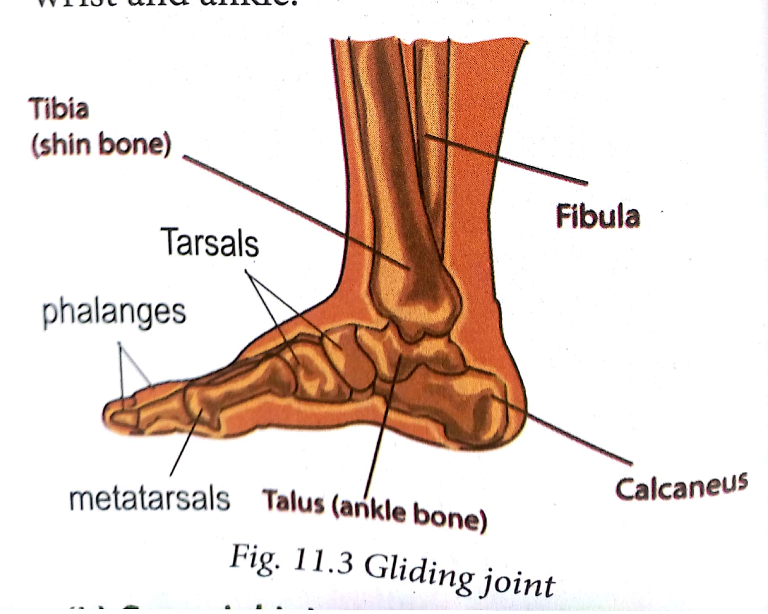

**(b) Synovial joints**

They include:

**(i) Saddle joints.**

Example is the joint of the thumb.

**(ii) Hinge joints**

Hinge joints allow movement in one plane. The joints at the elbow, knee and finger joints

**(iii) Pivot joints**

Examples include articulation of the axis with the atlas and the articulation between the head of radius and the proximal end of the ulna.

**(iv) Ball and socket joint**

Example is The shoulder joint and the hip joint.

**Structure of a synovial joint**

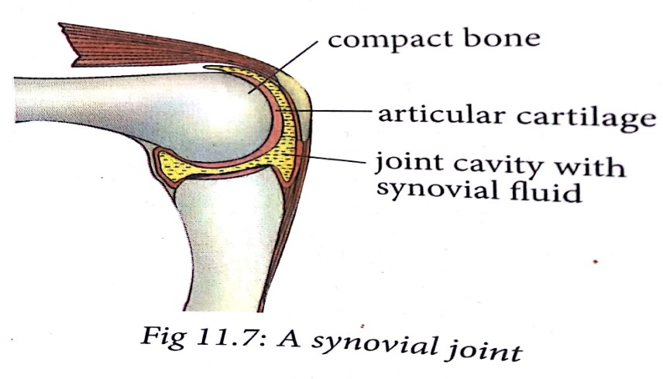

**11.2 Action of antagonistic muscles in the movement of a hinge joint**

The biceps and triceps are referred to as antagonistic muscles.

biceps is the flexor muscle while triceps is the extensor muscle.

Antagonistic muscles occur in pairs and oppose a specific movement such that when one muscle contracts, the other relaxes

**11.3 Practices that promote healthy bones and joints**

1. Eating calcium rich foods (eg: milk , Green leafy vegetables,), foods that contain Vitamin D ( eg:egg yolk and beef liver), Getting enough of Vitamin ( eg: fruits)

2. Avoiding alcohol consumption.

3. doing physical exercises

4. Avoiding smoking.

5. Maintaining a healthy body weight and posture

**UNIT 12 INFECTIOUS DISEASES**

Infectious diseases are also known as **communicable diseases**. They are diseases that are transmitted from one person to another.

These diseases are usually caused by harmful micro-organisms. Examples of micro-organisms include **viruses, fungi, protozoa** and **bacteria**.

**12.1 Transmission of infectious diseases**

**Pathogen or germs** : This is any disease-causing microorganism.

Example of pathogen : Bacteria, protozoa and viruses.

**Transmissible disease**: These are diseases capable of spreading from one person to another.

for example, common cold.

**Host:** This is an organism that harbours a disease-causing micro-organism,

**Vector:** This is a living organism that can transmit infectious diseases

Female anopheles mosquito is a vector to the plasmodium parasite malaria.

**Carrier:** This is a person who has been infected but develops no signs or symptoms.

**Signs:** These are visible expressions brought about by a disease,

for example, red spots on the body.

**Symptoms:** A physical or mental feature that is regarded as indicating a condition of disease,

for example, nausea, dizziness and headache

**Epidemiology**: The study of all factors that contribute to the appearance of a particular disease.

**Different ways by which Infections can be spreaded**.

Infectious diseases are transmitted through: air, contact, blood or other body fluids,

1. Diseases that are transmitted through the air are referred to as **air-borne** diseases. Tuberculosis and common cold are examples.
2. Diseases are transmitted through the consumption of contaminated water ( **waterborne Diseases )** and food ( **foodborne** diseases ). Examples are cholera and typhoid fever.
3. Through blood transfusion or contact with contaminated blood.

Examples : HIV and AIDS and malaria.

1. Physical contact with an infected person .they are known as **contagious Diseases**. They include ringworms, scabies and Ebola.
2. Communicable diseases are also spread by vectors. They are therefore known as **vector-borne** diseases, for example, sleeping sickness is spread by tsetse flies, malaria
3. Some infections can also spread through unprotected sexual intercourse with an infected person. These diseases are known as **sexual transmitted infections** (STIs), for example, HIV and AIDS.
4. Germs can also spread from a mother to her unborn child, usually through blood or other body fluids.
   1. **. Defense against infection**

**Immunity** is the ability of the body to resist disease infection.

**Resistance** : is The ability of the body to prevent itself from diseases using its lines of defense .

Body defence mechanisms can either be first line or second line.

**(a) Body’s first line of defence**

This line of defence prevents harmful micro-organisms from entering the body. It is the external defence system of the body. It includes both physical and chemical defence lines**.**

Example of the body defence mechanism include:

(i) The **skin.** creates a physical barrier

(ii) The nose and passages leading to the lungs. produce **mucus** that traps invading microbes and dust.

(iii) The stomach produces hydrochloric acid which destroys many of the microbes

(iv) Tears act as a barrier to pathogens.

(v) Clotting of blood occurs when an open cut or wound exposes blood to air.

**(b) Body’s second line of defence**

When pathogens are able to get past the first line of defence. This prompts the second line of defence to become active. This is the **immune response**.

The immune system attacks the pathogens.

White blood cells known as **phagocytes** are adapted to fight these disease causing micro-organisms

**IMMUNITY**

This is the ability of an organism to resist a particular infection or toxin by the action of specific antibodies or some white blood cells.

**An antibody** is a protein produced by the body’s immune system when it detects harmful substances, called **antigens**.

Examples of antigens include micro-organisms such as bacteria, fungi, parasites, viruses, and chemicals.

There are two types of immunity

* Natural immunity
* and artificial immunity

**(a) Natural immunity**

Natural immunity comes from the body itself.

It is divided into two: active and passive natural immunity.

**(i) Active natural immunity** may develop after recovering from a disease.

**(ii) Passive natural immunity** is immunity acquired by the foetus from the mother through the placenta and also through breast milk.

1. **Artificial immunity**

is obtained by introducing antigens into the body of an organism to protect the organism from a disease. It is divided into two: active and passive artificial immunity.

(i) **Active artificial immunity** is induced by introducing antigens into the body of an organism through the use of a **vaccine**.

(ii) **Passive artificial immunity** is the transfer of immunity in the form of ready-made antibodies.

**12.3 Symptoms, prevention, control and treatment of common infectious diseases**

**Control and treatment of cholera**

(i) Drinking water should be treated or boiled and stored properly.

(ii) Proper disposal of human wastes.

(iii) Washing hands before and after eating and after visiting the toilet.

(iv) Covering cooked food to avoid contamination by house flies.

(v) Vaccination during epidemics or when one is visiting an infested area.

(vi) Cholera is treated using antibiotics. Prevention of dehydration also helps in the cure.

**c) HIV and AIDS**

The Human Immunodeficiency Virus (HIV) attacks the immune system.

HIV and AIDS is transmitted from one person to another through various ways. They include:

(i) By birth, from an infected mother to her unborn baby.

(ii) By having unprotected sexual intercourse with an infected person.

(iii) By transfusion of infected blood.

(iv) By sharing of unsterilised surgical and skin piercing instruments with infected people.

**Symptoms of HIV and AIDS**

An individual develop signs and symptoms, such as swollen lymph nodes, weight loss, fever, diarrhoea and cough.

**Prevention and control**

The following are the ways through which a person can prevent himself or herself from contracting the disease.

i. Abstaining from sex till marriage.

ii. Being faithful to one partner.

iii. Using condoms during sex.

iv. Mothers should give birth in hospitals and go for regular medical checkup.

v. Blood should be screened before transfusion.

vi. Avoid sharing piercing and cutting instruments like razorblades and safety pins.

**d.) Tuberculosis**

Tuberculosis (TB) is caused by bacteria called *Mycobacterium tuberculosis*

**Symptoms of pulmonary TB**

Common symptoms of active pulmonary TB are:

(i) Cough with sputum and blood at times

(ii) Chest pains

(iii) General weakness

(iv) Weight loss

(v) Fever

(vi) Night sweats

**Prevention and treatment of tuberculosis**

(i) Isolate patients

(ii) Immunise children with tuberculosis vaccine known as BCG.

(iii) Avoiding overcrowded places.

(iv) Drinking boiled milk.

(v) Once infected, tuberculosis is treated with antibiotics.

**e) Ebola**

Ebola is spreaded through human-to-human transmission via direct contact (through broken skin or mucous membranes) with the blood, secretions, organs or other bodily fluids of infected people

**Symptoms of Ebola virus disease**

(i) First symptoms are the sudden onset of fever, fatigue, muscle pain, headache and sore throat.

(ii) This is followed by vomiting, diarrhoea, rash,…

(iii) Internal and external bleeding

**Prevention of Ebola**

(i) Avoid direct contact with wild animals like bats and chimpanzees.

(ii) Avoid direct contact with people showing signs of Ebola virus**.**

(iii) Use gloves and other protective clothing when handling Ebola patients.

(iv) Wash your hands regularly with soap and water.

**f) Salmonellosis**

This is an infection caused by Salmonella bacteria.

Salmonella infection usually results from ingestion of the bacteria from contaminated food or water.

**Symptoms of salmonellosis**

Most people infected with salmonella experience diarrhoea, chills with fever, nausea

**Prevention and treatment of salmonellosis**

(i) People with *salmonella* infection should not be allowed to handle food or take care of children.

(ii) Food should be well cooked.

(iii) Do not purchase dirty or cracked eggs.

(iv) Boil milk thoroughly before drinking.

(v) Always wash your hands with soap and clean water.

(vi) Wash fruits (including melons) and vegetables before eating.

(vii) Swimming pools should be disinfected regularly.

**g) Typhoid**

It is caused by a bacterium called *Salmonella typhi*,

typhoid is spread by eating food or drinking water contaminated with faeces or urine of patients and carriers.

**Symptoms of typhoid**

(i) Sustained high fever

(ii) Continuous headache

(iii) Malaise (feeling of being unwell)

(iv) Decreased appetite

(v) Enlarged spleen which may cause abdominal discomfort

(vi) Dry cough in the early stage of the illness

(vi) Constipation or diarrhoea

**Prevention and treatment of typhoid**

1. Isolation of the patients to avoid spread of the disease
2. Proper disposal of faeces in toilet and in pit latrines.
3. Water treatment and purification to kill the bacteria.
4. Boiling drinking water and cooking of food properly to kill the bacteria.
5. Practice good hygienic methods like washing hands properly after visiting the toilet.
6. Washing fruits and vegetables with clean water before eating.
7. Vaccinations in the case of outbreaks of the disease in epidemic

**UNIT 13. IMMUNITY AND VACCINATION**

**immunity** is the Ability of the body to defend itself against foreign bodies and disease-causing micro-organisms.

**immune system is** the system that is responsible for defending the body against diseases

**13.1 Antibodies and antigens**

An **antibody** a l so known as an **immunoglobulin** is a large Y-shaped protein.

It is produced mainly by **plasma cells**.

The antibody recognises a unique molecule of the harmful agent, called an **antigen**.

**Antigen**

This is any substance that is capable of stimulating an immune response, specifically activating the body to produce antibodies.

In general, two main divisions of antigens are recognised: foreign antigens and self-antigens.

• Foreign antigens come from outside the body.

• Self-antigens, on the other hand, come from within the body.

**Antigen–antibody reaction**

An antigen and antibody reaction works like a lock and key mechanism.

Antibodies themselves do not destroy antigens.

Defensive mechanisms used by antibodies are **neutralisation,** **agglutination, precipitation and plasma complement system.**

i) **Neutralisation** – antibodies bind to and block specific sites on antigens; viruses and bacteria.

ii) **Agglutination** – antibodies bind the same determinant on more than one antigen.

antibody surrounds antigen and prevents it from entering other body cells.

iii) **Precipitation** – soluble molecules are cross-linked into large insoluble complex.

iv**) Plasma complement system-** The antibodies coat infectious bacteria

**13.2 Immune response**

**Immune response** : is the process by which the body recognises and defends itself against bacteria, viruses and substances that appear foreign and harmful.

**The immune system** :is a collection of cells, tissues and molecules that protect the body from numerous pathogens and toxins in our environment.

two general types of reactions in defense against microbes:

• Reactions of innate immunity

• Reactions of adaptive immunity.

**a) Innate immunity (** nonspecific immunity )

Innate immunity is the body defense system that one is born with.

The main components of the innate immune system are:

i. Physical epithelial barriers

ii. Phagocytic leukocytes

iii. Dendritic cells

iv. A special type of white blood cells called a natural killer (NK) cell

v. Circulating plasma proteins

**b) Adaptive immunity (**acquired immunity**)**

Adaptive immune system is immunity that develops after exposure to various antigens.

The immune system includes certain types of white blood cells, for example, **lymphocytes.**

There are 2 type lymphocytes :

* B lymphocytes
* T lymphocytes

• **B** lymphocytes are cells that produce antibodies.

• **T** lymphocytes are cells that attack antigens directly and help control the immune response.

**Active immunity**

This is the immunity that results from the production of antibodies by the immune system in response to the presence of an antigen.

Types of Active immunity :

* **Naturally acquired active immunity**
* **Artificially acquired active immunity**

• **Naturally acquired active immunity** occurs when a person is exposed to a live pathogen.

• **Artificially acquired active immunity** can be induced by a vaccine, a substance that contains alternated form of the antigen.

**Passive immunity**

This is a short-term immunity that results from the introduction of antibodies from another person or animal.

Types of Passive immunity :

* **Artificially acquired passive immunity**
* **Naturally acquired passive immunity**

• **Artificially acquired passive immunity** It is achieved by the injection of antibodies that are not produced by the recipient's cells.

• **Naturally acquired passive immunity** occurs during pregnancy, in which certain antibodies are passed from the maternal body into the foetal bloodstream.

**13.3 Immunisation and autoimmunity**

**Immunisation** is the process whereby a person is made immune or resistant to an infectious disease, typically by the administration of a vaccine.

**Autoimmunity** is a condition whereby the immune system attacks and kills own cell.

Any disease that results from such an immune response is termed an **autoimmune disease**.

Complications from altered immune responses include:

i. Allergy or hypersensitivity

ii. Autoimmune disorders

iii. Immunodeficiency disorders

iv. Serum sickness

v. Transplant rejection

**Type 1 diabetes and the immune system**

**Type 1 diabetes** was initially known as **juvenile** diabetes or insulin-dependent diabetes mellitus. It is a chronic condition in which the pancreas produces little or no **insulin**.

Insulin is a hormone needed to enable sugar (glucose) to enter cells to produce energy.

Specific cells in the pancreas known as the **beta cells** are responsible for manufacturing insulin.

When some virus ( • German measles • Mumps • Rotavirus ) that have the same antigens like those of the beta cells in pancreas . the T-cells mistakenly recognise beta cells as foreign to the body. They attack these cells hence destroying them.

Once the beta cells of the body are destroyed, no insulin is produced. This leads to an increase in blood sugar level and therefore increases the possibility of having diabetes.

**Type 2 Diabetes** mellitus occurs when the body cells becomes resistant to insulin or when less insulin is produced by the body.

**UNIT 14 . SEXUAL BEHAVIOUR AND SEXUAL RESPONSE**

14.1 Male and female sexual responses

The human sexual response is a series of changes that take place in the body in response to sexual stimulation.

four phases of sexual response :

i. Excitement phase

ii. Plateau phase

iii. Orgasmic phase

iv. Resolution phase

**1. Excitement phase**

This is the initial stage of stimulation that gets the body ready for sex. The stimulation may be due to kissing, seeing an attractive person or soft touches.

**2. Plateau phase**

This is a phase that prepares both man and woman for orgasm.

**3. Orgasmic phase**

The orgasm is the climax of the sexual response cycle.

This phase is accompanied with sexual pleasure and satisfaction

**4. Resolution phase**

During resolution, the body slowly returns to its normal level of functioning.

**Sexual stimulation**

This is any stimulus whether physical or mental that leads to sexual arousal.

**Puberty in boys and girls**

Puberty is a period during which adolescents reach sexual maturity and become capable of reproduction.

**Puberty in boys**

Puberty in males takes place between the ages of 11 and 13 on average.

The problems faced at this stage include:

• Abuse of drugs and alcohol

• Lack of respect for authority

• Fighting among peer groups

• Parental hatred

• Poor hygiene and general body cleanliness.

**Puberty in girls**

On average, girls begin puberty at an early age of about 10-11years.

Puberty in girls occurs fast as compared to boys.

Menstruation in girls is a characteristic that shows the onset of puberty.

The main challenge that girls face during puberty is unwanted pregnancies.

**14.2 People and sexual relationships**

People develop different types of relationships ranging from acquaintances to friendships to romantic relationships.

Partners in a healthy relationship should have the following characteristics; they should:

• Treat each other with love and respect.

• Be honest to each other.

• Spend time with each other.

• Take special interest in activities that each likes.

• Respect each other’s emotional, physical and sexual limits.

• Speak honestly about their feelings.

The following are forms of sexual relationships:

**a) Exogamy**- is a relationship where individuals find their mates outside their family circles.

**b) Monogamy:** This is a longterm relationship between a man and a woman in which none has other sexual partners.

**c) Polygamy:** This is a long term sexual relationship of having more than one wife or husband at the same time.

**d) Casual relationships:** This is an act of having sex with someone you do not have an attachment to.This is the case when one engages with a sex worker.

e**) Dating relationships:** This is when two people (a boy and a girl) go out together.

**Sexual problems and disappointment**

The following are some of the sexual disappointments.

**In males**

**a) Premature ejaculation:** This is a condition whereby a man cannot delay ejaculation long enough to satisfy the woman.

**b) Impotence:** This is the inability to produce or maintain an erection.

**c) Inflammation:** Blockage of the urethra

**In females**

**a) Vaginal discharges**: This is any abnormal discharge from the vagina.

**b) Functional disorders**: This is the inability of a woman to experience sexual pleasure and satisfaction.

**Sexuality, age and culture**

Sexuality refers to anything to do with being male or female.

The following sexual behaviors are unacceptable in the Rwandan culture:

**i) Incest:** This is the act of having sex with a close relative.

**ii) Homosexuality**: This is where people of the same sex are engaged in a sexual relationship.

**iii) Masturbation:** The act of self-stimulation that leads to sexual satisfaction.

**iv) Anal sexual intercourse**

**v) Rape:** The act of forcing some one into sexual intercourse without consent.

**vi) Adultery**: Having sex outside wedlock.

vii) Prostitution: Engaging in sexual relationships for financial gains

**Violation of human rights**

**Human rights** are the rights a person has simply because he or she is a human being.

Violation of human rights includes: sexual harassment or abuse, coercion and human trafficking.

**Child sexual exploitation**

Child sexual exploitation is a type of sexual abuse in which children are sexually exploited for money, power or status.

**Sexual assault**

Sexual assault is any forced or coerced sexual contact or behavior that happens without consent.

**UNIT 15 . PREGNANCY PREVENTION**

**15.1 Contraceptives**

Contraceptives are the things that are used to prevent occurrence of pregnancies.

**Common myths about contraceptives**

i. Birth control pills make women gain weight and can cause cancer.

ii. The birth control pill has to be taken at the same time every day.

iii. Mothers who breast feed do not need to be on birth control pill.

iv. Being on the pill for a long time makes it harder to get pregnant later.

v. Intra uterine device (IUD) should be used by women who already have children.

vi. A girl cannot get pregnant when she has sex for the first time.

**Importance of using contraceptives**

It allows couples to have their desired number of children, and control the spacing and timing of their births.

**15.2 Natural contraceptives**

Natural family planning methods relies on knowledge of the menstrual cycle of the woman. This knowledge enables couples to avoid having sex when the woman is fertile.

**Advantages of natural contraception**

a) Effective method of birth control.

b) Have no negative health side effects.

c) An alternative for women who cannot or do not want to use hormonal methods.

d) Promotes positive body awareness.

e) Consistent with many religious beliefs and lifestyles.

**Disadvantages of natural contraception**

a) Provides no protection from sexually transmitted infections.

b) Often difficult to find trained instructors.

c) Requires time to learn (usually 3 to 6 cycles).

d) Requires discipline and commitment to chart fertility signs and follow the rules to avoid pregnancy.

e) Times of abstinence from intercourse may be a challenge for some couples.

**Types of natural contraception**

**a) Abstinence**

Sexual abstinence is the avoidance of vaginal intercourse.

**Advantages of abstinence**

a) Minimal risk of misuse.

b) Prevents transmission of STIs including HIV and AIDS.

c) No physical side effects.

d) No need to visit a health care provider.

e) No cost involved .

**b) Lactation Amenorrhea Method (LAM)**

is used by a mother who has just given birth and is exclusively breastfeeding. This method is highly effective for the first six months after childbirth. The mother has to breastfeed the baby at least every four hours during the day and every six hours through the night.

**c) Temperature method**

a woman measures her basal body temperature: temperature when fully at rest especially after waking up. It is believed that ovulation may cause a slight increase in basal body temperature.

**d) Calendar method**

Calendar method is also known as Rhythm method or cycle beads.

It predicts a woman’s fertile days using calculations based on the length of past cycles

**f) The Billings Ovulation Method**

It enables a woman to recognise her body's natural signal of fertility through production of cervical mucus.

**15.3 Artificial contraceptives**

Artificial birth control is any product, procedure or practice that uses artificial or unnatural means to prevent pregnancy.

Most types of artificial contraceptives work by:

• Preventing an egg from being released every month (hormones).

• Preventing sperms from reaching the egg (barrier and some IUD methods).

• Blocking the reproductive function in men or women (sterilisation).

• Preventing a fertilised egg from implanting in the uterus (hormones).

**artificial birth control methods include**

1. **Barrier methods**
2. The male condom
3. The female condom
4. Spermicide
5. **The Diaphragm**
6. **Hormonal based contraceptives**

They are administered in three ways:

• Orally (oral contraceptives)

• Through injections

• Administration of implants

**a) The Pill**

It is taken orally in form of a tablet, every day at almost the same time.

**b) Contraceptive Injections**

This is an injection that contains artificial progesterone (progestin).

**c) The contraceptive implant**

**d) The vaginal ring**

is a small, transparent plastic ring that is inserted in the vagina and kept for three weeks.

**e) The contraceptive patch**

**f) Emergency contraception**

**C. Non – hormonal based contraception methods**

**a) The Intrauterine Device (IUD)**

**b) Permanent contraception methods**

**Sterilisation**

Sterilisation is a procedure that closes or blocks fallopian tubes in women and sperm duct in men.

**i) Vasectomy**

This involves tying off and cutting the tubes that carry sperms; the vas deferens.

**ii) Tubal ligation**

• Surgical sterilisation: This involves cutting and tying the fallopian tubes

• Non-surgical sterilisation: This involves placing a coil in each fallopian tube through the vagina and uterus.

1. **Abortion**

Abortion is the deliberate process of prematurely terminating a pregnancy usually before the embryo or foetus is capable of independent life.

**Menopause**

This is a term used to describe that state when a woman stops having monthly periods and is no longer able to get pregnant naturally.

It is the period in a woman's life (typically between 45 and 50 years of age) when this occurs.

**UNIT 16. REDUCING RISK OF STIS AND HIV AND AIDS**

**16.1 Transmission of STIs**

Sexually transmitted infections (STIs) are transmitted by infected persons to healthy persons during sexual intercourse.

Examples of STIs are chlamdia, gonorrhoea, syphillis and, HIV and AIDS.

**1. Chlamydia**

Chlamydia is caused by the bacterium *Chlamydia trachomatis*.

The disease is spread by oral, vaginal or anal sex, and also through touch, for example, touching the eyes with a contaminated hand, may lead to conjunctivitis.

**Signs and symptoms of chlamydia**

**In males**

• Pain when passing out urine.

• White discharge from the penis.

• The testicles may be painful or swollen.

• Swelling of skin around the anus.

**In females**

• Painful and frequent urination.

• Smelly yellowish and abnormal vaginal discharge.

• Pain in the lower abdomen.

• Swollen skin in the vagina or around the anus.

**Treatment**

Chlamydia is easily treated using antibiotics.

1. **Gonorrhoea**

Gonorrhoea is transmitted through sexual contact with the penis, vagina, mouth or anus of an infected partner. Gonorrhoea can also be spread from mother to baby during childbirth.

Gonorrhoea is caused by a bacterium called *Neisseria gonorrhoeae*.

**Signs and symptoms of gonorrhoea**

Some men with gonorrhea may have no symptoms at all. However, men who do have symptoms may have:

• A burning sensation when urinating.

• A white, yellow, or green discharge from the penis.

• Painful or swollen testicles (although this is less common).

Symptoms in women can include:

• Painful or burning sensation when urinating.

• Increased vaginal discharge.

• Vaginal bleeding between periods.

**3. Syphilis**

Syphilis is transmitted from person to person by direct contact with a syphilitic sore, known as a *chancre*.

Syphilis is caused by a bacteria called *Treponema pallidum*.

The bacterial infection progresses through several stages.

1. In the ***primary stage***, small hard painless sores develop at the penis and the vagina.
2. The disease enters ***secondary stage*** several weeks later characterised by rashes on the skin and mild fever.
3. In the ***tertiary stage***, lesions develop and cause extensive tissue damage that may lead to paralysis, insanity, blindness and eventually death.

**Treatment**

Antibiotics like penicillin, erythromycin or tetracycline are used to treat syphilis

**Transmission of HIV (Human immunodeficiency virus) infection**

HIV is the virus that causes AIDS (Acquired immune deficiency syndrome). It is mainly transmitted through:

a) Certain body fluids: blood, semen, pre-seminal fluid, rectal fluids, vaginal fluids and breast milk from a person who has HIV.

b) Having anal or vaginal sex with someone who has HIV without using a condom

c) Sharing needles or syringes or other equipment used

d) Mother to child during pregnancy, birth or breastfeeding.

**16.2 Ways of reducing STIs and HIV infection**

The following are ways of reducing STIs and HIV infection:

a) Abstinence is the only sure way to prevent STIs.

b) Being faithful to one trusted partner.

c) Using condoms every time when engaging in sexual intercourse.

d. Reduce the number of sexual partners.

e. Avoid sharing towels or underclothing.

f. Get a vaccination for hepatitis B.

g. Get tested for HIV.

h. Avoiding alcohol consumption and abuse of drugs

**Treatment of STIs and HIV**

**Treatment of STIs and HIV is based on their causative agents.**

1. Bacterial STIs can be cured using antibiotics if treatment begins early enough.

2. Viral STIs cannot be cured, but the symptoms can be managed with medications.

3. HIV cannot be cured but can be managed.

Antiretroviral therapy (ART) is the use of HIV medicines to treat HIV infection.

**END !!!!!!!!!!!!!!!!!!!!!!!!!!!!!!!!!!!!!!!**

.